NIHR MRes Clinical & Health Research
Studentship Information and Guidance

Clinical Academic Training Pathway
for nurses, midwives, allied health professionals and healthcare scientists

Information and Guidance for Studentship Applicants

Contents:

- Clinical Academic Pathway – information
- The Faculty of Health Sciences
- The MRes Clinical & Health Research
- The NIHR funded studentships
- Application process
- Further information

1 Clinical Academic Training Pathway

The National Institute for Health Research (NIHR) provides funding for an integrated clinical academic training pathway for nurses, midwives, allied health professionals and healthcare scientists. The Faculty of Health Sciences has secured funding for 10 fully funded places per year on our MRes Clinical & Health Research programme, between 2015 and 2017. We can confirm that we have 10 places to allocate for September 2017.

The NIHR Integrated Clinical Academic Training Pathway comprises four levels of Award: Masters, Doctorate, Clinical Lectureship and Senior Academic Clinical Lectureship. The Pathway supports nurses, midwives, allied health professionals and healthcare scientists committed to developing a career involving research, allowing them to integrate clinical practice and research or (post-graduate) training.

The Masters in Research represents the first stage of the Integrated Clinical Academic Training Pathway. It is the first phase of training suitable for graduate nurses, midwives, allied health professionals or health care scientists who have at least 1 years’ experience of clinical practice since graduating but who have little formal research experience or training. The training is available 1 year full-time or 2 years part-time.

We recommend that you visit the NIHR Trainees Coordinating Centre website
http://www.nihr.ac.uk/funding-and-support/funding-for-training-and-career-development/training-programmes/nihr-hee-ica-programme/
for further information on the Clinical Academic Careers pathway and the list of eligible professions.

Studentships are offered on a secondment basis, and applicants must demonstrate support for their application from their clinical manager/employing organisation. Applicants must therefore discuss their application with their relevant manager or employing organisation, prior to submitting the application form.

2 The Faculty of Health Sciences

The Faculty of Health Sciences is a nationally, and internationally recognised centre of excellence for nursing, midwifery, allied health professional (AHP), health care science research and education. A well-developed framework for preparing for, and developing, research careers is in place in the Faculty of Health Sciences, including the MRes in Clinical & Health Research and a multi-professional PhD programme, Doctorate of Clinical Practice, and a post-doctoral career development programme. The Faculty has established clinical academic careers posts for nurses, midwives and AHPs at doctorate and post-doctoral levels, working with partner Trusts and HEE. Graduates from our MRes Clinical & Health Research have been successful in progressing onto the next stages of the NIHR Clinical Academic Training Pathway.

The Faculty’s Research Groups are: Complex Healthcare Processes; Fundamental Care and Safety; Health Work and Systems; Active Living and Rehabilitation. Successful applicants will be supported to work within one of these Research Groups, with an experienced research supervisor. Further information on our research and the research groups can be found on our website: http://www.southampton.ac.uk/healthsciences/research/groups.page

3 The MRes Clinical & Health Research

The overall aim of the course is to prepare nurses, midwives, AHPs and healthcare scientists with the requisite knowledge and skills to effectively undertake, manage and deliver all aspects of the clinical research process, making an effective contribution to the generation & application of patient-focused, applied research in the clinical context. The course encourages students to draw on clinical practice to inform their learning throughout the programme.

The MRes combines training in research methods (both qualitative and quantitative) with training in research management and governance, and equips its graduates with the skills to manage and deliver research in clinical and health care settings. The course is aimed at preparing graduates for research roles, future research at PhD level or clinical research practice.

The programme is targeted at nurses, midwives, AHPs and healthcare scientists, including research-active staff based in clinical research facilities, clinical trials units and other academic/research units, and other graduates seeking preparation for a clinical research career. We envisage that graduates from the MRes will engage in clinical research in a variety of employment settings and will be able to take up key roles in research teams to manage and deliver research in clinical settings and/or will be well prepared for future development as clinical research leaders.

Modular structure of the course
The course consists of six taught modules leading to 60 ECTS credits and a dissertation (30 ECTS). Students undertake an introductory research methods training module, and modules in both quantitative and qualitative research methods. They also take a module focused on the challenges of carrying out research in clinical practice settings and building a clinical research career. Students will also complete a research skills development module linked to a Research Group within the Faculty of Health Sciences. The clinical research project component of the course extends over the period of registration.
Students will also select a further module from the range of clinical, research and leadership modules provided within the Faculty (see our website for further details of level 7 modules available: http://www.southampton.ac.uk/healthsciences/cpd/courses.page 3

Modules are as follows:
Designing and Conducting Research L7 (10 ECTS)
Clinical Research in Practice (10 ECTS)
Applied Quantitative Research Methods (10 ECTS)
Applied Qualitative Research Methods (10 ECTS)
Developing Research Skills (10 ECTS)
Research dissertation (30 ECTS)
Option module (10 ECTS)

In relation to specific questions about timetable, we do not have a set MRes programme timetable, as some modules are optional. However, mostly the modules follow the same timetable pattern year to year, so you should be able to extract approximate attendance from each individual module profile. Many modules have e-learning linked with lecture attendance, so the time not allocated to attendance is dedicated to independent study. For more detail on our programme structure and the modules please follow this link:
http://www.southampton.ac.uk/healthsciences/postgraduate/taught_courses/mres_clinical_research.page

4 The NIHR funded studentships

The studentships provide funding to cover salary backfill and course fees.

Six Places are available part-time (104 weeks maximum) and four full-time (52 weeks) and successful applicants will combine a role in clinical practice with study on the MRes. It should be noted that, due to research ethics and governance procedures, the scope to carry out research projects in the clinical area may be more limited for full-time students. You will need to agree your chosen study route (full or part-time) with your manager prior to application. Full-time applicants are encouraged to work with their manager to create a plan to maintain contact with their clinical area during the programme, possibly via scheduled ‘keeping in touch’ days.

The NIHR funding stream, is extremely competitive and candidates require relevant clinical/professional experience, along with a good first degree of 2:1 or above.

The eligibility criteria are as follows:
Normally a 2:1 degree or above (applicants without a first degree may be considered if they can demonstrate additional research experience and/or the ability to study at Masters level)
Registration with the NMC or HPC or other relevant professional body
At least 1 years’ experience of clinical practice since graduating
Current employment by an organisation delivering health care for the NHS or providing services to the NHS
Able to be registered as a ‘home’ student for fees purposes

If you do not meet the eligibility criteria for the funded studentships you may still be able to apply for a self- or employer-funded place. Please contact [ PGapply.fhs@soton.ac.uk ] to obtain further information about this process.

NIHR-funded MRes students will be required to attend the University at least two days per week during the period of study.

5 Application process

For entry in September 2017, please apply via the University of Southampton on-line application system.
** Please ensure that you select the following buttons: ‘taught’ the correct academic year, either part-time or full time, on the form, and the correct course. See the example below which shows a selection example for full-time
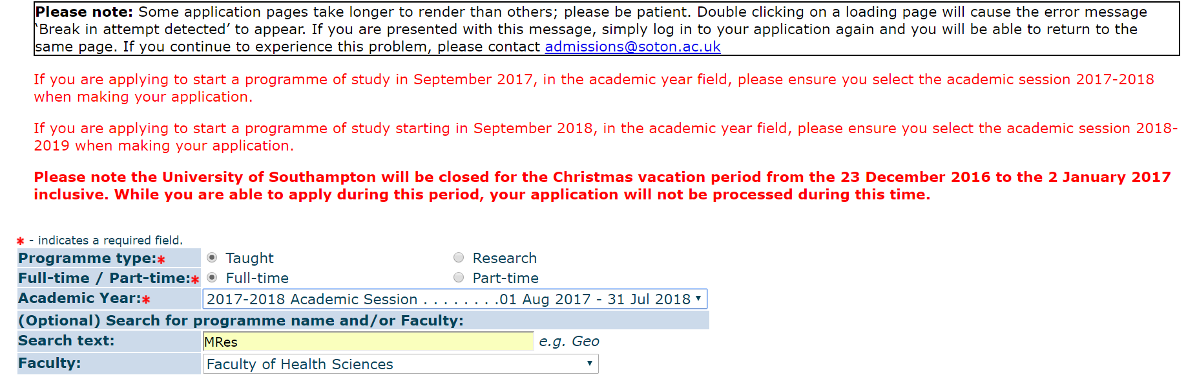

Under the General Information (Checklist item 11 of 14) In the box that states: ‘Please give any further details about your funding, including whether the funding has been awarded yet’ please insert ‘NIHR studentship’

Additionally, in your personal supporting statement, consider that applications will be assessed against the following criteria:
- Ability to demonstrate clinical experience/expertise/leadership in their field of practice
- Is supported to undertake the MRes by their clinical line manager or appropriate person in their employing organisation
- Demonstrates relevant research interest, experience and/or a commitment to developing clinical research in practice
- Potential for high quality supervision within the Faculty of Health Sciences
- Potential to link with experienced researchers within research groups in the Faculty or beyond
- Ability to demonstrate support for their progression in a clinical academic career from the clinical environment in which they work
- Demonstrate a clinical academic career plan
- The potential of the candidate to make a contribution to clinical research development and capacity in their chosen field in the UK

Within applications we do ask you to identify a potential research area / question and the Research Group in which your work would fit and possible / potential supervisors. We have four research groups within the Faculty of Health Sciences:
Complex Healthcare Processes
Fundamental Care and Safety
Health Work and Systems
Active Living and Rehabilitation

Follow this link to review the groups:
http://www.southampton.ac.uk/healthsciences/research/index.page?

You should be able to identify all active researchers and their defined areas and methodologies from this, which will help you identify where your project may fit and also identify potential supervisors and/or approach the most appropriate person to discuss your project idea with. We strongly recommend that you contact potential supervisors for an initial informal discussion about potential project areas.
6 Further information

For further information please email Francesca Lambert, Project Co-ordinator F.Lambert@southampton.ac.uk quoting ‘MRes Clinical Research studentships’.

Closing date for applications will be THURSDAY 7th April 2017.

†Programme structure and content is subject to change through periodic review and quality assurance processes.

