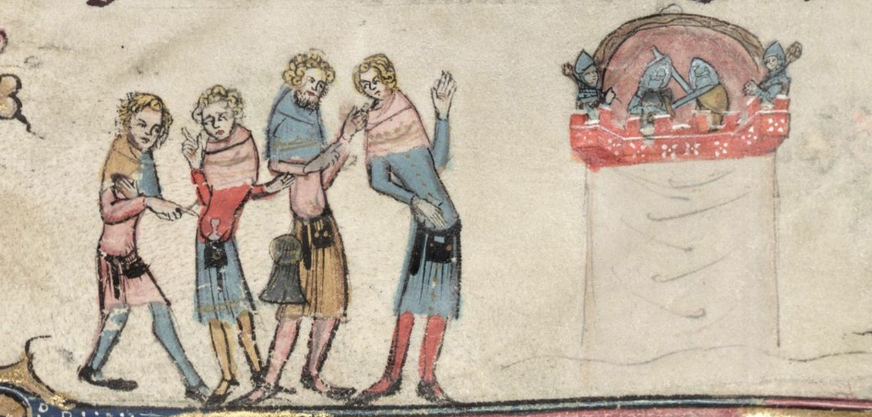
Modes of Spectatorship from the Middle Ages to 1700
A Symposium in Honour of Prof. John J. McGavin
Keynote Speaker: Professor Greg Walker (Edinburgh)
11 May 2016, University of Southampton
Since John McGavin joined the University of Southampton in 1975, his research has ranged widely across medieval and early modern drama, performance, and theatricality in both Scotland and England. A long standing board-member and contributor to the Records of Early English Drama project, John’s work in the gathering and editing of primary sources relating to performances and their venues has been instrumental in building the foundations of future studies in the field.
2016 sees the publication of John’s latest book, co-written with Professor Greg Walker (Edinburgh), Imagining Spectatorship: From the Mysteries to the Shakespearean Stage (OUP). English and the Centre for Medieval and Renaissance Culture at Southampton are taking this occasion to mark John’s retirement by celebrating areas of interest that he shares with early career scholars. We invite Postgraduate and Early Career researchers to a half-day symposium to showcase current research and consider new directions in the study of medieval and early modern spectatorship.
We welcome proposals for 20-minute papers that touch on any aspect of spectatorship in the medieval and early modern periods. Subjects might include but are not limited to:
Real and Imagined spectators
Theorizing and reconstructing pre-modern spectators
Spectatorship beyond drama and performance
Performance-as-Research
Interpreting the historical record: REED and other archives
Comparative approaches: England, Scotland, and Europe
The places, spaces, and material conditions of spectatorship
Spectatorship and subjectivity
Spectacle and politics

Proposals for poster and other visual presentations are also welcome.

Submissions: please send title, abstract/summary (around 100 words) and a short biographical summary (around 50 words) by 14 March 2016 to Stephen Watkins sdw1g10@soton.ac.uk OR Marianne O’Doherty Mod1w07@soton.ac.uk.

Bursaries: thanks to the generous support of the Faculty of Humanities, a limited number of partial bursaries will be available to contribute towards travel costs for participating postgraduate and early career researchers (within four years of PhD award). If you wish to be considered for one of these, please indicate this with your abstract submission.

Image: A puppet show; Oxford, Bodleian Library, MS Bodley 264.

