PhD opportunity: Ultrasonic cleaning invention for ensuring salads and vegetables are free of microbes, pesticides, and animal waste before packaging
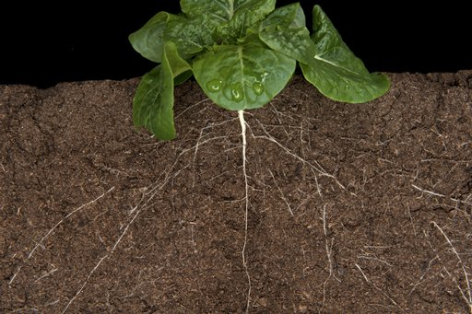
There is a global need for improved cleaning of salads after harvesting, to remove chemicals (fertilizers, pesticides etc.) and reduce microbiological contamination (e.g. from animal waste). Some countries allow a greater chemical load than does the EU, and in the developed world both organic and intensive food production have seen outbreaks of serious illness because of insufficiently cleaned leaves (e.g. http://globalnews.ca/news/2471603/one-dead-12-sickened-from-listeria-contaminated-salad-from-dole-food-cdc/).

The ability to clean salads with just cold water would clearly be an advantage over the use of chemicals (and would leave no aftertaste). Prof Leighton at Southampton University pioneered several technologies for cleaning using just cold water, with no chemicals, by the addition of ultrasound and bubbles. For example, StarStreamTM (http://www.southampton.ac.uk/engineering/research/projects/starstream.page? passes a stream of water over the object to be cleaned. However this is unlikely to be the best solution for cleaning salads. Instead, this project will pioneer a new approach - mass washing of salad leaves by immersion of the salad in water activated by sound. This project will develop ‘green’ cleaning systems in baths and pipes to clean salads in cold water without chemicals. The inclusion of the partner industry, VitaCress, will ensure this fundamental research goes through to real impact, helping society, probably in the lifetime of this project.

Although this project will be based in Engineering, we have a strong collaboration with Life Sciences who will undertake measurement of the microbiological load and can provide cross-disciplinary experience if the student wishes it: in the future careers market, researchers with cross-disciplinary experience will be well placed. It is particularly important to note that the project will receive the support of the University Strategic Research Group, NAMRIP (see http://www.southampton.ac.uk/namrip/news/latest.page), which seeks to invent, and implement in the wider world, innovative solutions to AntiMicrobial Resistance and to support Infection Prevention, without which the world will face global catastrophes in health care and food supply by 2050 (https://theconversation.com/we-need-more-than-just-new-antibiotics-to-fight-superbugs-44054).

The applicant should have a 2:1 or first class undergraduate degree in a physical science or engineering. The funding covers stipend and fees at EU/UK rates, which means that applicants must be able to meet EPSRC eligibility criteria for a full EU/UK studentship (fees and stipend) as laid out at https://www.epsrc.ac.uk/skills/students/help/eligibility/
The PhD will be supervised by Professor Timothy Leighton FREng FRS of the Faculty of Engineering and the Environment (http://www.southampton.ac.uk/engineering/about/staff/tgl.page#research), and by Professor Bill Keevil of the Centre for Biological Sciences (http://www.southampton.ac.uk/biosci/about/staff/cwk.page).

