

A pre-arrival online course for all international students about life and study at the University of Southampton

Since mid-May 2011 all international students already holding offers or in the process of applying for a place on a University of Southampton course, have been invited to do a free online course to help them find out what living and studying in Southampton will be like. The Moodle-hosted course is called ‘Get Ready for Southampton’ and is available for them to use online until they arrive. The self-access course contains activity-based, multimedia learning resources to help students learn about Southampton; find out about everyday life at the University, UK academic culture and what to expect when they begin their studies.

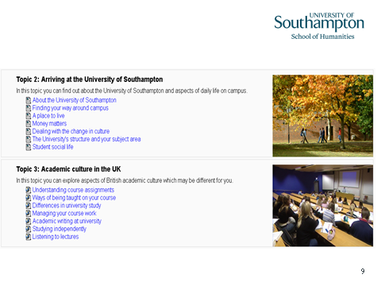
Current status:
To date almost one third of the new intake of international students (expected c. 2500) have accessed the course. These include both pre-sessional and direct entry students. The number is still climbing and data from Moodle tracking and student evaluation forms are expected to yield much useful information.

The course has been developed by the eLanguages team in Modern Languages with the aid of funding from the Transition to Living and Learning Project. For further information please contact: Julie Watson (J.Watson@soton.ac.uk)

