Biographical notes - William A. Schabas OC MRIA

Current as of 14 October 2011
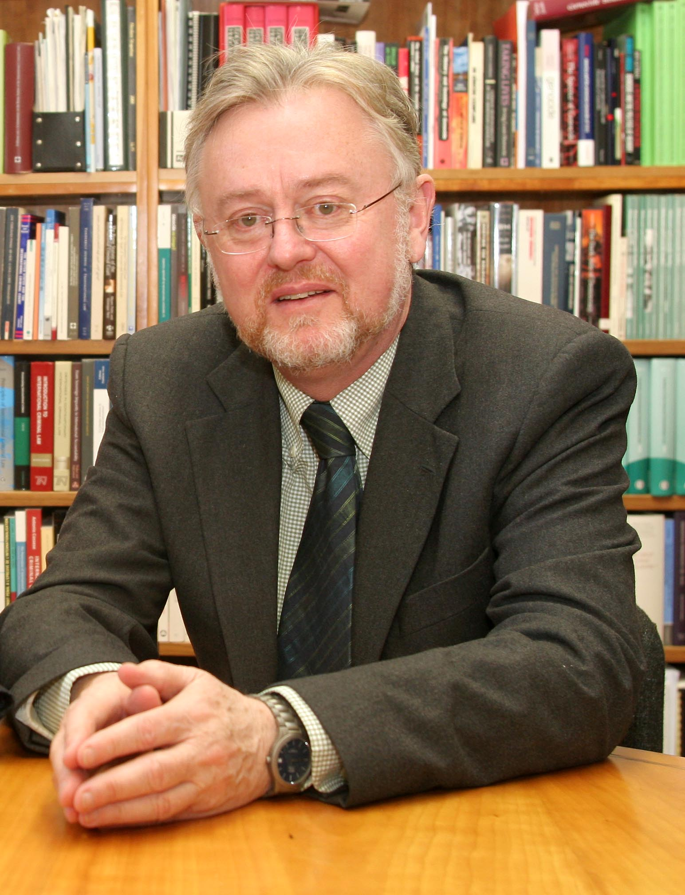
Professor William A. Schabas is professor of international law at Middlesex University in London. He also has appointments at the National University of Ireland Galway, where he is professor of human rights law and chairman of the Irish Centre for Human Rights, at the Chinese Academy of Social Sciences, in Beijing, as honorary professor, Kellogg College of the University of Oxford, where he is a visiting fellow, and at the Université du Québec à Montréal, as professeur associé. Prof. Schabas is a ‘door tenant’ at the chambers of 9 Bedford Row, in London.
Professor Schabas holds BA and MA degrees in history from the University of Toronto and LLB, LLM and LLD degrees from the University of Montreal, as well as honorary doctorates in law from Dalhousie University, Case Western Reserve University and Northwestern University. He is the author of more than twenty books dealing in whole or in part with international human rights law, including The International Criminal Court: A Commentary on the Rome Statute (Oxford: Oxford University Press, 2010), Introduction to the International Criminal Court (Cambridge: Cambridge University Press, 2011, 4th ed.), Genocide in International Law (Cambridge: Cambridge University Press, 2nd ed., 2009) and The Abolition of the Death Penalty in International Law (Cambridge, Cambridge University Press, 2003, 3rd ed.). He has also published more than 300 articles in academic journals, principally in the field of international human rights law and international criminal law. His writings have been translated into Russian, German, Spanish, Portuguese, Chinese, Japanese, Arabic, Persian, Turkish, Nepali and Albanian.
Professor Schabas is editor-in-chief of Criminal Law Forum, the quarterly journal of the International Society for the Reform of Criminal Law. He is Chairman of Board of Trustees of the United Nations Voluntary Fund for Technical Assistance in the Field of Human Rights, President of the International Association of Genocide Scholars, President of the Irish Branch of the International Law Association and chair of the International Institute for Criminal Investigation. From 2002 to 2004 he served as one of three international members of the Sierra Leone Truth and Reconciliation Commission. Professor Schabas has worked as a consultant on capital punishment for the United Nations Office of Drugs and Crime, and drafted the 2010 report of the Secretary-General on the status of the death penalty (UN Doc. E/2010/10).
Professor Schabas was named an Officer of the Order of Canada in 2006. He was elected a member of the Royal Irish Academy in 2007. He has been awarded the Vespasian V. Pella Medal for International Criminal Justice of the Association internationale de droit pénal.

Professor William A. Schabas OC MRIA
Law Department, Room W209
Middlesex University, Hendon Campus
The Burroughs
London NW4 4BT United Kingdom

