Guidance for Students on Raising Concerns Relating to Practice

What is the guidance for?
This guidance sets out the current duties, rights and procedures for pre-registration students when raising concerns about safety, malpractice or wrongdoing in practice (also known as whistleblowing).
Following serious failures in care such as those highlighted in the Francis report, and the Winterbourne Hospital, attention has been focussed on the need to develop whistleblowing policies that ensure all staff and students feel able to raise concerns, and are supported in doing so. In recognition of this, the rights and responsibilities of NHS staff in respect of whistleblowing have been embedded in the NHS Constitution (DH 2014 Updated), which makes clear that health professionals who wish to raise concerns relating to poor patient or client care can do so, knowing they will be protected.
The Francis Report (2013) also identified key principles of openness, transparency and candour as the “cornerstone of healthcare”. This means every health care organisation and everyone working in them must be open, honest and truthful in their dealings with patients and the public. This has been accompanied by a new Duty of Candour. Organisations who fail to adhere to this principle may in future face criminal sanctions. Therefore, all health and social care staff, including students, have a duty to report concerns they have about practice, and you must act to protect the people in your care, if you believe that they may be at risk (NMC 2013).
We appreciate that although there is an expectation that as a student you will raise concerns, making the decision to go ahead and do this is not an easy one. The aim of this guidance is to enable you as a student to feel confident in raising concerns and to reassure you that if you do raise a concern, the Faculty will support you at every stage of the process.

In what circumstances do I raise concerns?

If you have reason to believe there is danger or risk of:

- Alleged abuse of a vulnerable adult or child

- Unsafe or poor practice/patient care delivery and professional training issues

- Danger or risk to health and safety, such as health and safety violations

- Someone for whom you are providing care has suffered harm for some reason, or they have indicated that they are unhappy about their care or treatment

This is not an exhaustive list however, and if you are unsure whether your concerns fit within these categories then please seek clarification from your Academic Tutor, the Faculty Lead for Incidents in Practice, Faculty Lead for Safeguarding or Faculty Lead for Practice Learning. Please note, Placement Providers will specify timescales for reporting any concerns identified with regard to Safeguarding of Vulnerable Adults or Children that must be adhered to, and you should be prepared to see through any related process to its conclusion. You must make yourself familiar with these policies at the start of a placement and refer to them when necessary to inform your decision-making if you raise a concern.

How do I raise a concern? (See Appendix A)

STAGE 1
When an issue of concern is identified or witnessed you will need to decide whether immediate or prompt action is required.
For example, if you witness or suspect there is a risk to the safety of the people in your care and you consider there is an immediate risk of harm, you should report your concerns straight away, and inform the person in charge, or your Practice Assessor/Mentor immediately.

You will need to provide your Mentor or person in charge, with the following details:

- What happened, where, what you saw, who was involved, what you heard, and what you did

Try to be factual and avoid making accusations. Express your concerns, perspectives and feelings

In some instances, an initial discussion with the person in charge, or your Mentor may achieve a resolution to your concern. This may be because events are clarified, and there is a legitimate explanation ( e.g. student reporting an ‘assault’ of a patient who was receiving supra orbital painful stimuli as part of neurological assessment).
If the issue is not resolved at this stage, and the concerns warrant further consideration, move to
Stage 2

STAGE 2
The Mentor or person in charge, should use the local process for raising concerns. Their senior manager may visit the area to make an initial assessment. The Mentor, or student, should contact the Placement Team who will notify the Incidents in Practice Team of the concern raised. The Placement Team will notify the Academic Tutor, Programme Lead, Practice Academic Coordinator and Learning Environment Lead that a concern has been raised (see Appendix B).
The raising of a concern may result in an investigation by the practice area, and an Investigating Officer appointed to gather more information. This may involve obtaining the perspectives of others involved through statements and interviews, whilst following local policies and guidance on the management of complaints / incidents.
If you are asked to provide a statement, please seek advice from the University via your Academic Tutor before doing so. You will be offered support to complete this by the Faculty Lead for Supporting Students, Incidents in Practice.
As a witness to the facts, you may be invited to meet with the person appointed to investigate the claims in order to clarify the events. You should contact your Academic Tutor who will arrange for you to be accompanied and supported by an experienced representative from the Faculty.
Following the completion of an investigation, you should expect to receive feedback from the above named Faculty Lead. You will also be offered the opportunity to reflect and debrief on the events, to identify lessons learnt, new insights gained, identify any contributing or mitigating factors surrounding the events and the human factors involved. This can be an important opportunity for personal and professional development.
If the investigation resulted in disciplinary proceedings then details of the outcomes for the individual(s) concerned cannot be divulged to the Faculty, as this is considered a breach of confidentiality. You will still receive some feedback on the outcome of the investigation.

STAGE 3
If the plan of action instigated at Stage 2 in not satisfactory or you believe immediate risk still remains, contact your Faculty representative who will assist you to escalate your concerns to the Director of Nursing and Allied Health Professionals or equivalent.
If both the student and the Faculty believe that the concerns are not being adequately addressed the Faculty will escalate the concerns raised to the relevant regulatory body, e.g. Care Quality Commission (CQC), Nursing and Midwifery Council (NMC), Health and Care Professions Council (HCPC), Local Authority.

For details of how the Faculty will respond to the concerns raised, please see Appendix C

Where can I get support and advice?
You will be able to access support throughout this process from your Academic Tutor who will put you in touch with other support mechanisms that may be appropriate, e.g. Midwifery students will be in contact with a Supervisor of Midwives. The Faculty Lead for Incidents in Practice along with members of that team will offer you support, will assist you in the construction of a formal statement, accompany you to any related meetings or proceedings, prepare you for attending any related meetings, provide progress reports, feedback, debriefing and an analysis of the process following the raising of a concern. University Student Services offer a range of support services independent from the Faculty which you may choose to access. There are organisations external to the University which also offer confidential advice to support those raising concerns related to practice (further information is available at the end of this guidance).

Can I be guaranteed confidentiality?
Any related process will be dealt with confidentially, and details only shared with identified appropriate personnel. Your anonymity cannot be assured, as your details may be required if an effective investigation is to take place. It is important that you do not discuss the case with anyone except the identified advisor key personnel supporting you in the investigation and you must not interfere in any way with any investigation or personnel involved

I am concerned about the implications for my placement, my programme and future employability
You will be supported throughout the process, and if necessary given the option to move to another placement. There is no evidence to suggest that students who have raised concerns have had difficulty subsequently in relation to employability. On the contrary, students have been sent letters of commendation by some of the most senior members of staff within placement areas for the integrity and professionalism they have shown. When you raise a concern in good faith you are acting on your professional duty to safeguard the people in your care or the public, and this will not affect your progress on the programme.

Untrue Allegations
If you raise a concern in good faith, but it is not upheld at investigation, no action will be taken against you. If however, you make an allegation frivolously, maliciously or for personal gain, this will be considered a breach of the Code of Professional Conduct and Fitness to Practise.

Further information and support

Please refer to local whistleblowing policies for your placement provider

The Whistleblowing Helpline – a national services for those in the NHS and social care which provides free confidential advice and information on whether or how to raise a concern.
http://www.wbhelpline.org.uk/ or 08000 724 725

Public Concern at Work – the whistleblowing charity
http://www.pcaw.org.uk/ or 020 7404 6609

Raising and escalating concerns in the workplace – HCPC guidance
http://www.hpc-uk.org/registrants/raisingconcerns/

Raising concerns – NMC guidance
http://www.nmc-uk.org/Nurses-and-midwives/Raising-and-escalating-concerns/

References

Francis R (2013) Report of the Mid Staffordshire, NHS Foundation Trust Public Inquiry.
The Stationery Office.

NHS Constitution for England (2014)

NMC (2013) Guidance on Raising Concerns for Nurses and Midwives

Originated by: | Incidents in Practice Task and Finish Group – sub group of the Practice Learning Committee
Date of Approval | 21 October 2014

Appendix A

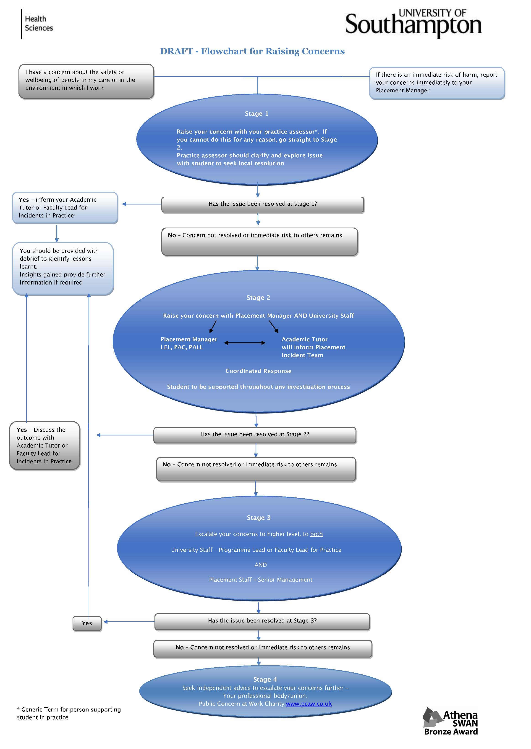
Appendix B

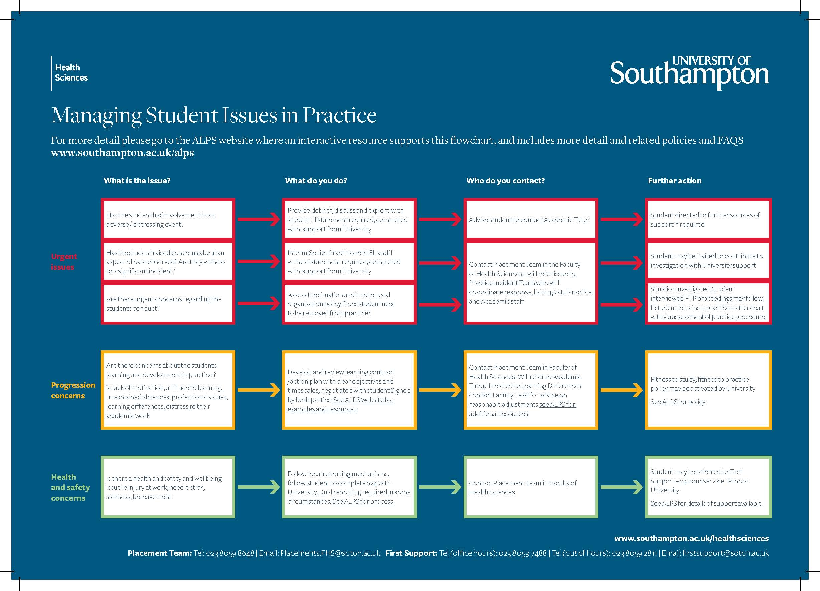

Appendix C

