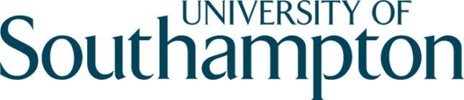

Arms, Armies and Aristocracy, c. 1300-1550:
Day Conference in Honour of Professor Anne Curry

Saturday 11 January 2020
Lecture Theatre B, Avenue Campus, University of Southampton

Coffee will be available from 9.00 am 9.20 Welcome. Dr Rémy Ambühl.

9.30 Session 1

Key players in French and English History
- Dr Aleksandr Lobanov: 'The collapse of Anglo-Burgundian alliance, 1435-1436'
- Ms. Chloe Mckenzie: ‘Katherine de Valois‘
- Dr Lynda Pidgeon: '”A Strange Marriage”: the marriage of Jacquetta Wydevile to Lord Strange’ ▪ Ms. Katie Bicknell: ‘Ballad sources on the battle of Bosworth’

11.05-11.20 Tea/coffee break

11.20 Session 2

Military Recruitment
- Dr Andy King: 'Affinity and Recruitment on the Scottish Marches: The Retinues of the Umfraville Family, c. 1296-1337'
- Dr Michael Warner: ‘The Dynamics of Recruitment at the time of the Agincourt Campaign’
- Dr James Ross: ‘Early Tudor Noble Military retinues - a case study, 1489-97’
- Prof Peter Clarke: ‘English Clergy and Later Medieval Warfare: New Fifteenth-Century Evidence from the Papal Penitentiary Registers’

13.00 Lunch

13.45 – 14.45

Lecture
▪ Prof Bertrand Schnerb: ‘The battle of Montépillloy’ (15 August 1429)

14.45 Session 3:

Mortality in War
- Prof Michael Hicks: ‘The impact of the Hundred Years War on the Demography of the Peerage of early fifteenth-Century England’
- Ms. Emily Mitchell: 'War, Wounds, and Medicine: A Re-examination of the Crew of the Mary Rose’

15.35 Tea/coffee break

15.50 Session 4:

Arms and Armour
- Dr James Hester: 'Strategic Principles in Medieval Armed Combat’
- Dr Dan Spencer: 'Artillery and the "Coronation Expedition" of 1430 to 1432'
- Dr Michael Depreter: ‘A Necessary Evil? State Service, Dynastic Service, and Self-Enrichment in Practices of and Reactions to Corruption and Embezzlement in the Artillery of the Dukes of Burgundy (15th c.)’
- Dr Malcolm Mercer: ‘From King’s Armourer to Master of the Armoury’

17.45-19.00 RECEPTION

