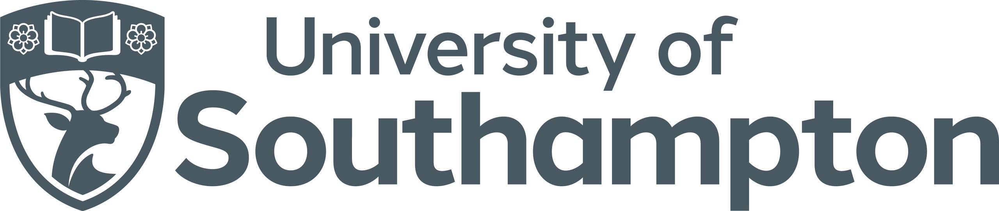

Student Innovation Projects - Client Brief

Organisation Name:
Address:
Sector:
Main Contact Name:
Main Contact Telephone Number:
Main Contact E-mail Address:
Alternative Contact Name:
Alternative Contact Telephone Number:
Alternative Contact Email Address:
Website:
Briefly describe your organisation:
Does your organisation have a sustainability policy? If not, would you like our support with developing one?

Please detail below the business issue or need you would like a team of students to address. To ensure your project is suitable for a Student Innovation Project, please refer to the Client Handbook.

Project Title:
Business Issue or Need (please contextualise this if appropriate):

Project Aims (please be mindful that the expected student outcomes are a set of recommendations, not to implement their suggested solutions):
1.
2.
3.
Skills you think the students will require to complete the project:

Students are expected to arrange a client meeting with yourself during the first week of their 4-week project, ideally as early as possible.
Please detail any dates or times that are not suitable for an initial client meeting during week 1.
Dates unavailable for initial meeting:

We understand that every organisation will have a different approach to minimising the risk of COVID-19. Please select below if you are happy to meet the students in-person over the duration of this project at your premises or visit our campus where suitable space can be booked by your teams.

Please add an ‘x’ in the right-hand column for all statements relevant to you:

I am happy to have the students visit our workplace for an initial meeting and / or the final presentation
I am happy to travel to the University to meet the students for an initial meeting and / or the final presentation

Please return to employ@southampton.ac.uk along with your completed Health and Safety form.

