NHS Cancer Vaccine Launch Pad (CVLP) -
Summary Participant Information Sheet
IRAS Project ID: 325291

What is the NHS Cancer Vaccine Launch Pad?
The NHS Cancer Vaccine Launch Pad (CVLP) is looking for people who may be able to take part in research trials for new ways to treat cancer, such as new immunotherapy treatments including cancer vaccines.
What are you being asked to do?
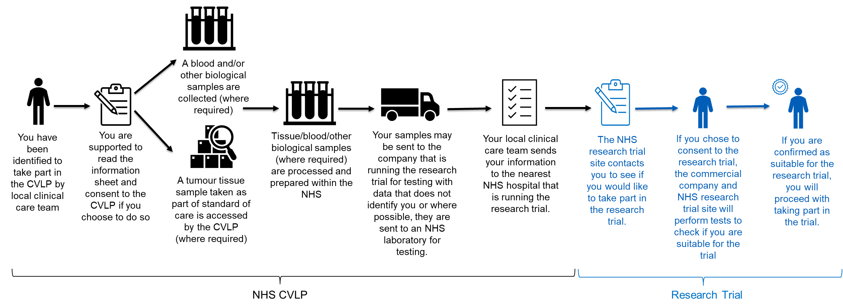
We are offering NHS cancer patients the opportunity to be considered for cancer vaccine and immunotherapy research trials that have partnered with the CVLP. This may include having their cancer DNA tested for changes that could be targeted to treat your cancer and prevent it from coming back. It is important to understand that being part of the CVLP does not guarantee that you will be able to take part in a research trial as not all patients are suitable for cancer vaccine or immunotherapy treatments. It is also important to understand that you may be suitable for other trials outside of the CVLP and your local clinical team can discuss this with you.
What type of treatment is being offered in the research trials?
Immunotherapy, including cancer vaccines, help the body’s immune system to recognise and attack cancer cells. These treatments are being tested in research trials to understand how well they work.

What will happen if you join the NHS Cancer Vaccine Launch Pad?
To assess if you might be suitable for a research trial, the CVLP may:

- Access a sample of your unused cancer tissue. You will not need to undergo extra procedures to get a tissue sample for the CVLP.
- Collect a blood sample or other biological sample from you, such as urine, stool or saliva. Not all patients will be asked for a blood or other biological sample. This is dependent on the requirements of the specific research trial.
- Collect information about you and your cancer. We will obtain information from you and your medical records. We will only collect information that we need for the research study.
- Share information about you and your cancer. Staff at your local hospital will share your contact details and information about your cancer diagnosis securely with trial staff at the NHS hospital where the research trial is being run. We will let very few people know your name or contact details, and only if they really need it for this study. Everyone involved in this study will keep your data safe and secure, we will also follow all privacy rules. At the end of the study, we will save some of the data in case we need to check it and for future research. We will make sure no-one can work out who you are from the reports we write. The patient information sheet tells you more about this.

If you are considered suitable to take part in a research trial, the hospital where the research trial is being run will then invite you to take part. You can stop being part of the CVLP at any time without giving a reason.
If you would like to find out more about the CVLP, please speak to your local clinical care team:
Doctor/Nurse’s name: (Insert) | Telephone number: (Insert)
Name of hospital: (Insert)

