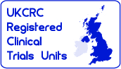Sponsor Logo - Colour - High Definition -  01-10-11



|  |  |
| --- | --- |
| <*patient name and address*> |  |
| <*insert date*> |  |

Dear <*insert patient name*>

**An Invitation to take part in catheter research**

**You are invited to take part in a catheter research study.**

**A new catheter, called Optitip, has recently become available which is designed differently to the standard ‘Foley’ catheter which is used by most catheter-users .**

**We want to find out whether or not the Optitip reduces:**

* **Infections**
* **Blockages**
* **Other catheter harms such as bladder spasm**

The Optitip catheter is already used by some NHS patients, but it is more expensive than the Foley (standard) catheter, so we also want to see if it offers value for money for the NHS. The Optitip catheter used in the same way as a Foley (standard) catheter.

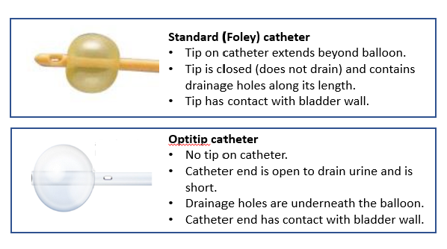

**If you decide to take part:**

* **You will be allocated to use either your usual catheter or the Optitip for 12 months**
* **Your catheter will be changed by your usual care team.**
* **No other care relating to your catheter will change**
* **You will be in the study for 12 months (unless you withdraw)**
* **You won’t be asked to travel anywhere**
* **You can decide whether you complete your monthly study questionnaires by post, telephone, or online.**

Please take the time to read the enclosed information sheet to help you decide whether you might want to take part. This describes what the trial is about and what you would be asked to do.

If you are interested in taking part in the trial or just want to find out more and talk about it please let us know by:

* **completing the enclosed reply slip and return it** directly to the Research Team in the pre-paid envelope provided

OR

* you can **register your interest directly on the trial website** ([www.cadettrial.com](http://www.cadettrial.com))
* Phone us on <insert site contact number> please leave your name and phone number so we can call you back

A member of the Clinical care team or Research Team at <insert site name> will contact you (by telephone or letter) in approximately 3 weeks' time if they have not heard from you. They will discuss the trial with you and answer any questions that you may have. You will receive a text notification to let you know that they will be calling you. However, there is no obligation for you to respond to this text/ and call. Nor is there any obligation for you to respond to the reminder letter.

If you do not want to participate, the Research Team would be grateful if you would be willing to let them know the reason by selecting from the list on the reply slip and returning in the pre-paid envelope. Knowing reasons why people do not want to take part is also useful for the research team and future studies. However, there is no obligation to return the reply slip or to provide a reason. This is optional and anything that you say will not affect your medical care in any way.

If you do not want to take part in the trial but are interested in being interviewed about your thoughts and feelings about the trial, please let us know by completing item 2 on the enclosed reply slip **and return it** directly to the Research Team in the pre-paid envelope provided.

Thank you for taking the time to read this letter and the attached Participant Information Sheet.

Yours sincerely

Dr <*insert PI name*>