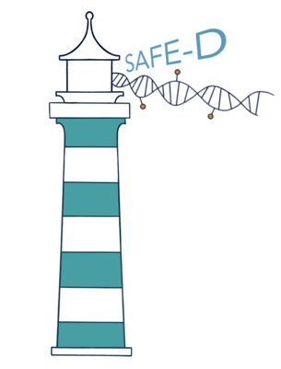

The SAFE-D Study Summary
Surveillance of pAncreatic health aFter diabEtes Diagnosis.

You have been asked if you would like to participate in the SAFE-D clinical research study because you have recently been diagnosed with type 2 diabetes or have an elevated blood sugar level and this is a risk factor for pancreatic cancer. A new blood test, developed by the biotechnology company ClearNote Health, aims to detect the presence of pancreatic cancer in the blood when it is at an early more treatable stage.
Help us improve early pancreatic cancer detection to save lives

What you need to know:
- The purpose of this study is to test a new experimental blood test called Avantect which detects signals of the presence of pancreatic cancer.

- Why are we looking at pancreatic cancer in people who are diagnosed with or have early signs of type 2 diabetes? Pancreatic cancer can damage the insulin-producing cells just like in diabetes and can that way be mistaken for being diabetes. People with signs of or newly diagnosed type 2 diabetes therefore have a higher-than-normal risk of also being diagnosed with pancreatic cancer within the next 3 years. In the UK, the lifetime risk of being diagnosed with pancreatic cancer is around 2%. Of these, 1 in 4 people are first diagnosed with diabetes. So, while most people with diabetes will not go on to develop pancreatic cancer, this patient group gives us a good opportunity to test how accurate the new blood test is at the same time as ruling out pancreatic cancer earlier.
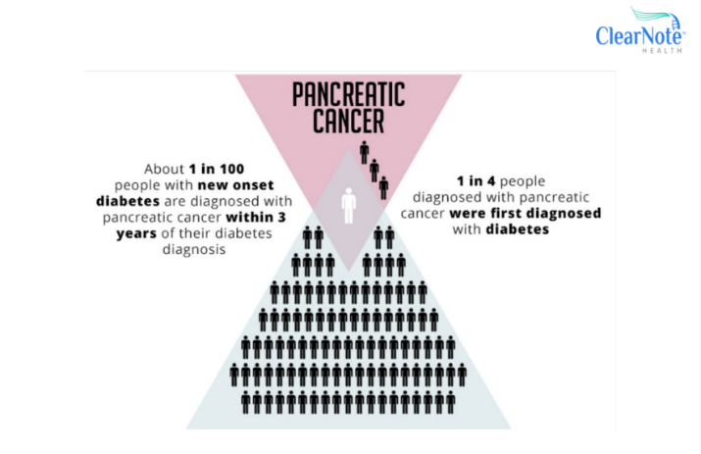

Figure 1. Diagram showing distribution of pancreatic cancer within a population newly diagnosed with type 2 diabetes.

- Why would we need a blood test for pancreatic cancer? The problem with pancreatic cancer is that it has few obvious symptoms at the early stages, and so it is often only picked up at more advanced stage when the cancer is more difficult to treat. Currently there is no screening test for pancreatic cancer. This new Avantect test is designed to detect the possible presence of pancreatic cancer at an early treatable stage, long before symptoms become apparent.
- If the Avantect blood test is proven to accurately detect the presence of pancreatic cancer early enough, it will have life-changing benefits for thousands of people with newly diagnosed diabetes.
- It is up to you if you want to take part. If you decide to take part, you are free to stop at any time for any reason, and you will always receive the best possible care available.

Requirements to take part:
- Aged between 50 and 84 years old.
- Recently diagnosed with type 2 diabetes or have had an elevated blood sugar level (within the past 6 months)

What you would be asked to do:

- You will be required to fill in a consent form to take part.
- You will be asked to attend a total of 3 appointments, 6 months apart at a conveniently located research site, which could be a GP practice or other local medical centre.
- During each of these appointments, you will be asked to
  - Complete a short questionnaire to provide information about your medical history, and how you are feeling. This should take only a few minutes.
Figure 2. A questionnaire
  - A trained healthcare provider will take about 30 ml of blood (roughly 2 tablespoons) from your vein.

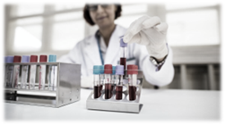
What happens next?:
- Your blood samples will be transferred to a laboratory at University Hospital Southampton for processing and storage.
- We need to compare participants who follow the normal standard of care process with those who have their blood tested on the Avantect test.
Figure 3. Scientist processing blood samples
- To do this, half the study participants will be randomly assigned to a Control Group (following standard of care for comparison) and half to an Intervention Group (where the blood samples are tested by the Avantect test).


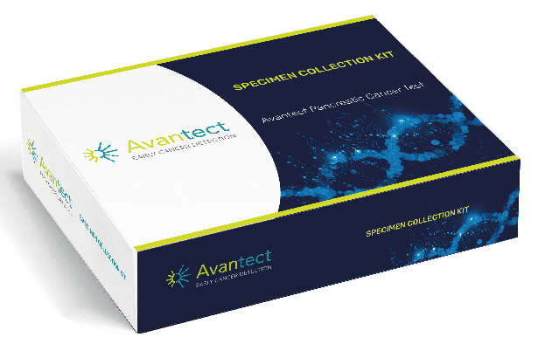



Comparison & future research
Avantect Test
Intervention Group
Control Group

Intervention Group
Control Group

Figure 4. Illustration of randomisation of participants into the Control and Intervention group
- You have equal chance of being listed in either group and you will not know which group you have been assigned to, unless the Avantect test returns a “detected” result.
- If you are listed in the Intervention group and a cancer signal is detected with the Avantect test, you will be informed and your GP and the SAFE-D team will arrange a follow-up imaging scan such as MRI or CT scan, which are similar to an x-ray, these take a detailed picture of your pancreas to rule out a pancreatic cancer.
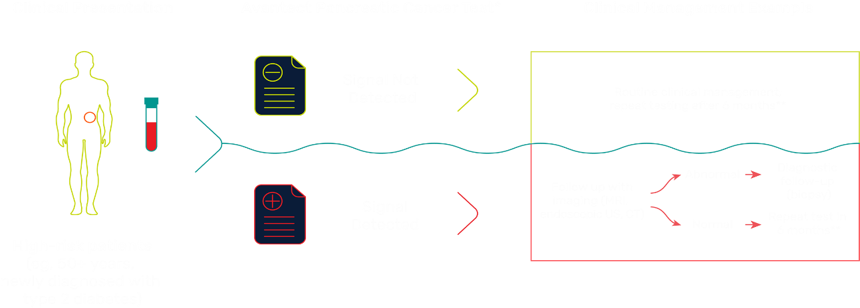
- If you do not receive a test result from us, you either have a non-actionable “non-detected” Avantect test result (Intervention group) or you have been listed in the Control group where samples are not run on the Avantect test. It is therefore really important you continue to monitor your own health as normal and inform your healthcare provider of any issues.
Figure 5. Illustration of the clinical management process following Avantect testing in the Intervention group
- On up to 3 occasions, over the duration of the study, we will collect data from cancer and mortality registries to see if you have been diagnosed with any cancers, details of any treatments for those cancers, and confirmation that you are still alive.
- The blood samples collected from participants in the Control group will help us better understand and treat pancreatic cancer in future ethically approved research studies.

Safety:
- Like any standard blood test, the process of collecting blood from your vein poses almost no risk to you. The Avantect test is non-invasive which means it is only applied to your collected blood sample and cannot affect you directly.
- If at any stage you have symptoms that you are worried about, you are advised to contact your healthcare professional or 111 as normal. If you feel it is an emergency, call 999 or go to the Accident and Emergency (A&E) department at your local hospital.

Confidentiality and Data Protection:
- We will need to use information about you from your medical records, and your GP for this study. We will only use information that we need for the research study. We will let very few people know your name or contact details, and only if they really need it for this study.
- If you decide to stop participating in the study, we will destroy the samples and data you have provided where possible and if that is your wish.

- Any data collected for research and any results produced will not identify you personally. A code number will be used instead. Some of your coded information may be accessed by approved collaborators from outside of the UK to carry out this research study.
- Some of your information will be stored on secure servers within the United States. Everyone involved in this study will keep your data safe and secure. We will also follow all privacy rules. All collaborators (both in the UK and abroad) are required by law to strictly adhere to the UK Data Protection Act (DPA) and General Data Protection Regulation (GDPR), one of the toughest security and privacy laws in the world.
Figure 7. Cartoon of hand, lock and key representing confidentiality
- At the end of the study we will save the data in case we need to check it and for future research. All information about you will be held securely in an access restricted database.
- We will make sure no-one can work out who you are from the reports we write.

Need more information?
More detailed information about the SAFE-D Study and contact details for the SAFE-D Study team may be found in the SAFE-D Participant Information Sheet and on the study website [www.safe-d.uk]
This is also where we will keep you updated about how the SAFE-D study is progressing.


Your contribution to this study is valued enormously. Thank you!

