Report Title: Electrical Vehicle Charging Standard Specification v1

From: Environment and Sustainability

Date: 22 November 2023

Report Author: Marc Goodman

Introduction

The University ensures that there is provision to charge electrical vehicles for staff, students, and visitors on most campuses.

The University’s parking strategy supports the use of electrical vehicles and as such will will lead to an increase in the provision of chargers, with a target of 5% of parking spaces to have charging facilities.

Currently charging points are located at:

- Salisbury Road car park (Highfield Campus)
- B46 Physics and Astronomy car park (Highfield Campus)
- Boldrewood Campus (main and multi-storey car parks)
- Winchester School of Art
- Avenue Campus

Specification for Chargers and Installation

- The University has partnered with Pod Point (https://pod-point.com) to deliver our electrical vehicle charging infrastructure for an initial period of 3 years from October 2023.
- The University’s preferred charger is a Twin 7Kwh charger.
- Chargers should not be positioned so that they obstruct paths, pavements, or footways.
- Chargers should be positioned on a purpose laid concrete pad with dimensions of 600 x 600 x 400mm (WxHxD).
- Supply cables are to be routed into the bottom of the charger ensuring the duct is centralised. The maximum duct size is 110mm.
- No wired or wireless internet connection is required.
- Electrical vehicle chargers will need to be supplied from a Feeder Pillar with an electrical supply that can be isolated, so that maintenance can be carried out.
- The data sheet, technical file and the enabling document outlining installation can be found on page 3.
- Electrical assessments will need to be carried out by Estates and Facilities to ensure that there is adequate supply in the proposed charger location. Please contact the Mechanical and Electrical design team.
- The Transport team will be able to assist with getting a quote from Pod Point, the university benefits from ESPO framework pricing for the charging units. (https://www.southampton.ac.uk/transport/contact.page)
Bay Marking

- Electrical Vehicle parking bays should incorporate a hatched area to allow additional access space for side charging. This hatched area should be at least 500mm wide.
- Bays should have light green coloured thermoplastic lines and hatching and an EV logo designation. The transport team can facilitate the line marking process.

BAY MARKING GUIDE AND EXAMPLE LOGO AND COLOUR
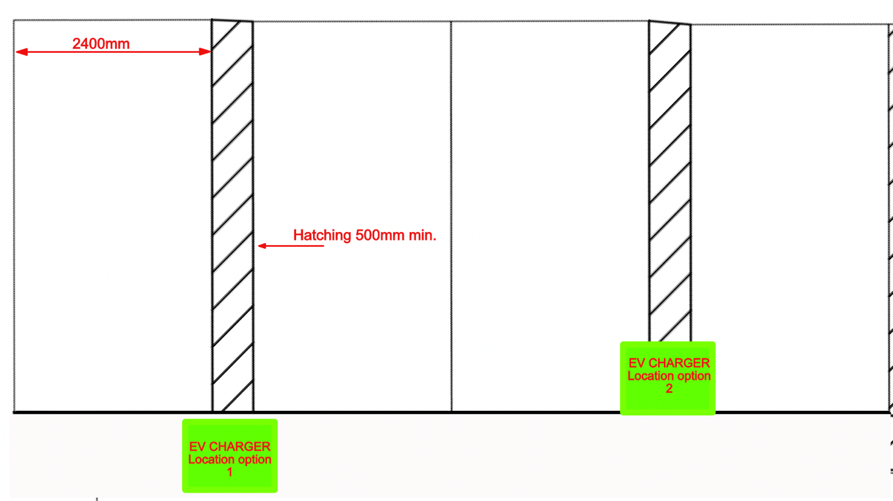

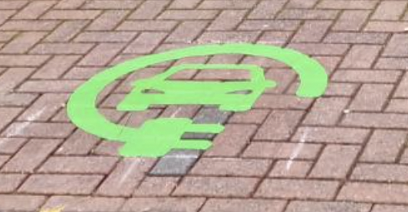

POD Documents
- PP-D-201456-3-Twin-V6-Charger-Installation-Guide-web-version

- PP-D-210225-1-pod-point-twin-datasheet

- Technical-File-Commercial-PP-D-220203-1

