Sharks: Conflict and Death to Coexistence and Life

Jennifer Rebecca Schauer, Erin C. Walsh, Cosette L. Patterson
Boston College

Abstract: Interactions between humans and wildlife range from negative (conflict) to positive (coexistence), vary in intensity, and may involve intentionality and sentience. In the case of sharks, many interactions are provoked by humans rather than sharks. We analyze human/shark interactions from the extremes of conflict (finning) to coexistence (active conservation with shared sentience) with a view to promoting understanding, conservation, and coexistence.

Keywords: Sharks, Diving, Conflict, Coexistence, Intentionality, Killing, Fishing

Jennifer Rebecca Schauer is an Environmental Sociologist and an Animal Studies Scholar, Teacher and Activist. She studies human coexistence with wild animals. Her work focuses on large carnivores with whom we share this earth, specifically she has written on Jaguars and Pumas, and recently on Sharks and Lions. She has published on human relations, interactions and encounters with wild animals, on a global scale, as well as within the United States, Paris, as well as Costa Rica, and recently has expanded into Africa.

1. Introduction

Human-wildlife interactions and encounters tend to be conflict oriented. In the literature the acronym for this is human-wildlife conflict (HWC). We view our work on sharks along a dimension of conflict to coexistence (Frank 2016; Nyhus 2016). Human activities can either harm or conserve sharks. We analyze this in terms of provocation, intentionality, frequency, and shared sentience.
Extreme conflict involve negative behaviors towards wildlife, including killing wild animals and employing extermination strategies for wildlife management (Frank 2016, p. 740), which is also considered perpetual systematic killing. Less extreme Conflict are negative behaviors, which are less about direct behaviors then they are about a lack of support for wildlife conservation and management strategies (Frank 2016, p. 740). Another step toward the coexistence range of the spectrum entails a neutral or mixed area, according to Frank, which we later define as the Tolerance Zone. Here neither positive nor negative practices exist. In this range encases a lack of action taken by humans towards conservation. Beyond the Tolerance Zone, the continuum moves toward positive behaviors, where individuals work towards conservation goals and respect wildlife. At the Extreme Coexistence end of the spectrum, human interests are secondary in prioritization over the needs of wildlife. Such a frame restricts human access (Frank 2016, p. 740); in our work, we situate this as a deep affiliation with wild animals.
Beyond Frank’s continuum, Nyhus offers a more expansive framework, which not only includes a negative to positive continuum of interactions, but also frequency and intensity (Nyhus 2016, p. 146). Attacks from apex predators, such as sharks, are often relatively uncommon, yet strong in severity, leading to an explosion of media coverage. This is Nyhus’s intensity scale. For example, in the last 218 years in Australia, there have only been 178 fatalities from sharks, resulting in an average of less than one per year (Nyhus 2016, p. 150). While globally 130 shark attacks were reported in 2018, with 66 unprovoked and 34 provoked, this data, from the International Shark Attack File, does not differentiate between fatal and non-fatal injuries (Naylor & Bowling 2018 as cited in Kelly et al. 2019, p. 22). The frequency of shark attacks on humans has impending factors. For example, the number of people in the water, the size of shark populations in the area, and the way in which humans are using the water, for instance, swimmers, board users, (Nyhus 2016, p. 153), wading, surfing, scuba diving, and freediving-all affect the likelihood of being bitten by a shark (ISAF 2019). Frequency and intensity are what we consider anthropocentric paradigms, herein we add another dimension to the continuum which sees interactions and encounters, through the lens of sharks, via provoked and unprovoked. When possible throughout this paper, we replace the word “attack” to interaction, encounter, and incident to align with Hammerton and Ford (2018), who argue the word attack creates the shark to be a villain with malicious intentions. As a way to reestablish equanimity we align with the principle that “attacks” are not intended harms of the shark toward the human, but rather natural behaviors of an offering, much greater than we can logically understand in a third dimension.

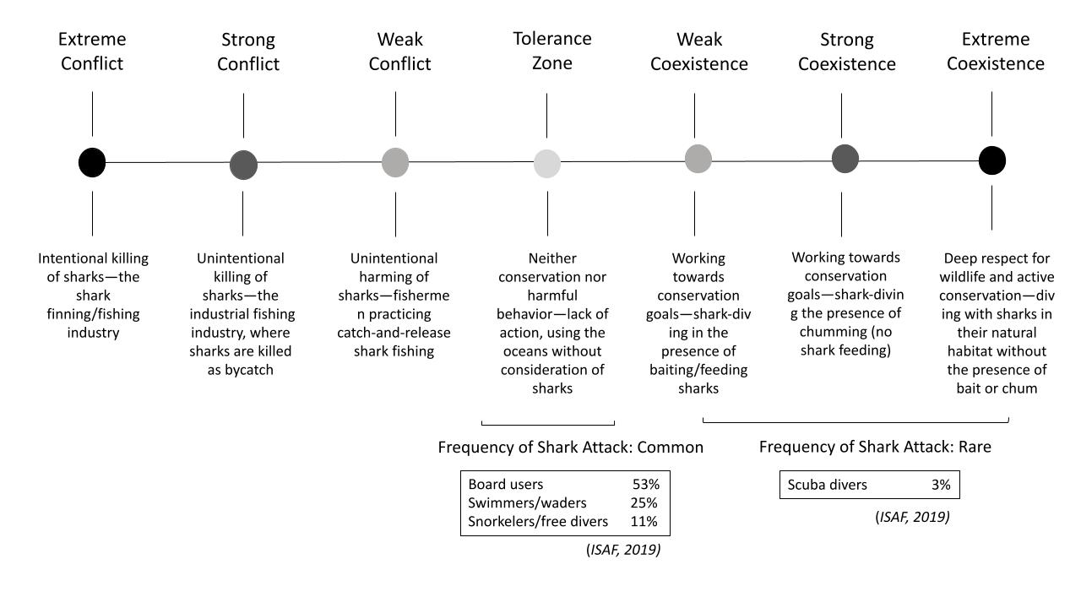
Figure 1. A Shark-Centric Interpretation of a Conflict-to-Coexistence Continuum
2. Conflict and Death to Coexistence and Life
Unprovoked attacks have been defined as “animal approaches and attacks, with the principal attraction being the person(s)” (Quigley & Herrero 2005 cited in Kelly et al. 2019, p. 18). Moreover, in contrast to unprovoked attacks, provoked attacks occur when “a person(s) enters an animal's personal space or purposely tries to touch, injure or kill the animal, and the animal attacks” (Quigley & Herrero 2005 cited in Kelly et al. 2019, p. 18). According to the International Shark Attack File’s (ISAF) 2019 Worldwide Shark Attack Summary, the frequency of shark attacks was low in 2019. For example, there were 64 unprovoked attacks, just two of these were fatal and over half of the incidents occurred with board users (ISAF 2019). Other encounters included swimmers and waders, as well as snorkelers and free divers. As illustrated in Fig. 1, we classify these types of human behaviors in the Tolerance Zone of the continuum, as they entail humans recreationally using the ocean. This group saw a much higher relative frequency of attacks—in total accounting for 89% of unprovoked attacks—compared to scuba diving, with just 3% (ISAF 2019). This may be a result of scuba divers’ increased awareness of their surroundings below the surface waters in awareness to and with other living sentient beings, such as sharks. Such familiarities are in contrast to swimmers, waders and snorkelers, who are not completely immersed in the ocean and aware of her, as a feminine sentient life. Moreover, we believe the 3% of attacks, which is rare and occurs within the coexistence side of the continuum, justify the classification of scuba diving within the positive interactions side of the spectrum. This is further supported by the work of Hammerton and Ford (2018) who find scuba divers are able to see sharks as sentient beings, over other water users, such as surfers.
Encased in the coexistence space, we dichotomize forms of scuba diving by the presence and absence of provisioning, which is used to attract sharks to the dive site. We classify feeding as Weak Coexistence, chumming as Strong Coexistence, and no form of provisioning as Extreme Coexistence. Although not depicted in Fig. 1, another layer within our coexistence continuum are elements of reverence and sentience. In such space, we argue scuba diving with sharks in their natural habitat and home, without the presence of bait, is Extreme Coexistence. Here we see a deep reverence for sharks, which allows for shared sentience. Sentience is a capacity for animals to consciously perceive by the senses and to feel or experience subjectively (Mellor 2019). Therefore, “shared sentience” is a mutual recognition of sentience between humans and animals, in this case sharks. We believe such sentience can also be shared through Weak and Strong Coexistence, both include shark-diving with different forms of provisioning, which vary through invasiveness or intrusion. While photography and diver experiences in support of shark conservation is one justification for provisioning, arguments against it contest shark reliance on humans for food, which questions the natural order. Finally, we note that all activities along the continuum can be subject to an invasion of a sharks’ agency, which can align with attacks. These include instances when sharks are provoked by: people trying to touch or feed them, spearfishers, people attempting to remove a hook from them or detach them from a fishing net (ISAF 2019).
In this paper, we offer an expanded form of the human wildlife conflict and coexistence continuum, building on Frank’s (2016) and Nyhus’ (2016) work of a negative to positive spectrum. We have include the frequency aspect from Nyhus’s work. Additionally, we provide language to identify various stages of the range, including Extreme Conflict all the way to Extreme Coexistence. For each notch along the continuum, we offer a definition, an example of a human action toward a shark, a case study, and mass statistics, when possible. See Fig. 1 for our visual representation of theoretical concepts (Frank 2016; Nyhus 2016) applied to sharks.
3. Extreme Conflict
Frank (2016, p.740) defines the most intense form of conflict as “extreme negative attitudes/behaviors toward a species,” which includes the killing of wildlife. We argue here the intentional killing of sharks by humans embodies the Extreme Conflict portion of the continuum. For example, the shark finning industry relies on the mass slaughtering of various types of sharks for sale of the meat in their fins. During the finning process, sharks are pulled from the water, the fins are removed, and the sharks are discarded back into the water. The fins are then sold at a high value in Asian markets. This practice has been widespread globally (Worm et al. 2013), while Hong Kong hosts the largest shark fin market in the world-including more than 50% of trade world-wide (Shea & To 2017, p. 330). Specifically, from 1993 to 2013, a total of 130 nations reported exporting fins to Hong Kong (Shea & To 2017, p. 336), where only 83 countries and territories submit their shark fin trade data to FAO annually (Shea & To 2017, p. 332). Discrepancies between legal and illegal killing and markets exist, as illustrated below:
2016 reported: global shark “catch” of 767,000 tons according to FAO (Oliver 2017, p. 3).
2011 reported: global shark fin “exports” was 17,154 tonnes (Dent & Clarke 2015, p. 1).
2010 estimated: global shark “catch” of 1.41 million metric tons, including reported and unreported landings, discards, and shark finning (Worm et al. 2013, p. 194).
2015 Hong Kong shark fins “imported” 5,528,862 kg, 22,348.8 kg of which were from CITES listed sharks (Cardeñosa et al. 2017, p. 4).
Reported here includes only legal, declared, shark derivatives. While differences in years—as well as catch versus imports and exports—exist, the estimates from the reported declarations are strikingly different, illustrating there is an illegal trade, and lucrative market for shark fins.
While the above data provides a lens into the mass scale of slaughter we also believe that speaking of strictly weight in relation to sharks is objectifying. Therefore we use Worm and colleagues (2013, p. 194) conversion in their analysis of average shark weights, which they estimated to be 97 million sharks in 2010, with a potential range of 63 and 273 million sharks per year (Worm et al. 2013, p. 194). This way of describing sharks, allows us to see them as sentient beings rather than merely by their mass. Importantly, such mortality rates are far beyond the average rebound rate for sharks, meaning sharks cannot repopulate quickly enough to replace their populations after their slaughter.
We believe the heinous act of intentionally and brutally killing sharks—slicing off their fins and leaving them to suffer death from drowning, simply for the sale of their fins—aligns with Frank’s definition of the most intense form of conflict. The practice of shark finning is torturous, cruel (Stewart 2006) and largely underreported (Shea & To 2017, p. 336). It is incredibly inhumane as the finning most often occurs when the shark is still alive (Stewart 2006), as their fins are cut, sharks are thrown back into the ocean, where they suffocate or die of blood loss (Fairclough 2013). Without question, this is classified as Extreme Conflict in our application of sharks to this continuum.
4. Strong Conflict
While Frank’s (2016) continuum defines Extreme Conflict, there is no given definition for a substantive form of conflict, which we identify as “Strong Conflict.” We argue this entails the unintentional killing of sharks by humans. While this portion of the continuum captures behaviors and practices that still result in the killing of wildlife, the lack of intentionality makes it less conflict-oriented than the former. For example, practices within the industrial fishing industry result in massive amounts of bycatch (Watson et al. 2009). The definition of bycatch, provided by the National Oceanic and Atmospheric Administration (NOAA), is “discarded catch of marine species and unobserved mortality due to the direct encounter with fishing vessels and gear,” with “these unintentionally caught animals often [suffering] injuries or [dying]” (“What is bycatch,” n.d.). Moreover, bycatch can result in the large-scale death of countless sentient species—ranging from sharks to sea turtles, dolphins, whales, seals, seabirds, etc.—that suffer and lose their lives without even being targeted by industrial fishing practices. In this case sharks, while not chosen, are certainly and frequently killed as a result of fishing for other species.
One case, exemplifying the magnitude of harm caused to sharks by industrial fishing practices is from a study of the Eastern Pacific Ocean Tuna Fishery, West of Central America. Findings from data of bycatch, in observing vessels fishing for tuna, found a mean of 186,245 silky sharks, in addition to 28,400 oceanic whitetip sharks and 10,492 hammerhead sharks (Watson et al. 2009, p. 628 and 631). Importantly, numbers are from just one study in one region, which highlights the scale of inhumane treatment of sharks as well as the unsustainable fishing practices—such as purse-seine nets—used on sharks around the globe. In sum, hundreds of thousands of sentient sharks have lost their lives in just this one fishery. Though data may be underestimated, a study of 44 countries between the years 2000 - 2003 found that bycatch, in the fin trade, makes up 40.4% of global marine catches and 92.4% of total shark catch (Davies et al. 2009, p. 670). The ramifications such evidence holds for a global scale is equally terrifying and tragic; however, in this range of the continuum, we find sharks as bycatch and therefore our placement of this practice within the theoretical spectrum focuses on intentionality, specifically the unintentionality in this section, in contrast to the intentional killing within Extreme Conflict.
5. Weak Conflict
Moving another step towards tolerance (Frank 2016) is what we identify as “Weak Conflict.” Frank claims less extreme, yet still conflict-oriented, areas of the spectrum can entail behaviors that are still negative towards wildlife but less intense. Such behaviors can include the unintentional harming of sharks by humans. This is different from Strong Conflict in that the sharks are released back while alive rather than pulled on board the vessel as either dying or dead, such as with bycatch caught in netting. Here we use the example of catch-and-release fishing of sharks. While fishermen release the sharks after catching them and may not intend to harm them, significant physiological stress, injury and death can still occur (Cooke et al. 2013 cited in Gallagher et al. 2017, p. 390). A study evaluating the survival rate of sharks in Florida, after catch and release, estimated 31-40% died (Hueter et al. 2006, p. 506). While important, these results shed light on only mortality, and do not provide data on injury, harm and stress. This speaks to the wide-reaching range of negative effects that catch-and-release fishing have on sharks, with close to half in some regions dying. In line with the conflict zone, the lack of intentionality classifies this as Weak Conflict on our continuum.
6. Tolerance Zone
Frank defines the neutral zone of the conflict to coexistence continuum as a region capturing neither positive nor negative behaviors towards wildlife, often characterized by a lack of conservation action, passive coexistence, or tolerance (Frank 2016, p. 740). We choose to see this as a “Tolerance Zone,” given the range of possible human-shark interactions. Moreover, this space is much more complicated than simply negative, neutral, or positive. Specifically, the Tolerance Zone of the continuum captures significant features of acceptance as a principle. Bruskotter and colleagues (2-15) recognize a lack of action or a form of passivity that surrounds people during an encounter with an animal. While Bruskotter and colleagues are generalizing human behavior under the paradigms of tolerance or acceptance, the idea herein is people are not motivated to act for or against the animals (Bruskotter et al. 2015). However they identify a point in which this passivity transforms to an active interaction that could shift to be either positive or negative (Bruskotter et al. 2015, p. 260), this then could move toward either end of the conflict or coexistence continuum.
As an example, we offer recreational use of the ocean in the following ways: board users (surfers, boogie boards, paddle boards, etc.), swimmers and waders, as well as snorkelers and free divers. While each of these populations use the ocean for some recreational purpose, we assume there is not a strong inclination to take account of the presence of sharks in these waters. Furthermore, each of these ocean activities come with varying risk levels for a shark encounter. According to the ISAF Yearly Worldwide Shark Attack Summary report of 2019, the most commonly attacked population of humans was surfers and board users, with 53% of total attacks (ISAF 2019). This comes as no surprise given the surf is a place of sharks as well as board users. Further we know, splashing, paddling, and ‘wiping out’ (ISAF 2019) are all behaviors that mimic prey species and increase the chance of a shark’s attention and encounter. After surfers and board sport-users, the most commonly attacked groups of people include swimmers and waders (25% of incidents), snorkelers/free divers (11%), and body-surfers (8%) (ISAF 2019).
Importantly, we believe that intentionality is in question within this portion of the continuum. Moreover, while some people take specific precautions to limit their risk when entering the ocean, others enjoy the water without any consideration of the potential presence of sharks nearby. Overall, there is a range of human intentions within the Tolerance Zone, which may also be contingent on whether or not one has ever encountered a shark.
A note here on shark encounters and attacks within our Tolerance Zone, which includes swimmers and waders, board users, as well as snorkelers and free divers. The boarders, swimmers and waders are often in the surf zone, where sharks tend to hunt, they splash similar to prey animals, and swimmers and board users can often be horizontal, which mimics prey. Divers on the other hand experience the water in quite different ways. First and foremost, divers immerse themselves with sharks, intentionally, as opposed to swimmers and board users who prefer to avoid them. Furthermore, while some divers may use techniques to enter into the water that may cause a splash, it is a one time event, unlike swimming and board using. Furthermore, swimming horizontally may be common among divers, but there is a mandated sense of breath, presence and peace that is encased in the diving process and experience.
7. Weak Coexistence
The Tolerance Zone is followed by increasingly strong scales of coexistence-oriented behavior, which we characterize as behaviors and practices that work towards shark conservation. We define “Weak Coexistence” as shark-diving in the presence of feeding, as it has the potential to cause habituated shark behavior towards and with humans, as a source of a food giving presence. The term feeding is a more specific form of provisioning, in which pieces of fish are fed to sharks, either by hand or by a spear (Maljković & Côté 2011, p. 860). According to The Shark Watcher’s Handbook (2002), 40% of the 267 shark viewing sites used a form of attractant, such as chum, decoy, or bait (Carwardine & Watterson 2002 cited in Maljković & Côté 2011, p. 859). Such techniques are employed to increase the chances of seeing sharks in the global tourism industry (Maljković & Côté 2011). Here we consider feeding to be the most extreme type of provisioning, as it is the only form that entails a diver physically giving chunks of food into the mouth of a shark. The practice of feeding sharks can be dangerous, as it may unintentionally teach sharks to associate people with food, resulting in increased likelihood of a shark bite. For example, Caribbean reef sharks have been fed off the south coast of The Bahamas since 1986 (Maljković & Côté 2011, p. 860). While we know shark encounters, such as these in The Bahamas, increases the likelihood for people to have positive experiences with sharks, promotes conservation and ultimately keeps the sharks alive, we believe such experiences fall within the Weak Coexistence section of the continuum, given the feeding creates habituation, an unnatural shark behavior. Furthermore, while such experiences are part of the shark-diving ecotourism industry ultimately working to promote shark conservation, we realize such habituation actions may be indirectly harming sharks, as well as the humans who may be closely associated with their food source.

8. Strong Coexistence
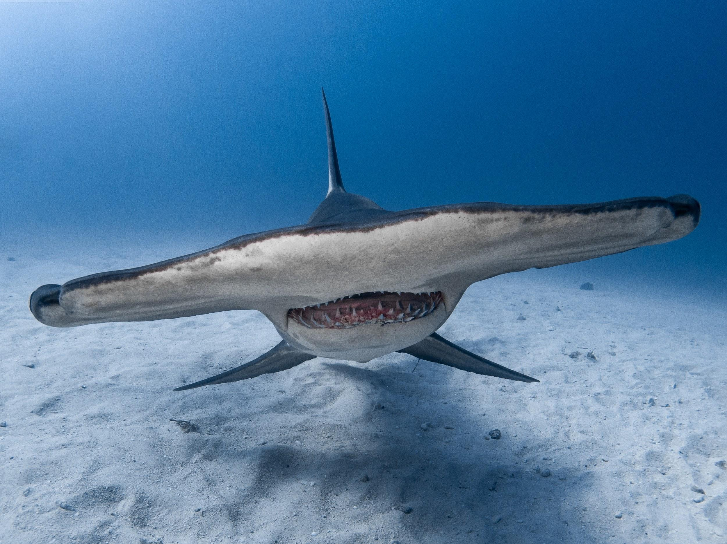
Figure 2: "Photo taken by Ryan Walsh; great hammerhead shark; 1/4/2019; Tiger Beach, The Bahamas"
Moving another step towards the Coexistence side of the continuum is “Strong Coexistence,” which we define as behaviors and practices that work towards conservation goals, but include perhaps, reverence, and shared sentience. For example, we believe that shark-diving in the presence of chumming—not feeding—embodies the characteristics of the “Strong Coexistence.” Moreover, “Chumming” is when fish parts are thrown into the water to attract sharks for viewing (Hammerschlag et al. 2012). The Florida Fish and Wildlife Conservation Commission defines chum as “fish, fish parts, other animal products, or synthetic products created or intended to chemically or otherwise resemble animal products placed in the water for the purpose of attracting a marine organism” (“Feeding sharks and other fish,” n.d.). Chumming is a much less aggressive form of provisioning when compared to feeding, since feeding involves a diver physically giving fish parts into the mouths of sharks, whereas
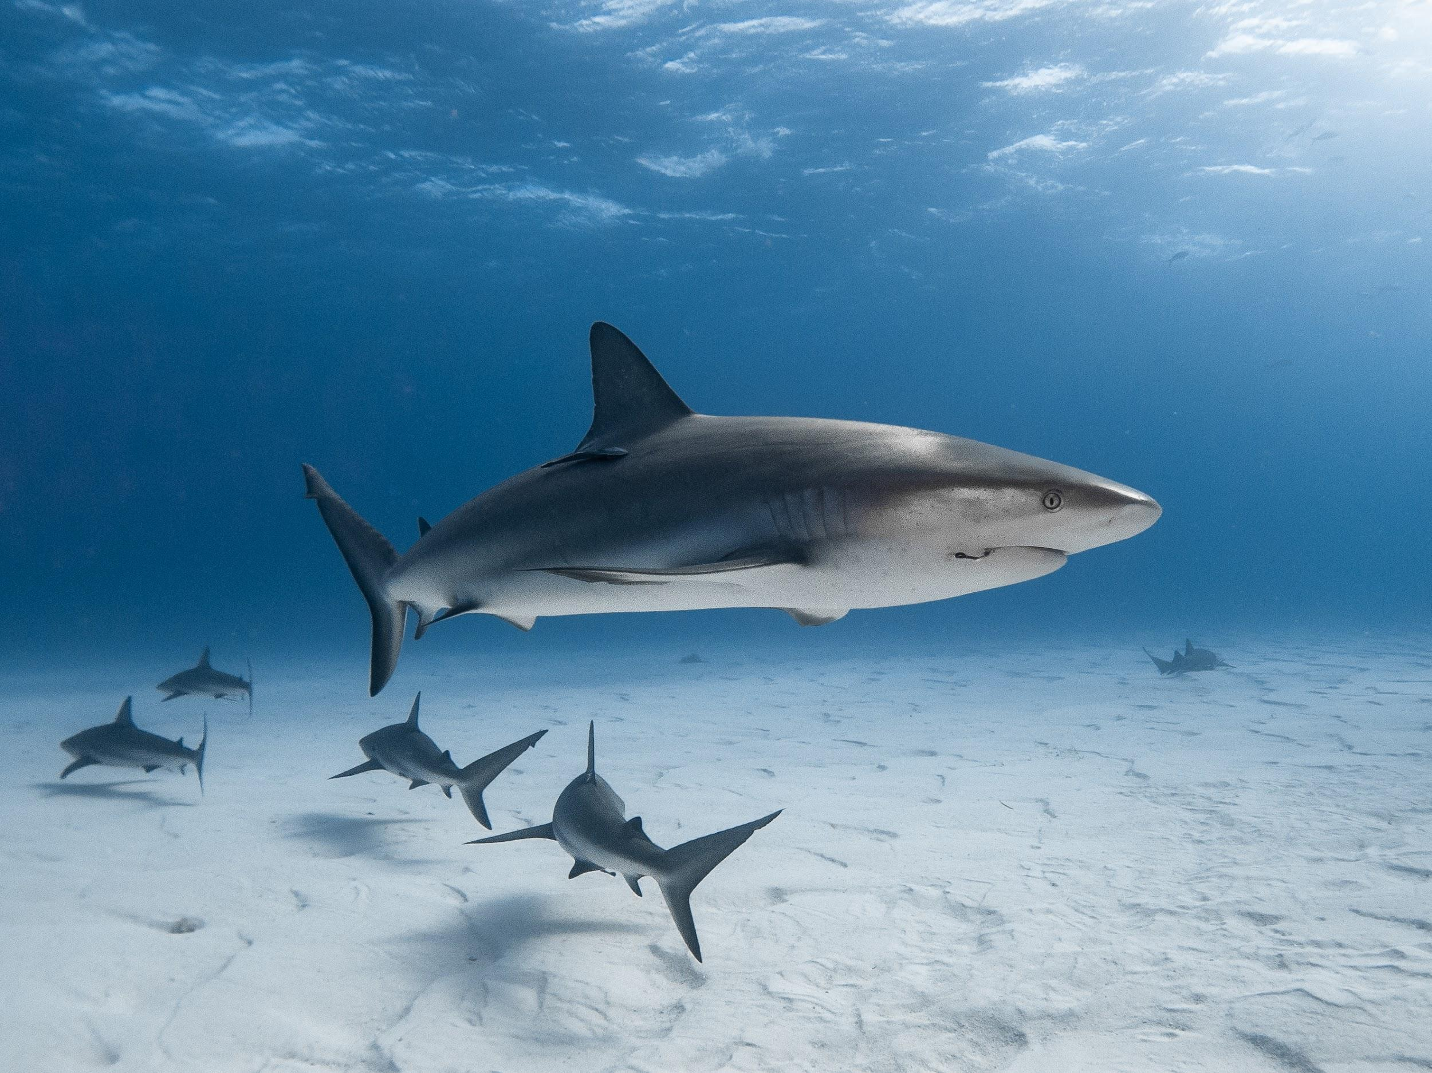
Figure 3: “Photo taken by Ryan Walsh; caribbean reef shark; 1/4/2019; Tiger Beach, The Bahamas"
chumming is a process to attract sharks to an area, reliant on the presence of the scent of the dead fish. Hammerschlag and colleagues (2012) studied populations of tiger sharks in two areas: the Bahamas, where provisioning is allowed, and off the coast of Florida, where all forms of provisioning are prohibited. Findings suggest, sharks in the Bahamas actually traveled greater distances during the study than those in Florida, and spent less time around the area where provisioning occurred (Hammerschlag et al. 2012, p. 570-571), concluding some forms of ecotourism provisioning like the chumming do not have detrimental impacts on sharks and the benefits of human encounters with sharks have widespread benefits to understanding sharks as apex predators and the conservation measures to support them (Hammerschlag et al. 2012). The one caveat is studies are species, site and scale specific. We position experiences where divers encounter sharks by means of chumming entails a stronger form of coexistence than feeding, as it is less intrusive. The three photographs of the Hammerhead shark in Figure 2, the Caribbean Reef shark in Figure 3, and the Tiger shark in Figure 4 all used chumming as an attractant.
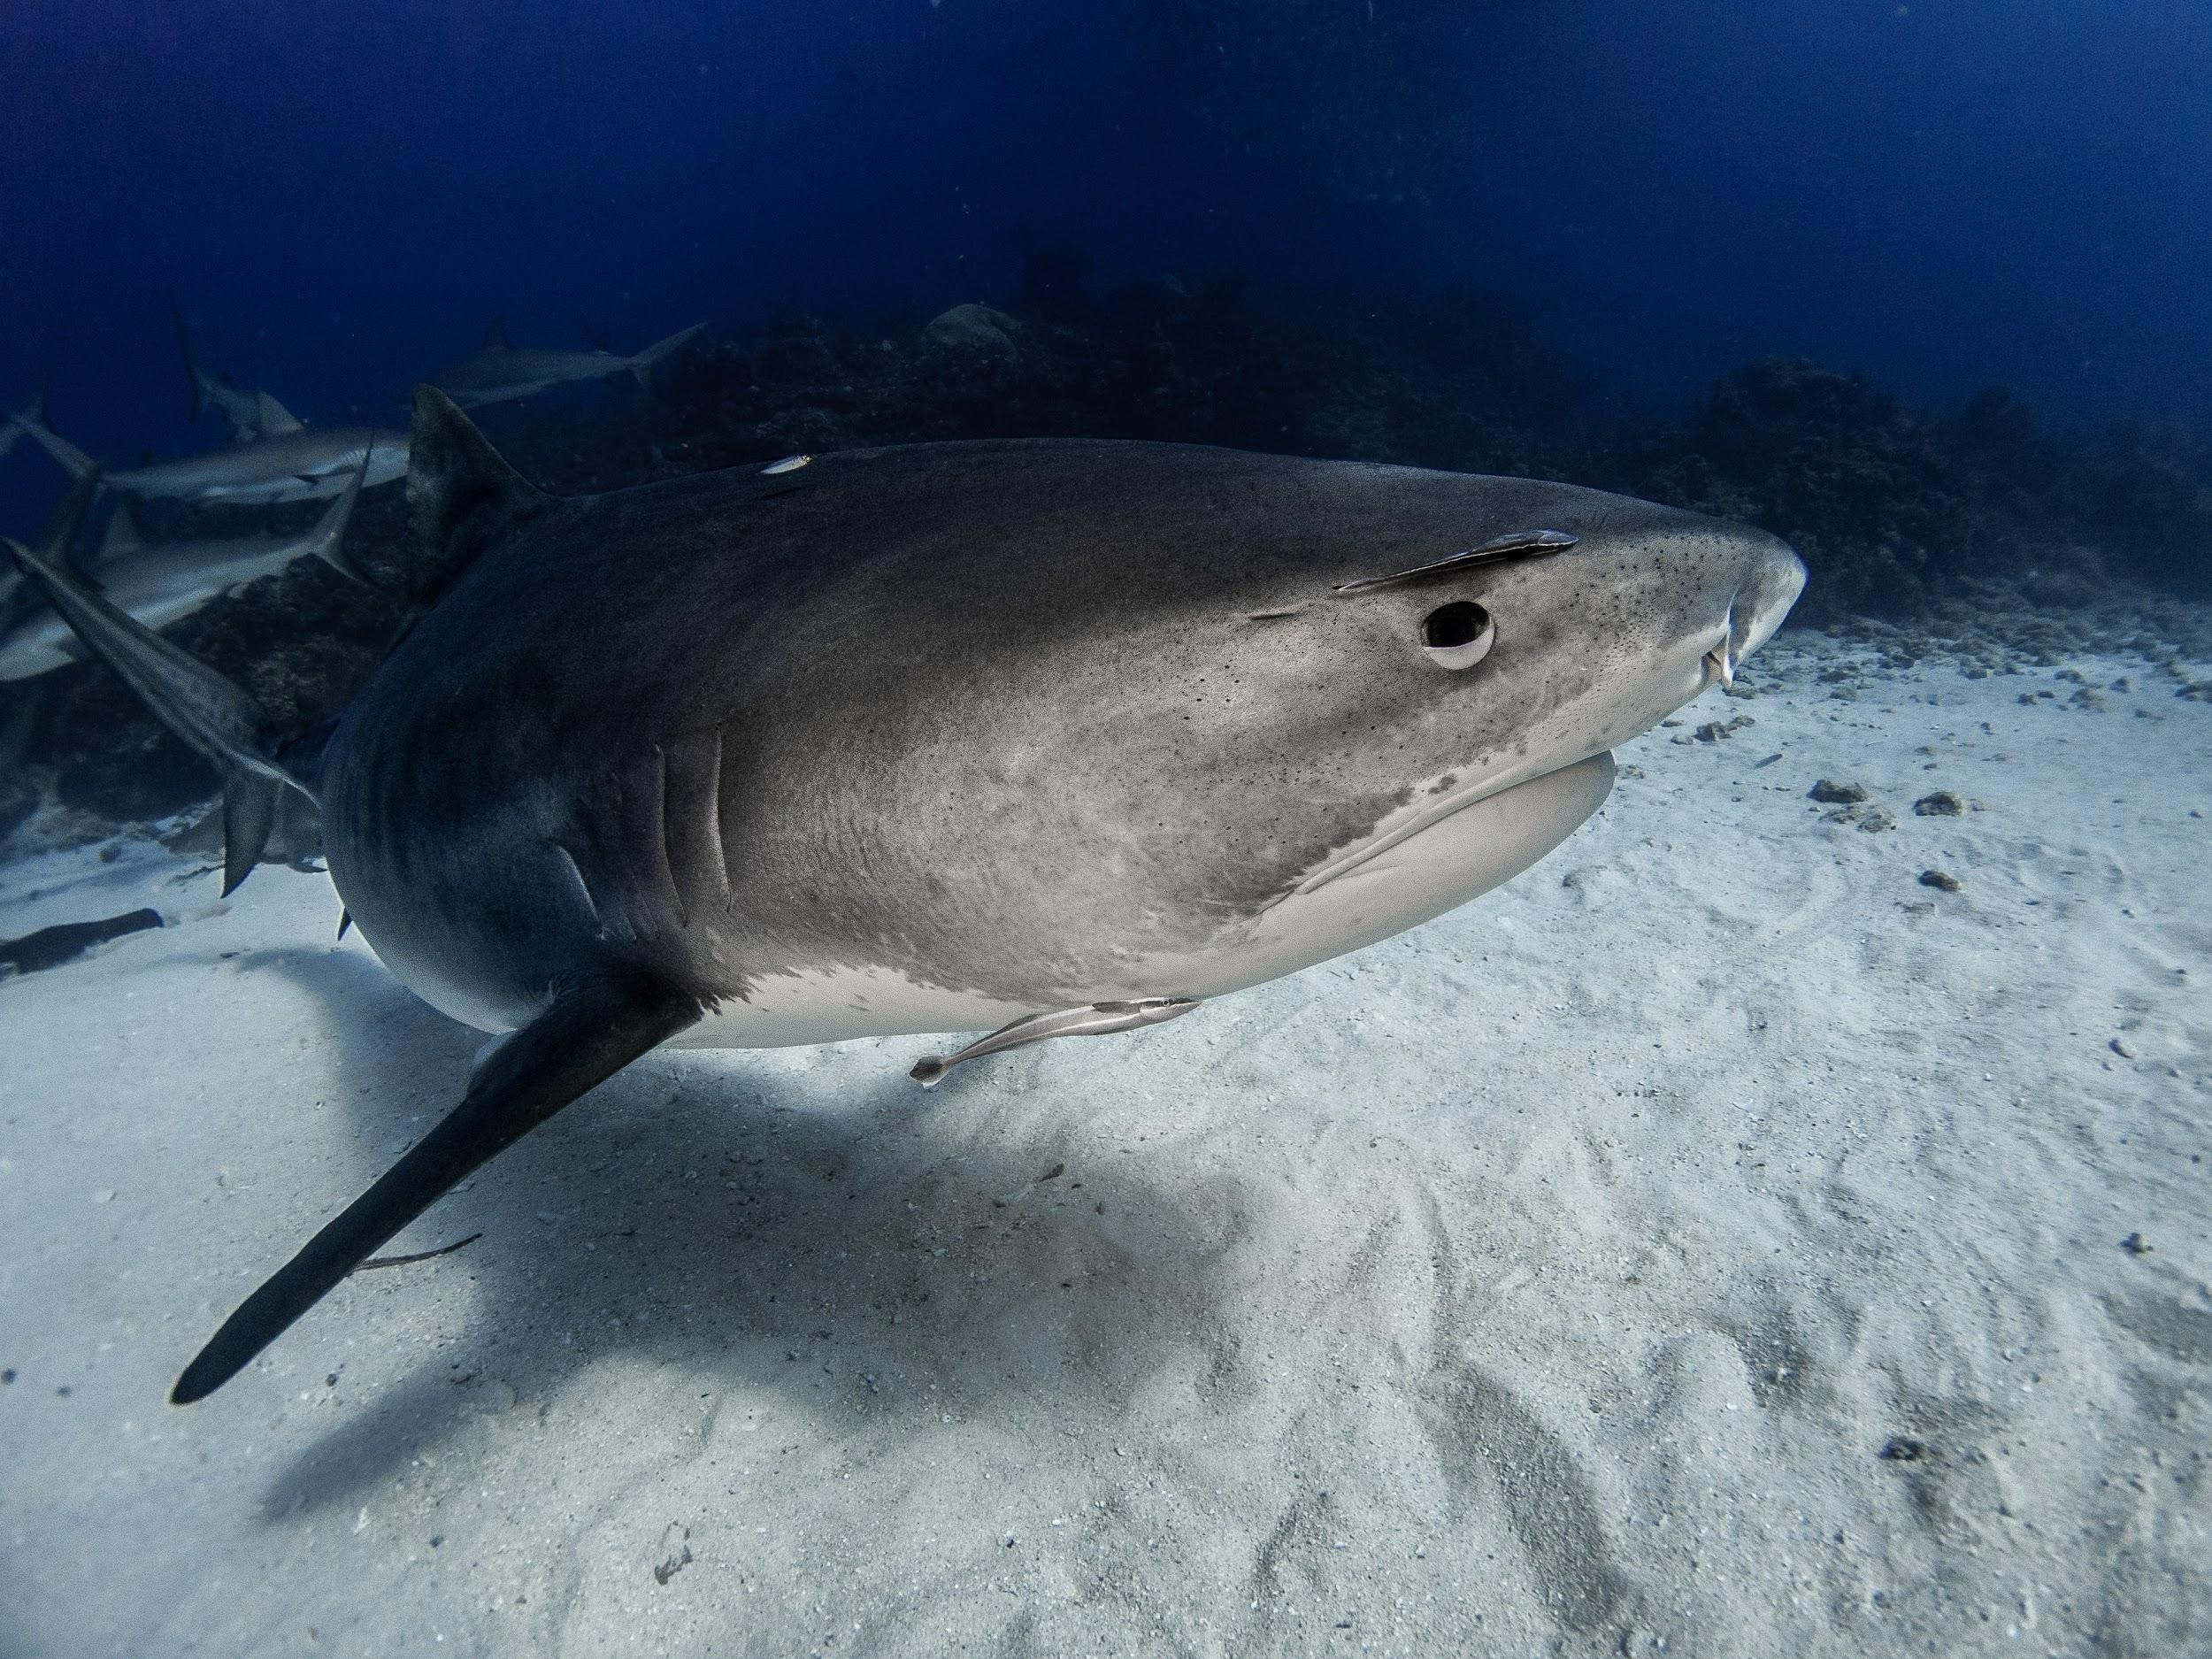
Figure 4: “Photo taken by Ryan Walsh; tiger shark; 1/4/2019; Tiger Beach, The Bahamas”
9. Extreme Coexistence
Finally, Frank defines “Extreme Coexistence” as encapsulating a kind of reverence, where humans understand wild animals have intrinsic worth and need space away from human presence (Frank 2016). Within the context of human-shark interactions, we define the Extreme Coexistence area as behavior motivated toward active advancement of conservation goals while exhibiting a deep respect for sharks. We offer the practice of scuba diving with sharks in their natural habitat without any provisioning—that is, no chumming or feeding—as an example of Extreme Coexistence. We believe diving with sharks in this nature entails a deep respect for the well-being of the shark by avoiding any potential risk of creating an association between humans and food, which may shape behavior and travel (Gallagher & Huveneers 2018).
Not only does scuba diving with sharks without bait represent the most extreme form of coexistence, but it can still allow divers the opportunity to use photography as a conservation tool. Conservationist and photographer Shawn Heinrichs exemplifies how photography can aid shark conservation efforts. Heinrichs embarked on a roughly five-year mission chasing down shark fin operations on the high seas in an effort to document their actions on camera. He finally captured video of a tawny nurse shark lying on a reef, with all of its [her] fins hacked off, trying to swim, drowning to death (Joffe 2018). Heinrichs used this video to try to educate as many people as possible about the truth of shark finning. Specifically, Heinrichs worked with Wildaid executive director Peter Knights, and they launched shark fin educational campaigns in China. To make the campaign as impactful as possible, they recruited Yao Ming, an influential ambassador, to create a high-impact commercial (Joffe 2018). The commercial received the backing of the Chinese government, and was shown on prime-time state media to hundreds of millions of individuals. After being educated about the truth of the shark-finning process and learning how the sharks are killed and released into the oceans alive, shark fin consumption reportedly decreased by 70-80% in China (Joffe 2018). As a film-maker and photographer, Heinrichs notes that imagery gives a voice, and combining visual elements with education resulted in an incredibly impactful change in behavior, exemplifying how educating individuals about conservation crises and campaigns can result in positive changes in action. We believe this behavior embodies Extreme Coexistence, as it uses photography as a tool to promote shark conservation without any form of provisioning, this can be seen in Figure 5 below of the Whale Shark, where no form of provisioning was used.

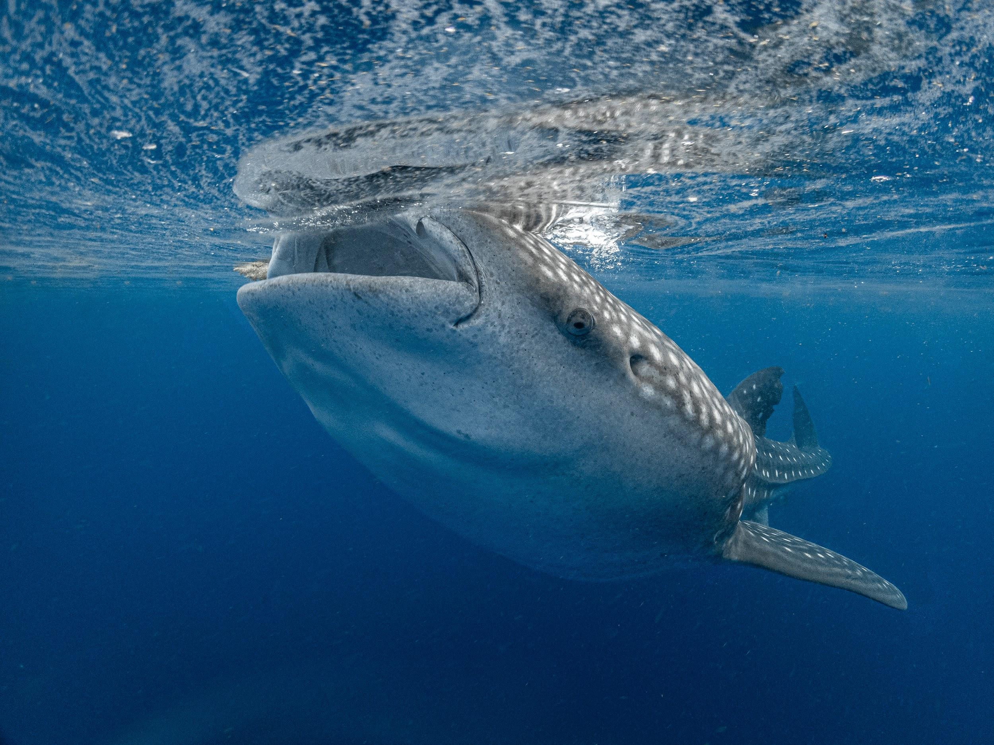
Figure 5: the whale shark: "Photo taken by Ryan Walsh, whale shark, 7/6/2020; Isla Mujeres, Mexico”
In addition, we present a hypothetical case study in order to provide an example, though a theoretical version of Extreme Coexistence. Specifically, we imagine a marine sanctuary—free of any fishing or killing practices, where perhaps no humans may enter. Alternatively, the sanctuary may have limited recreational water users who must abide by strict precautionary measures ranging from using reef-safe sunscreen to ensuring that humans avoid accidentally touching any of the corals. Importantly, humans in this theoretical sanctuary all exhibit thoughtful, meaningful, intentionality for shark sentience and marine conservation at large. One could argue that a sanctuary as such, free of any destructive human behaviors or practices could be rewilding, or perhaps rewilding is what we call Extreme Coexistence. We believe that a sanctuary that truly focuses on protecting the animals that call it home gives humanity a chance to create Extreme Coexistence in the future.

Similarly, Hammerton and Ford (2018) argue, humans have colonized the waters, believing their rights to use, through consumption or recreating supersede, the organic rights of sharks, who actually call the ocean home. They argue for a decolonization of oceans to allow sharks their natural born freedoms. We align with their position. And further it, by offering a nationhood for sharks, where humans are the visitors and sharks are the inhabitants.
Often consumption and killing of sharks has been justified through their lack of sentience among other human qualities, such as cognition. There are scientific arguments that fish feel pain, but not without criticism (Sneddon et al. 2018). With a lack of scientific consensus on Shark sentience, we turn to other ways of knowing through our own innate embodied knowings and deep wisdom from within. Moreover, the openness, empathetic understandings and higher consciousness of the humans who do know sharks can suffer. Such knowings are founded in our own innate wisdom, rather than scientific evidence. Moreover, we align with the work of Porcher (2018) in moving forth not only the human belief of Shark sentience, but expanding that to be inclusive of innate knowings through our own human felt consciousness and embodied experiences. Moreover, by interacting with living sharks in their natural state, there is a sense of knowing through the felt body, the empathetic physicality, in such a way that we see sharks as sentient beings who share in the interactive experience. Here we move away from the paradigm of wildlife watching (Chris 2006). Rather, do we feel the shark’s fear in those moments? Is her fear in our awareness and is our fear in her awareness? Do we feel her sense of being, of life? Does she feel ours? We see a powerful and sovereign alchemical exchange through two agentic beings, a human and a shark. We argue an interaction between two sentient beings, who are sovereign, invokes an emotional response which transforms ways of knowing. Moreover, there is value in sharing sentience with a shark in the sea, but only can this be done with a diver. We argue, such an exchange transforms the human condition. Here Erin Walsh, a co-author of this paper, discusses a sharing of sentience with a shark:
Diving at Tiger Beach in The Bahamas with Jim Abernethy was a perspective-changing experience. Tiger Beach is one of the shark capitals of the world, home to tiger sharks, great hammerhead sharks, bull sharks, lemon sharks, Caribbean reef sharks, and nurse sharks. I was fortunate enough to be able to have countless cage-free experiences with large predatory sharks in their environment. Because of the safety precautions with which we were trained before the dive—remaining in an upright position and using a specific, detail-oriented method of entering the water by gently rolling off of a foot-deep submerged platform in the water to avoiding splashing at the surface—we were able to project ourselves as non-threatening beings which are neither her predator nor her prey. The goal for these dives, needless to say, was to have a close-up interaction with a tiger shark. The moment that simply changed my perspective came along in the body of a 13-foot tiger shark. At first, she kept her distance—it was clear that she was wary if not fearful of my presence. After making a couple passes in the background, she finally came in for a closer look. As she saw my figure kneeling on the sandy ocean floor, motionless and void of threat, she recognized that I was not a danger to her, and she swam—or rather glided—right up to me, less than a foot from my face, and smoothly turned to loop around. Upon circling back again, our eyes locked. She maintained eye contact with me for a few seconds, and seemed to feel more comfortable around me, as she remained close and calmly glided by. By keeping our eyes locked, we were both able to not only study each other, but somehow use nonverbal communication through our eyes and behavior to signal a mutual understanding that neither of us are a threat to the other. I instantly felt her recognition of me as another living, sentient being beneath the surface. In that moment, we were both two large animals underwater, rather than two foes. I felt almost incapacitated by her curiosity, grace, and intelligence; it was nothing short of mesmerizing. The ability to connect with a wild animal that is so falsely perceived as a fearful, dangerous predator was incredibly empowering, and it changed my perspective from that point on. We shared the capacity to perceive each other as fellow sentient beings—neither of us felt threatened by the other’s presence, and a chord was struck within us both that radiated a connection based on curiosity and trust rather than fear. I strongly believe that we went through a transformation of knowledge together, as we recognized each other’s agency and built a level of respect for each other. From that point on, there was simply no way that I could continue to live my life as usual. I knew that I had to do everything in my power to respect and protect sharks moving forward. (E. C. Walsh 2020).
Extreme coexistence then, can embrace conservation, but not a colonist approach, rather a conservation that emerges from a sharing of sentience between two agentic beings, a shark and a human. We align with Hammerton and Ford (2018), purporting the sanctuaries need to be decolonized giving the waters back to sharks. This already is different from a colonialist paradigm of conservation. Nyhus (2016), as well as Hammerton and Ford (2018), find divers to be the most able to have communal interactions with sharks. We believe divers share sentience with sharks. To illustrate this we draw on two diver experiences here, one from conservationist and photographer Shawn Heinrichs, the other from shark enthusiast and co-author of this paper, Erin Walsh. Through these narratives, we try and capture, in the written language, how sentience is shared in an underwater space between a shark and a human.
10. Conclusion
Interactions between humans and wildlife vary from negative to positive experiences and from conflict to coexistence, with encounters varying in intensity and frequency. We identify various scales of conflict based on invasive and violent practices in finning and fishing. Like Frank (2016) and Bruskotter et al. (2015), we see acceptance and tolerance in interactions between humans and sharks based on diving with or without feeding or chumming. The frequency of shark encounters varies with the recreational water activity: it is lowest with divers and highest with swimmers, waders, and board users. We use the word “encounter” in contrast to “attack,” which is restricted to conflict categories (Hammerton and Ford 2018). We appeal to shared sentience in our encounters with sharks, the apex animal of the sea, pointing out which activities underlie conflict and death and which coexistence and life. We hope this work will help shift the perception of sharks and interactions with them to one that embodies respect and shared sentience.
Having identified some of the pervasive economic factors—finning, fishing, surfing and diving—there is also a need to assess the instrumental and monetary value of each industry. What is the cost and value of shark fins and how do we compare that to the cost and value of a diving experience? One promotes a livelihood of humans at the expense of shark life and the other promotes the life of humans and sharks.
References
Bauer, G. B. (2005). Research training for releasable animals. Conservation Biology, 19(6), 1779-1789. doi: 10.1111/j.1523-1739.2005.00246.x.
Bruskotter, J. T., Singh, A., Fulton, D. C., & Slagle, K. (2015). Assessing tolerance for wildlife: clarifying relations between concepts and measures. Human Dimensions of Wildlife, 20(3), 255-270. doi: 10.1080/10871209.2015.1016387.
Cardeñosa, D., Fields A. T., Babcock E. A., Zhang H., Feldheim K., Shea S. K. H., Fischer G. A., & Chapman, D. D. (2018). CITES‐listed sharks remain among the top species in the contemporary fin trade. Conservation Letters, 11(4), e12457. doi: 10.1111/conl.12457.
Chris, C. (2006). Watching Wildlife. Minneapolis, MN: University of Minnesota Press.
Clarke, S. C., McAllister M. K., Milner-Gulland E. J., Kirkwood G. P., Michielsens C. G. J., Agnew, D. J., Pikitch E. K., Nakano H., & Mahmood S. S. (2006). Global estimates of shark catches using trade records from commercial markets. Ecology Letters, 9(10), 1115-1126. doi: 10.1111/j.1461-0248.2006.00968.x.
Davies, R. W. D et al. (2009). Defining and estimating global marine fisheries bycatch. Marine Policy, 33(4), 661-672. doi:10.1016/j.marpol.2009.01.003.
Dent, F. & Clarke, S. (2015). State of the global market for shark products. FAO Fisheries and Aquaculture Technical Paper, 590. Food and Agriculture Organization of the United Nations, Rome, Italy.
Fairclough, C. (2013). Shark Finning: Sharks Turned Prey. Smithsonian, Washington D.C. Available from https://ocean.si.edu/ocean-life/sharks-rays/shark-finning-sharks-turned-prey (accessed December 2020).
Florida Fish and Wildlife Conservation Commission. (n.d.). Feeding Sharks and Other Fish. Florida Fish and Wildlife Conservation Commission, Tallahassee. Available from https://myfwc.com/fishing/saltwater/recreational/fish-feeding/ (accessed December 2020).
Frank, B. (2016). Human–wildlife conflicts and the need to include tolerance and coexistence: An introductory comment. Society & Natural Resources, 29(6), 738-743. doi: 10.1080/08941920.2015.1103388.
Gallagher, A. J., Hammerschlag, N., Danylchuk, A. J., & Cooke, S. J. (2017). Shark recreational fisheries: Status, challenges, and research needs. Ambio, 46(4), 385-398. doi: 10.1007/s13280-016-0856-8.
Gallagher, A. J. & Huveneers, C. P. (2018). Emerging challenges to shark-diving tourism. Marine Policy, 96, 9-12. doi: 10.1016/j.marpol.2018.07.009.
Hammerton, Z. & Ford, A. (2018). Decolonising the waters: Interspecies encounters between sharks and humans. Animal Studies Journal, 7(1), 270-303. https://ro.uow.edu.au/asj/vol7/iss1/13.
Hammerschlag, N., Gallagher, A. J., Wester, J., Luo, J., & Ault, J. S. (2012). Don’t bite the hand that feeds: Assessing ecological impacts of provisioning ecotourism on an apex marine predator. Functional Ecology, 26(3), 567-576. doi: 10.1111/j.1365-2435.2012.01973.x.
Hueter, R. E., Charles, A. M., Tyminski, J. P., Hoenig, J. M., & Hepworth, D. A. (2006). Assessing mortality of released or discarded fish using a logistic model of relative survival derived from tagging data. Transactions of the American Fisheries Society, 135(2), 500-508. doi: 10.1577/T05-065.1.
Kelly, J. R., Doherty, T. J., Gabel, T., & Disbrow, W. (2019). Large carnivore attacks on humans: The state of knowledge. Human Ecology Review, 25(2), 15-33. doi: 10.22459/her.25.02.2019.03.
Mclean, J. (Producer), & Joffe, A. (Director and Producer). (2018). Tales by Light. [Television series]. United Film Works.
Maljković, A. & Côté, I. M. (2011). Effects of tourism-related provisioning on the trophic signatures and movement patterns of an apex predator, the Caribbean reef shark. Biological Conservation, 144(2), 859-865. doi:10.1016/j.biocon.2010.11.019.

Mellor, D. J. (2019). Welfare-aligned sentience: Enhanced capacities to experience, interact, anticipate, choose and survive. Animals, 9(7), 440. doi:10.3390/ani9070440.
Office of Protected Resources. (2019). Fishing gear: Purse seines. NOAA Fisheries, Silver Spring. Available from www.fisheries.noaa.gov/national/bycatch/fishing-gear-purse-seines (accessed December 2020).
NOAA Fisheries. (n.d.). What is bycatch? NOAA Fisheries, Silver Spring. Available from https://www.fisheries.noaa.gov/node/251 (accessed December 2020).
Nyhus, P. J. (2016). Human–wildlife conflict and coexistence. Annual Review of Environment and Resources, 41, 143-171. doi: 10.1146/annurev-environ-110615-085634.
Oliver, C. (2017). 2017 Shark finning report to Congress. NOAA Fisheries, Silver Spring, Maryland.
Porcher, I. F. (2018). Fish sentience, consciousness and Al. Animal Sentience, 21(4), 119. https://www.wellbeingintlstudiesrepository.org/animsent/vol3/iss21/4/.
Shea, K. H. & To A. W. L. (2017). From boat to bowl: Patterns and dynamics of shark fin trade in Hong Kong―implications for monitoring and management. Marine Policy, 81, 330-339. doi: 10.1016/j.marpol.2017.04.016.
Sneddon, L. U., Lopez-Luna, J., Wolfenden, D. C. C., Leach, M. C., Valentim, A. M., Steenbergen, P. J., Bardine, N., Currie, A. D., Broom, D. M., & Brown, C. (2018). Animal Sentience, 21(1), 115. https://www.wellbeingintlstudiesrepository.org/animsent/vol3/iss21/1/.
Stewart, R. (Director). (2006). Sharkwater. [Film]. SW Productions; Diatribe Pictures; Sharkwater Productions.
Watson, J. T., Essington, T. E., Lennert-Cody, C. E., & Hall, M. A. (2009). Trade‐offs in the design of fishery closures: Management of silky shark bycatch in the Eastern Pacific Ocean tuna fishery. Conservation Biology, 23(3), 626-635. doi: 10.1111/j.1523-1739.2008.01121.x.
Worm, B., Davis, B., Kettemer, L., Ward-Paige, C. A., Chapman, D., Heithaus, M. R., Kessel, S. T., & Gruber, S. H. (2013). Global catches, exploitation rates, and rebuilding options for sharks. Marine Policy, 40, 194-204. doi: 10.1016/j.marpol.2012.12.034.

