**Hoist Components:** *Prof John Chad 17.11.2021*

**On/Off** switch is top press button

**Red LED** lit when On

**Switch Off** before shutting tailgate

**Controller** has magnetic mount to upright for stowage

Controller **arrowed push buttons** for up/out/in/down

**Scoot Components:**

**Brake lever** locks/unlocks rear axle

Hoist strap buckles fit over **lifting points**, pushed on then pulled up to secure clip

**Column angle** can be adjusted when screw handle is undone a couple of turns to unlock teeth

**Steering lock** secures in straight-ahead when pressed in and turned vertical, stops column swinging when loading/unloading

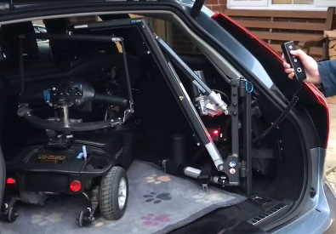**Unloading:** *(loading is reverse of sequence)*

**Fold out mat**

**Turn On** hoist

**Hoist up** to take weight off wheels

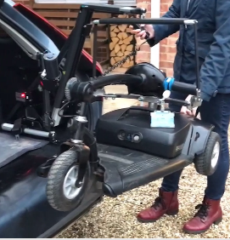

**Hoist out** to swing scoot from car

Control back of scoot to **keep level**

**Swing out** parallel with rear of the car

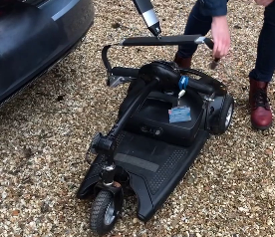**Hoist down** to lower scoot to ground and straps slack

**Unclip** straps *(push clip down)* to release scoot

**Hoist up** then **Hoist in** to stow

**Turn Off** hoist, **fold in mat**, then **close Tailgate**

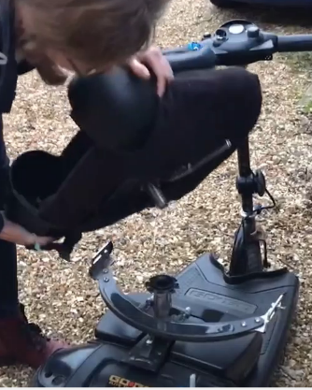**Set up Scoot:** *(packing to load is reverse of sequence)*

Loosen **column angle adjuster,** pivot column to upright, tighten adjuster to lock

Take **scoot seat** from car (rear seat), put **peg** into **seat post**, swivel straight

*(side lever of seat slots into one of the slots on top “cog” of post)*

Undo **steering** lock *(turn anti-clockwise to horizontal)*

Undo **brake lever** *(push forward)* to allow free-wheel

Push scoot to driver’s door