Martinez et al paper:
List of figures

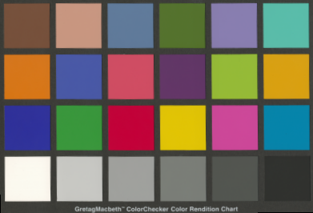
1 Schematic of the VASARI scanner lighting system

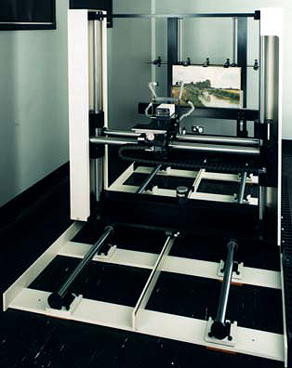
2 Macbeth Colorchecker chart

3 shows the VASARI scanner as it appeared in early 1992 when the hardware design was complete.

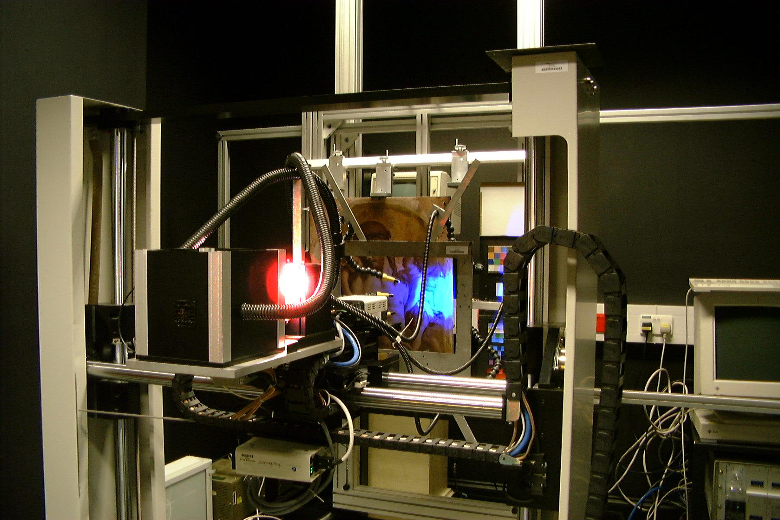
4 Plots of L* vs a* and b|* vs a*, for the real (diamonds) and measured (circles) MacBeth chart values.

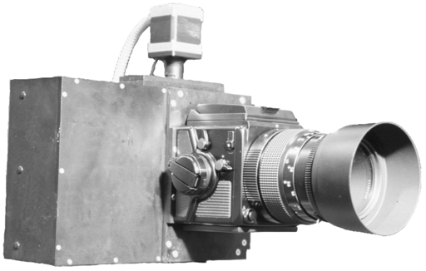
5 The Vasari scanner in 2000.

6 the MARC camera
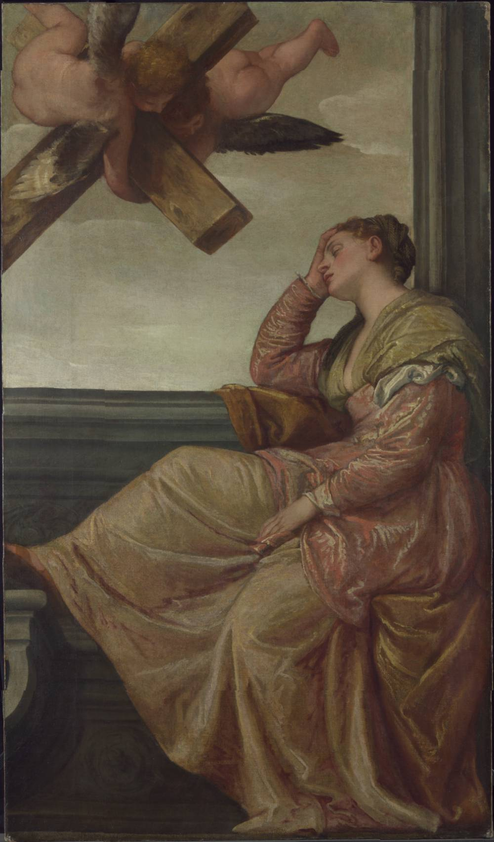
7 Veronese before processing.
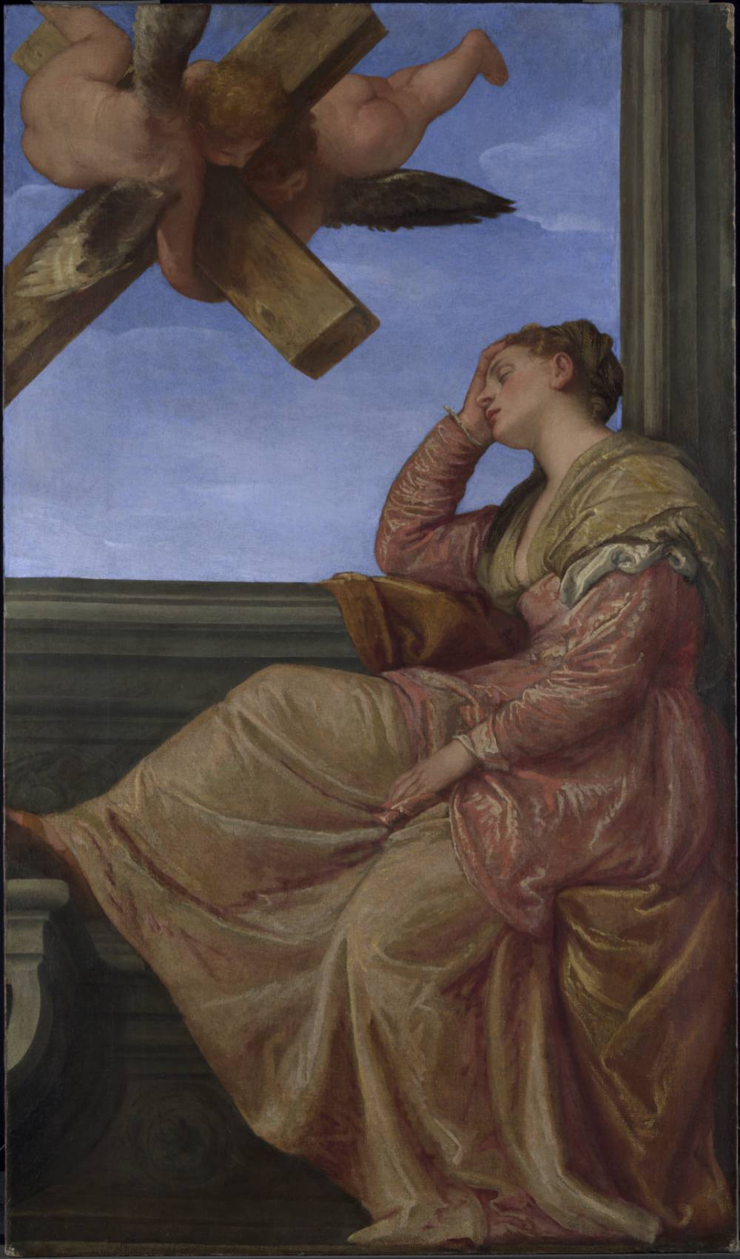
8 Veronese after processing.

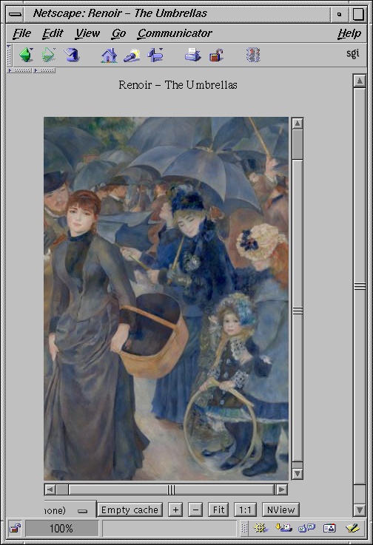
9 High resolution image shown in Web viewer

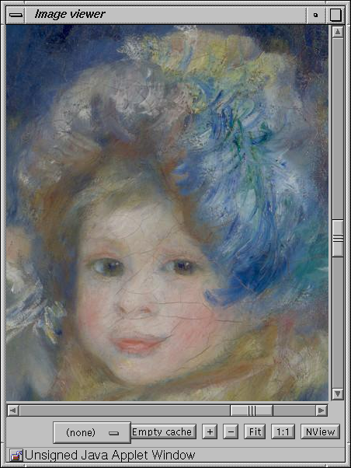
10 Close-up of the full 7295x9982 pel image

