
ARTISTE, D2.6
#905-0004461 Rev. A
May, 2002

Document Changes
2002-05-13
D 2.6 Final Prototype Evaluation Report
Project acronym | ARTISTE
Contract number | IST 11.978
Deliverable number | D2.6
Deliverable title | Final Prototype Evaluation Report
Workpackage | WP 2 User Requirements and Evaluation
Task | T2.5 Final Prototype Evaluation
Date of delivery | Contractual |  | Actual
Code name | D2.6.doc |  | Version 1.0 draft final
Nature | Report
Dissemination level | Internal ARTISTE
Authors (Partner) | GIUNTI Ilabs, NCR, UoS , UoS IT Innovation, Uffizi, C2RMF, VAM
Contact Person | Fabrizio Giorgini  Via Portobello  Abbazia dell'Annunziata  16039 Sestri Levante, Italy  Ph: +39 0185 42123 / 42608  Fax: +39 0185 43347  email: f.giorgini@giuntilabs.com
This document, and information herein, are the exclusive property of the partners of the ARTISTE consortium: NCR Systems Engineering Copenhagen (Denmark), Southampton University (England), Interactive Labs S.r.l. (Giunti Publishing Group) (Italy), Centre de Recherche et de Restauration des Musées de France (France), Victoria and Albert Museum (England), The National Gallery (England), Soprintendenza per i Beni Artistici e Storici de Firenze, Prato e Pistoria (Italy)
Copyright (C) 2002
Rev. | Date | Section | Comment
A | 07/05/02 | All | Initial Issue

Reviewers of Current Revision
Rev. | Name, Organisation | Role
A

Trademarks
All trademarks and service marks mentioned in this document are marks of their respective owners and are as such acknowledged by the ARTISTE Consortium.
Control Information
Page is the last page of this document.
Contents
Executive Summary 1
1. Introduction 2
2. The Fourth Prototype 3
2.1 System Characteristics: what’s new 3
3. Usability Test Plan 5
3.1 Introduction 5
3.2 Usability Test Plan 7
3.3 Recommendations / Notes 12
3.4 Submitting a bug 12
3.5 Proposed heuristic evaluation 12
4. Evaluation Report 15
4.1 Introduction 15
4.2 System Performance Evaluation 15
4.3 Usability Evaluation 15
4.3.1 Overview 15
4.3.2 V&A usability evaluation 15
4.3.3 NCR usability evaluation (Warren Sterling) 20
4.3.3.1 General Usability Evaluation 41
4.3.4 NCR usability evaluation (Gert Presutti) 45
5. Conclusions 49
6. References 50

Figures

Tables

Table 1: Jacob Nielsen’s Heuristics 14

Executive Summary

Introduction

The Fourth Prototype

System Characteristics: what’s new
The description of the system architecture developed so far is out of the scope of this document so the remaining part of this paragraph is dedicated to a short summary of the main characteristics of the new prototype. They are illustrated below:

- Improved user interface

  - Removed technical terminology
  - Created a query wizard that guides the user through the querying process
  - Cross browser compatibility
  - Multilingual support
  - User interface component to view and crop the query image
  - User interface component to view a result image

- New search techniques

  - Query by selected colour
  - Find images of a similar texture using the Pyramid Wavelet Transform (PWT) algorithm
  - Query by faxed image

Two extra algorithms for the image content analysis have been integrated. They are:
- Pyramidal Wavelet Transform

Provides facilities for looking at the general texture distribution within the image and finding images which show similar textures to a query image. Texture based searches will prove very effective when working with textiles.

Note: This algorithm is used when the user selects Image Search Type: Images of a similar pattern or texture to my image

- Fax

Provides facilities for searching by a low quality faxed image.

Note: This algorithm is used when the user selects Image Search Type: Images that are similar to my fax

- Improved performance

  - General speed up when navigating the site e.g. browse query runs, browse analysers
  - Faster query times and result browsing

- Dynamic and distributed linking

  - Inserting links into metadata in the more info page.

The dynamic and distributed linking functionality introduced into prototype 4.0 enables organisations to provide links to resources associated with images. Each organisation will maintain a linkbase that contains a set of URL's to resources published on the Internet that are referenced by keywords. When an image is viewed in the user interface, ARTISTE will examine the image metadata and attach links to keywords that appear in the linkbase.
The main benefits of dynamic linking are that existing metadata does not have to be changed and links can be applied to multiple images that have the same keywords in their metadata. Also, as each organisation maintains their own linkbase and links are attached at presentation time, results from other collections will contain links associated from the local organisation. This is desirable, as linkbases from other organisations may contain irrelevant information.
Although we have yet to receive any links from the users for prototype 4 we have created a test linkbase for the Victoria and Albert Collection.

Usability Test Plan

Introduction
The chapter presents a template for the evaluation of the fourth prototype early release P4.0.
The test plan is designed to focus on those elements new to ARTISTE in prototype 4.0, namely:

- Improved user interface

- New search techniques

- Improved performance

- Dynamic and distributed linking

The user should:
a) Run the tests suggested in the Test Plan paragraph and:
- Specify the query. Indicate for each test:
  - Used database/databases;
  - If query by metadata or complex query, used metadata term/terms and its/their value;
  - If query by image or complex query, used query image (include the picture).
- Compare the obtained results with the expected results.
  - Comment the result
Note that the user can repeat one or more of the proposed tests, changing the query data. In this case feedback should specify the query and comment the result for each repetition.
b) Run additional tests as required to evaluate the usefulness of the system to your business
c) Evaluate the usability of the prototype by answering or commenting the heuristic questions.
Note that because the redesigned user interface is one of the main changes to the ARTISTE from prototype 3, feedbacks on this feature of the system assume a relevant aspect of the entire prototype evaluation.

Example Response:
Query combining text and image search terms
Access to http://c2rmf.artiste.it-innovation.soton.ac.uk/
Selection of Image Collection: The Victoria and Albert Collection and The National Gallery Collection
Selection of Search Type: Both text and image
Selection of Image Search Type: Images of a similar colour to my image
Selection of Image Colour: Colour
Image:

Metadata Specification: Border Shape = Circle
No Exact Match
Case Insensitive
Expected results: The prototype should return circular images of a similar colour

Obtained results:
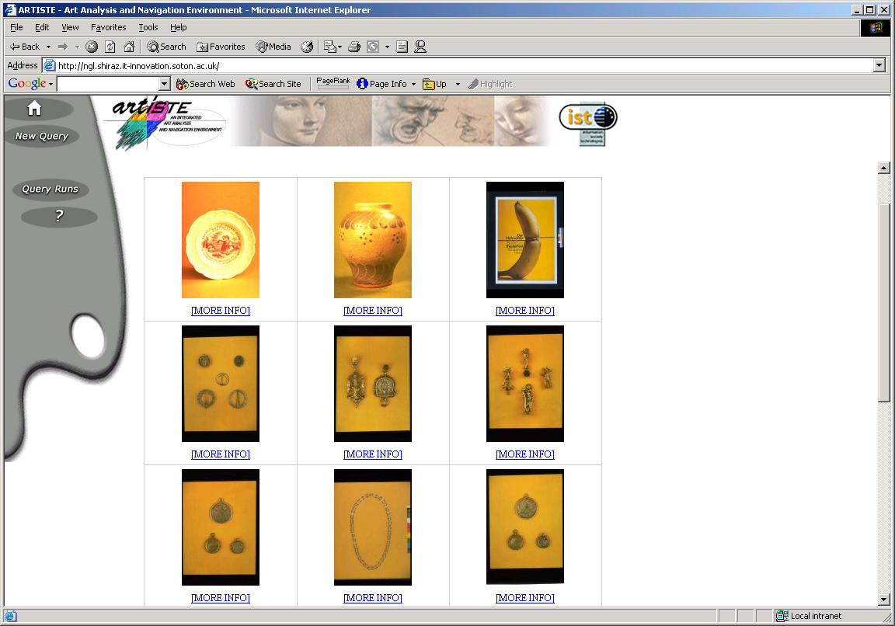

Comments:
The query image is not in the database. The system did return images of a similar colour. The query took 1 minute 5 seconds which seems reasonable. The progress bar and feedback were helpful. But it seems that the searching based on colour similarity takes account of the background colour.

Usability Test Plan
- Search for similar images to a faxed image
Use the context sensitive help to find information about running an image query. Follow the steps in the query wizard to build and run a query to find the original image from a faxed copy. The query image must be a grey scale image.
Browse the results .
Expected result: The context sensitive help should provide relevant information. The query wizard should guide the user through the necessary steps to building a query. The system should provide useful feedback on the status of the search. This is the expected result of all queries executed on ARTISTE.
It should be clear to the user how many results have been returned. The user should be able to alter the number of results shown per page and to browse amongst the many pages of results either by using the back and forward arrow buttons or the links to numbers pages. Again, this is the expected result of all queries executed on ARTISTE.
The user should be able to view a full size image and associated metadata in the ‘More Info’ window. The user should be able to zoom in on particular points on the image and resize it. Again, this is the expected result of all queries executed on ARTISTE.
If the original image on which the fax is based is in the database, it should be retrieved, together with other images, both greyscale and colour. If the image is not in the database, then similar images should be retrieved.
Example
Access to http://vam.artiste.it-innovation.soton.ac.uk/
Selection of ImageCollection: The Victoria and Albert Collection
Selection of Search Type: Image
Selection of Image Search Type: Images that are similar to my fax
Image:
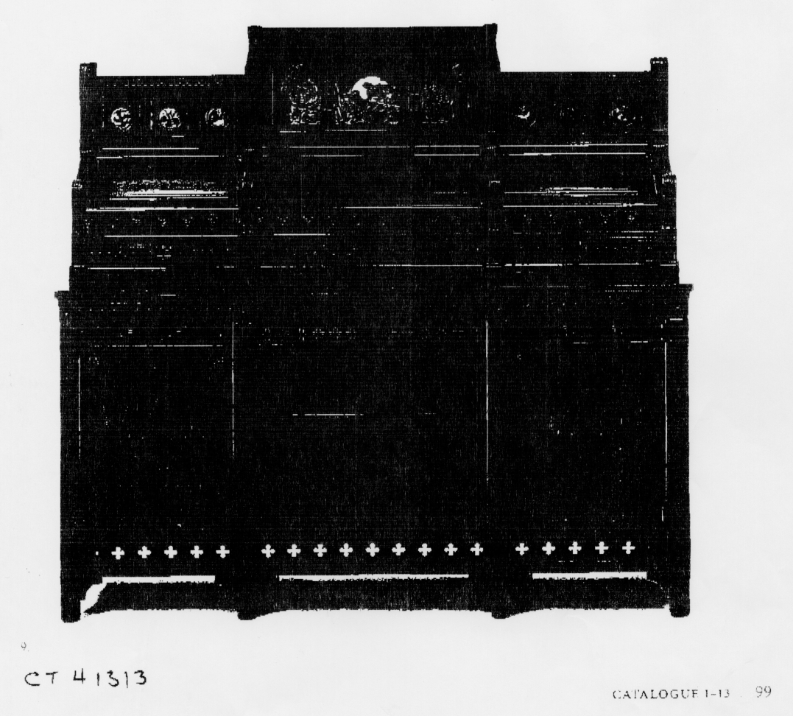

- Search for images similar to a given texture
Follow the steps in the query wizard to build and run a query to find images showing a similar texture to the texture shown in a query image. Crop the query image before submitting the query to focus on the desired texture. Browse the results
Expected Result: The user should be able to resize and crop the query image to the desired sub image before submitting the query. Images showing a similar texture should be returned.
Example
Access to http://ngl.artiste.it-innovation.soton.ac.uk/
Selection of ImageCollection: The Victoria and Albert Collection, The Uffizi Collection and The National Gallery Collection
Selection of Search Type: Image
Image:
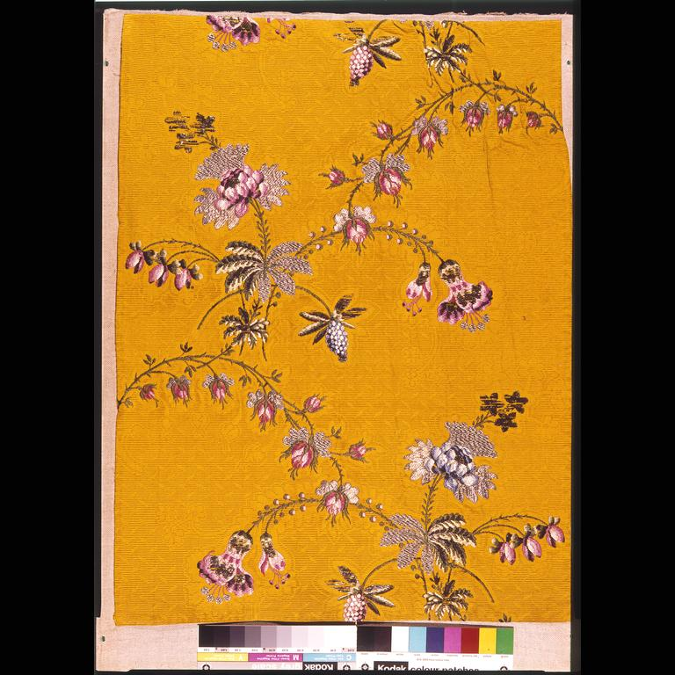
Cropped Image:


- Search for images similar to a specified colour
Follow the steps in the query wizard to build and run a query to find the images of a similar colour to one specified using the Colour Picker tool. Browse the results.
Expected Result: Images of a similar colour should be returned.
Example
Access to http://ngl.artiste.it-innovation.soton.ac.uk/
Selection of ImageCollection: The UffiziCollection and The National Gallery Collection and The C2RMF Collection
Selection of Search Type: Image
Selection of Image Search Type: Images of a similar colour to a selected colour
Colour :


- Create a query, adding criteria and deleting criteria before finally executing the query
Follow the steps in the query wizard to build using both text and a query image. When you reach the final step in the query builder process and see the Search Summary go back and alter some of the text criteria you have selected.
Execute the query and browse the results.
Review the query which generated the results by clicking on the search number.
Return to the results by clicking on View Results
Expected Result: The query should execute as normal and browsing between results and the query should be simple.

- Dynamic and Distributed linking
Follow the steps in the query wizard to build and run a query. Browse the results and explore the resources associated with the images.
Note that because the demonstration linkbase that has been created for the Victoria and Albert collection is not large it is important that the user tests the dynamic and distributed linking functionality using the example query below. It is unlikely that the user will retrieve results with dynamic links by chance in the normal use of the system.
Expected result: A number of images should be returned. The metadata values should be listed in the “More-Info’ window. A number of the metadata values should be hyperlinks. These should take the user to useful information and resources associated with the images. Browsing these resources should not force the user to leave the ARTISTE system.
Example
Access to http://ngl.artiste.it-innovation.soton.ac.uk/
Selection of ImageCollection: The Victoria and Albert Collection
Selection of Search Type: Text (metadata)
Metadata Specification: DC Creator contains Colin Pearson
Exact match not required
Case insensitive

- Browse results after email notification
Follow the steps in the query wizard to build a query over all four collections to find images of a similar colour to a query image (i.e. quite a computationally intensive search which one might expect to take some time). Ask to be notified by email when the search has completed. Execute the query and, rather than wait for the results to be returned, close down your browser.
On receipt of an email notifying you of the successful completion of the query, follow the instructions in the email to retrieve the results.
Expected Result: The user should receive an email when the query has completed. The instructions in the email should enable the user to retrieve the results of the their query.

- Test cross-browser compatibility
Connect to ARTISTE using Internet Explorer Follow the steps in the query wizard to build and run a query. Browse the results.
Reconnect to ARTISTE using Netscape. Build and run the same query as above.
Expected result: The query should retrieve the same results as the first execution of the query. The experience of using the system under different browsers should not be significantly different.

- Test multi-lingual support
Connect to ARTISTE and choose to use the system in English. Follow the steps in the query wizard to build and run a text query over the C2RMF collection using several controlled metadata terms.
Return to the home page and choose to use the system in French. Follow the steps in the query wizard to build and run the same text query over the C2RMF collection.
Expected Result: The user interface, including buttons and links, should be fully available both English and French (ARTISTE also supports Italian and Danish). The controlled metadata terms should also be displayed in the correct language but the results returned should be the same irrespective of the language in which the query was created.

Recommendations / Notes
The list of the recommendations/notes provided to the users for the correct use of the system follows:
- Use Internet Explorer V5 or Netscape 4.7
- If you experience problems using Internet Explorer ensure that that you are not using Java 2 for applets. To alter your settings go to Tools >> Internet Options >> Advanced >> and uncheck the box listed under “Java (Sun)” labelled as “Use Java 2 v1.3.1_02 for <applet>”.
- Query images may be in any standard format (eg jpg, gif, tiff, bmp) but they must not be bigger than 512 Kbytes
- Query images may be of min 64x64 pixels.
The width and height of the sub-image must be less than the width and height of the reference image

Submitting a bug
If the user discovers a bug they should submit it via the link at the foot of the prototype 4 home page, i.e.
http://vam.artiste.it-innovation.soton.ac.uk/bugs/bugForm.html
http://c2rmf.artiste.it-innovation.soton.ac.uk/bugs/bugForm.html
http://uffizi.artiste.it-innovation.soton.ac.uk/bugs/bugForm.html
http://ngl.artiste.it-innovation.soton.ac.uk/bugs/bugForm.html

Proposed heuristic evaluation
Heuristic evaluation developed by Jakob Nielsen and Rolf Molich ([Nielsen&Molich 90], [Nielsen 90], [Nielsen 92], [Nielsen 94]) is the adopted usability engineering method for evaluating the usability of our system through a list of questions.
For the sake of clarity, heuristics and their short meanings are illustrated in the following table. Details are given in the already realised document D2.4.

Heuristic | Meaning
Visibility of system status | Does the Prototype keep users informed about what is going on, through appropriate feedback within reasonable time?
Match between system and the real world | Does the Prototype speak the users' language, with words, phrases, and concepts familiar to the user, rather than system-oriented terms? Does the Prototype follow real-world conventions, making information appear in natural and logical order?
User control and freedom | Users often choose system functions by mistake and will need a clearly marked "emergency exit" to leave the unwanted state without having to go through an extended dialogue. Does the Prototype support undo and redo?
Recognition rather than recall | Are objects, actions and options visible? The user should not have to remember information from one part of the dialogue to another. Are instructions for using the Prototype visible or easily retrievable whenever appropriate?
Aesthetic and minimalist design | Do dialogues contain information which is irrelevant or rarely needed?
Help users recognise, diagnose, and recover from errors | Are error messages expressed in plain language (no codes)? Do they precisely indicate the problem, and constructively suggest a solution?
Help and documentation | Is it necessary to provide a help feature and documentation? If yes, which kind of help?
Consistency | Do different words, situations, or actions mean the same thing and create confusion?
Transparency and predictability | Can the user understand what is going to happen before proceeding with an action?
Learnability | Is the Prototype easy to learn? Does the Prototype require a particular use knowledge base? Does the Prototype involve particular cultural constraints? What could be done to improve its learnability?
Satisfaction | Are you satisfied with the Prototype? Do you have the feeling that the prototype is performing well, in relation with your tasks and its functionalities?
Considerations or suggestions | Are there other considerations or suggestions relating to the Prototype?
Table 1: Jacob Nielsen’s Heuristics

Evaluation Report

Introduction
This chapter reports the evaluation of the fourth prototype. It is mainly divided in a technical (and quantitative) evaluation and a qualitative evaluation. The assessment concerned:
- System Performance Evaluation (quantitative evaluation)
- Usability Evaluation (qualitative evaluation)
The usability evaluation followed the test plan suggested in chapter 3 so that it was divided into a test session, where executed tests are described and results are commented, and a heuristics evaluation session, where the prototype is assessed on the basis of the executed tests.

System Performance Evaluation

Usability Evaluation

Overview
This paragraph illustrates the users’ evaluation concerning the usability of the fourth prototype. When possible, contributions have followed, the suggested test plan (type of queries and heuristics) presented in chapter 3. For avoiding too many repetitions, only the answers to the heuristics are reported in these evaluation paragraphs. The questions of each heuristic can be easily retrieved in the Table 1 of the chapter 3.5.

V&A usability evaluation
In this section the usability evaluation of the VAM is presented. As suggested to him, the user executed suggested queries (they cover a large spectrum of all possible queries) and made his evaluation.

SEARCH FOR IMAGES SIMILAR TO A SPECIFIED COLOUR

VAM database selected,
Bright red from the colour picker selected,
Hodges, Sara inserted as metadata – “Photographers name”
Search Number: 1099
Query Number: 1154
Query Execution Time: 0 hours 1 minutes 36 seconds
Total Query Time: 0 hours 1 minutes 50 seconds
Comments:
When the results appeared I couldn’t see the metadata, i.e. Keywords etc. under the “More Info”.
Also I think a colour wheel on the colour picker page would be useful to help people understand how to mix the colours.

QUERY BY FAX

1) VAM data base selected
This image was submitted:


Search Number: 1121
Query Number: 1176
Query Execution Time: 0 hours 1 minutes 27 seconds
Total Query Time: 0 hours 1 minutes 42 seconds

Comments:
Results didn’t find my image and I was quite baffled with the results it returned.

2) VAM data base selected,
This image was submitted and cropped so that the colour chart and background was missing.


Search Number: 1123
Query Number: 1178
Query Execution Time: 0 hours 1 minutes 15 seconds
Total Query Time: 0 hours 1 minutes 29 seconds

Comments:
My image was found but not in the first nine.

3) VAM data base selected,
This image was submitted and cropped so that the colour chart and background was missing:


Search Number: 1124
Query Number: 1179
Query Execution Time: 0 hours 1 minutes 30 seconds
Total Query Time: 0 hours 1 minutes 44 seconds

Comments:
My image was found but not in the first nine and I am not sure why some of the results have been returned.

QUERY BY SIMIALR TEXTURE TO MY IMAGE

1) VAM data base selected,
This image was submitted and cropped to a detail of the relief of the object.
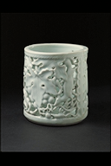

Search Number: 1125
Query Number: 1180
Query Execution Time: 0 hours 1 minutes 30 seconds
Total Query Time: 0 hours 1 minutes 44 seconds

Comments:
My image was found but not in the first nine and I am not sure why some of the results have been returned.

2) VAM, Nat Gal, Uffizi data bases selected,
This image was submitted and cropped to a detail of the relief of the object.
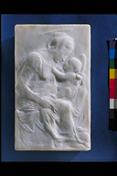

Search Number: 1126
Query Number: 1181
Query Execution Time: 0 hours 2 minutes 24 seconds
Total Query Time: 0 hours 2 minutes 43 seconds

Comments:
My image was not found in the first nine but images of similar subject have been found.

QUERY BY SIMILAR COLOUR

VAM, Nat Gal, Uffizi data bases selected,
I selected a purple colour from the colour picker.

Search Number: 1127
Query Number: 1182
Query Execution Time: 0 hours 2 minutes 31 seconds
Total Query Time: 0 hours 2 minutes 50 seconds

Comments:
I am not sure why any of these images have been returned with relation to the colour I chose.

2) VAM, data base selected,
I selected a purple colour from the colour picker.

Search Number: 1128
Query Number: 1183
Query Execution Time: 0 hours 1 minutes 35 seconds
Total Query Time: 0 hours 1 minutes 50 seconds

Comments:
I am not sure why any of these images have been returned with relation to the colour I chose. </DIV>
</DIV>

NCR usability evaluation (Warren Sterling)

Test Run:
- Where and When:
- The site logged into: C2RMF
- Date/time of query: April 16
- The Query
- Search number: N/A
- Databases searched: C2RMF
- Metadata term(s): Title equal TEMPEST [also tried other titles]
- Image: none
- Results:
- Expected results: Return an image of a picture titled TEMPEST, or multiple images of a picture titled TEMPEST (e.g., reverse image, UV, etc.)
- Obtained results: 0 returns
- Comments on results: I assumed there were images associated with every title. I also was confused by the fact that there were far fewer titles (around 200?) than there are images in the collection (12267). I received the following explanation from Alison Stevenson on the results of this search but there are still some things I don’t understand (I see around 200 titles, not 1200 titles). Also, it just isn’t intuitive that there are titles in the metadata list that don’t correspond to images in the collection.

“Hello Warren,
Thanks for all your testing of the system. I can confirm that we are receiving your reports.
I can also perhaps explain about the "Title" field in the C2RMF collection. The C2RMF store their metadata in the form of codes (e.g. 123) which are then mapped outside the database to human readable text in various languages. We have implemented this in ARTISTE using RDF thesauri. For each controlled metadata field there is an RDF file which describes the mapping from a code to the values you see displayed in the GUI.
For example the thesaurus for the term 'Title' contains the following description:
<z19:Category rdf:ID="1003">
<rdfs:label xml:lang="en">en:DOG CLOSE TO A DISPLAY OF DEAD GAME</rdfs:label>
<rdfs:label xml:lang="fr">fr:CHIEN AUPRES D'UN ETALAGE DE GIBIER MORT</rdfs:label>
</z19:Category>
The are 12267 images in the C2RMF collection and these are of around 1200 distinct works of art. There should therefore be a choice of around 1200 titles to choose from. However the C2RMF thesauri cover the entire collection at the Centre, not just the works we currently have loaded into the ARTISTE system. This means that you are actually provided with a list of 10947 titles giving you at best around a 10% chance of success.
I should point out that this low level of successful matching does not apply to all the controlled fields - only those where there is a one-to-one correspondence between an entry in the thesaurus and a work of art.
I am sure you will be glad to hear that we aim to improve upon this situation in the next release.
Regards
Alison Stevenson
IT Innovation Centre”

Test Run:
- Where and When:
- The site logged into: UFFIZI
- Date/time of query: April 18, 2002
- The Query
- Search number: 425
- Databases searched: Uffizi
- Metadata term(s): DC title contains BAMBINO
- Image: no image
- Results:
- Expected results: 0 or more images returned (didn’t know for sure if any images had BAMBINO in title)
- Obtained results: 5 images returned
- Comments on results: Got the result I expected. I probably checked metadata on one or more of the images and found that the title contained BAMBINO

Test Run:
- Where and When:
- The site logged into: Uffizi
- Date/time of query: April 18, 2002
- The Query
- Search number: 426
- Databases searched: Uffizi
- Metadata term(s): DC title contains MADONNA
- Image: none
- Results:
- Expected results: 0 or more images returned
- Obtained results: I think I had some returns (didn’t record it, and can’t access the history at this moment)
- Comments on results: expected result, I think.

Test Run:
- Where and When:
- The site logged into: Uffizi
- Date/time of query: April 18, 2002
- The Query
- Search number: 427
- Databases searched: VAM
- Metadata term(s): Short Caption equals VASE
- Image: none
- Results:
- Expected results: a set of images (didn’t know how many) with Short Caption of VASE
- Obtained results: a set of images where Short Caption equals VASE (however see comment)
- Comments on results: The metadata that is listed when you select one of the returned images is incomplete and confusing. For some reason, not all the metadata is listed. The metadata listed seems to be based on the metadata specified in the query. I think all metadata should be listed, regardless of the query. Often I was hoping to find some metadata information about an image in the result set but it was not there. I have some specific examples in later test run comments (see Uffizi search 429 on April 18 below). Also, certain metadata seems to be listed under the wrong metadata tag. Specific examples are given in later test run comments.
Also a comment on the history file. There is no indication about which databases the search was performed against (I want to go back and double check this but the system is hung up now). You should get this when you click on VIEW SEARCH.

Test Run:
- Where and When:
- The site logged into: Uffizi
- Date/time of query: April 18, 2002
- The Query
- Search number: 428
- Databases searched: VAM
- Metadata term(s): none
- Image: “Images of a similar pattern or texture to my image” 0753-001

- Results:
- Expected results: Since this image is in database, I expected it to be found
- Obtained results: It was found
- Comments on results: Apparently the best match is in the lower right hand corner of the displayed result set. This confused me. I expected it to be in the upper left hand corner. This is more intuitive to me. I think that is where it was in previous prototypes. If I choose the 21 image display, I don’t even see the best match until I scroll down.

Test Run:
- Where and When:
- The site logged into: Uffizi
- Date/time of query: April 18, 2002
- The Query
- Search number: 429
- Databases searched: VAM
- Metadata term(s): Short Caption equals VASE
- Image: cropped version of 0753-001 of 428 above
- Results:
- Expected results: set of vases returned with 0753-001 in #1 position
- Obtained results: 0753-001 was not returned
- Comments on results: It turns out the image is not captioned as a vase. It looked like one to me. Herein lies the problem. In the previous search I found the image 0753-001. But the metadata listed did not include the short caption. If it had, I would have realized it was not a vase and not wasted time testing on the assumption it was a vase. This run also showed up another metadata problem. One of the metadata terms listed when you select a returned image is “Image ID”. But this is not a metadata term you can search on. There are other examples like this. This doesn’t seem right to me. We should make it as easy to cross-correlate information as possible, and be able to use the results of previous searches in future searches. But if the metadata tags listed with the returned images don’t match the metadata search terms, then this becomes very difficult or impossible. All the metadata for an image should be shown when you select a returned image and there should be a one-to-one correspondence between the metadata terms shown and the metadata terms upon which you can search. Also, although I used a metadata search term “Short Caption equals VASE”, in the returned image detail, VASE is listed under the metadata tags “Image Reference” and “DC Subject”. “Short Caption” shows a value of sch20000315mb19-006. Apparently there is some bug here.

Test Run:
- Where and When:
- The site logged into: VAM
- Date/time of query: April 23, 2002
- The Query
- Search number: 1185
- Databases searched: VAM
- Metadata term(s): Short Caption equals VASE
- Image: none
- Results:
- Expected results: all images with Short Caption equals VASE should be returned
- Obtained results: 733 images returned
- Comments on results: Later, when I reviewed the history and pulled up the results for this query, it tells me there are only 50 returned images. This is not correct. Also, history says this search ran in 53 minutes. This is not correct; it ran in seconds, which is to be expected. (I want to go back and check this query but the system is hung up now)

Test Run:
- Where and When:
- The site logged into: VAM
- Date/time of query: April 23, 2002; 4:20 PM PDT (USA)
- The Query
- Search number: 1186
- Databases searched: VAM
- Metadata term(s): none
- 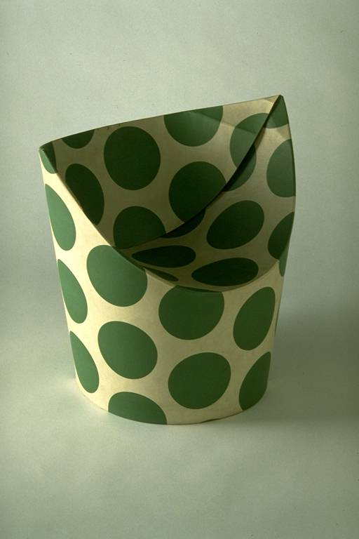Image: “A larger image containing my (sub)image” cropped version of 0753-0001 (image shown here is not cropped)

- Results:
- Expected results: The original image should be selected as the best match
- Obtained results: Got the correct result. In fact, there were two versions of this image in the collection and they showed up in the #1 and #2 positions. I disconnected from the site before this completed but it did complete and I was able to go back and view the result. It turns out that, for the first time, I was able to determine what this object is. The metadata listed for the return image had “DC Subject = CHAIR”. This had not shown up in previous query results based on using this image.
- Comments on results: a maximum of 12 minutes was estimated for the search; it actually took 1 hour 3 minutes. Thought I asked for e-mail notification when done. Don’t think I received it but I know this has worked on subsequent searches. However, there is a problem with the e-mail notification. There is not enough information in the notification. It does not say which search completed or what site the search was running on. When I was running multiple searches simultaneously, the e-mail notifications are confusing. It also does not have any instructions on how to view the results. I thought the notification was supposed to include that.

Test Run:
- Where and When:
- The site logged into: VAM
- Date/time of query: April 24, 2002; 12:05 AM PDT (USA)
- The Query
- Search number: 1188
- Databases searched: Uffizi, NGL, C2RMF
- Metadata term(s): none
- Image: “Images of a similar pattern or texture to my image” del_conestable1.jpg

- Results:
- Expected results: Since this image is in one of the collections (I believe) it should show up in the #1 position in the result set.
- Obtained results: Received some sort of error processing the search request but the history showed the query was initiated. It did complete but did not find the correct picture. There was a more serious problem. As I switched from a 9 image displayed result set to a 15 image displayed result set to a 21 image displayed result set, the actual images in positions 1 through 9 changed (and probably the same situation for positions 10 through 15 – I didn’t check). This should not happen. I never saw this type of problem searching the VAM collection.
- Comments on results: See comments in “Obtained results” above. Also, the history says it ran in 3 minutes. I don’t believe that. Is it possible because of the error I initially received, that the query was automatically rerun?

Test Run:
- Where and When:
- The site logged into: VAM
- Date/time of query: April 24, 2002; 8:37 AM PDT (USA)
- The Query
- Search number: 1197
- Databases searched: C2RMF, Uffizi, NGL
- Metadata term(s): none
- Image: “Images of a similar pattern or texture to my image” virgin.jpg

- Results:
- Expected results: Since this image is in one of the collections (I believe) it should show up in the #1 position in the result set.
- Obtained results: Did not find the image. Results don’t seem to be related to the search.
- Comments on results: My notes say that I got the same results regardless of the query. The results were the same results I got for search 1188, which also had invalid results. Also, for the 9 image display result, all 9 returned images are all Uffizi images. When I switch to the 21 image display result, the #1 position image is an NGL image. Noted another problem. On the search history, the Search Number and the Query Number are reversed. This is true for all query histories, I believe.

Test Run:
- Where and When:
- The site logged into: VAM
- Date/time of query: April 24, 2002; 9:19 AM PST (USA)
- The Query
- Search number: 1198
- Databases searched: C2RMF, Uffizi, NGL
- Metadata term(s): none
- Image: “Images of a similar pattern or texture to my image” mona.jpg

- Results:
- Expected results: Since this image is in the C2RMF collection (I believe) it should show up in the #1 position in the result set.
- Obtained results: Did not find the image. Again, for the 9 image display result, all images were Uffizi images (but I didn’t check to see if they were the same as the results of 1197 and 1188).
- Comments on results: Issue with the completion bar. It is misleading to me. It always reads 100%. I suspect that the number is supposed to label the position that the bar reaches when it registers 100% but there is not clear indication of where the bar actually ends at 100%. It would be better if the bar were filling in a contained rectangular area so that the area would be completely filled when the query was 100% complete. And it would be better to list the actual percentage completion rather than a constant 100%. Also, the completion measurement is not well correlated to actual completion time, which always seems to be significantly beyond the point where the query is estimated to be complete. Also, it is not clear under what conditions the system decides it cannot estimate the completion time. Is that explained somewhere?

Test Run:
- Where and When:
- The site logged into: VAM
- Date/time of query: April 24, 2002
- The Query
- Search number: 1199
- Databases searched: C2RMF, Uffizi, NGL
- Metadata term(s): none
- Image: “A larger image containing my (sub)image” mona.jpg (see above)
- Results:
- Expected results: Since this image is in the C2RMF collection (I believe) it should show up in the #1 position in the result set.
- Obtained results: Did not find the correct image in the C2RMF collection. It also returned a count of 4685 images. Why?
- Comments on results: Don’t understand the image count. I would think it should be the total of images in the 3 searched collection (around 12,700).

Test Run:
- Where and When:
- The site logged into: VAM
- Date/time of query: April 24, 2002
- The Query
- Search number: 1200
- Databases searched: C2RMF
- Metadata term(s): none
- Image: : “A larger image containing my (sub)image” mona.jpg (see above)
- Results:
- Expected results: I didn’t record results in my notes; I want to check and see if it is still in the VAM search history but the system is hung up.
- Obtained results:
- Comments on results

Test Run:
- Where and When:
- The site logged into: VAM
- Date/time of query: April 25, 2002; 3:30 PM PST (USA)
- The Query
- Search number: 1205
- Databases searched: Didn’t record this. But probably assumed by the numbering scheme that it was a VAM images so just specified VAM database
- Metadata term(s): none
- Image: “Images of a similar pattern or texture to my image” 0853-027

- Results:
- Expected results: Return the image in the #1 position
- Obtained results: Image returned in the #1 position
- Comments on results: worked like I expected it to work.

Test Run:
- Where and When:
- The site logged into: VAM
- Date/time of query: April 25, 2002
- The Query
- Search number: 1206
- Databases searched: VAM
- Metadata term(s): none
- Image: “images that are similar to my fax” 0761-038.jpg. This is not really a fax. It is an black and white image generated as follows: Print out the appropriate VAM image in B/W. Scan it back into the computer using a flatbed scanner and converting from TWAIN format to JPEG. I also made a TIFF version of the image by converting from TWAIN to TIFF.

- Results:
- Expected results: Return the original image from the VAM collection in the #1 position of the results.
- Obtained results: Original image was returned in the #2 position (distance = 181.9).
- Comments on results: The result is acceptable. The best match was a photo of a book page with about 30 pitchers, glasses and goblets (distance = 173.7). The system is very slow in constructing the query. In particular, after you select the target image, it take a long time to display the image for you.

Test Run:
- Where and When:
- The site logged into: VAM
- Date/time of query: April 25, 2002
- The Query
- Search number: 1207
- Databases searched: VAM
- Metadata term(s): none
- Image: “images that are similar to my fax” 0761-038.tif. See capture description in previous test run. Same image as above but in TIF format.
- Results:
- Expected results: Return the original image from the VAM collection in the #1 position of the results.
- Obtained results: Original image was returned in the #2 position (distance = 184.7).
- Comments on results: Result is acceptable. I was testing to see if it matter which image format was used for the target image. Doesn’t seem to matter. Same image was in #1 position as in last test run but distance changed slightly to 172.9.

Test Run:
- Where and When:
- The site logged into: VAM
- Date/time of query: April 25, 2002
- The Query
- Search number: 1208
- Databases searched: VAM
- Metadata term(s): Border Shape equals CIRCLE; Short Caption equals PLATE
- Image: none
- Results:
- Expected results: return images of all round plates
- Obtained results: only one image returned. It was a round plate.
- Comments on results: Apparently, all images of plates have not been processed with the border finder.

Test Run:
- Where and When:
- The site logged into: VAM
- Date/time of query: April 25, 2002
- The Query
- Search number: 1209
- Databases searched: VAM
- Metadata term(s): Short Caption equals PLAT
- Image: none
- Results:
- Expected results: return images of all plates
- Obtained results: 528 images of plates returned
- Comments on results: confirms my hypothesis in previous test run: border finder routine not run against all plates.

Test Run:
- Where and When:
- The site logged into: VAM
- Date/time of query: April 25, 2002
- The Query
- Search number: 1210
- Databases searched: VAM
- Metadata term(s): Short Caption equals PLATE
- Image: “Images of a similar pattern or texture to my image” 0754-080

- Results:
- Expected results: This image of plate should be returned in the #1 position.
- Obtained results: Found it in 38th position
- Comments on results: Not sure why it was not returned in #1 position, since it is an exact match to the target image (they are the same image file)

Test Run:
- Where and When:
- The site logged into: VAM
- Date/time of query: April 25, 2002
- The Query
- Search number: 1211
- Databases searched: VAM
- Metadata term(s): Short Caption equals PLATE
- Image: “Images of a similar pattern or texture to my image” 0754-080 (see photo in previous test run) cropped to just show the texture, not the shape of the plate.
- Results:
- Expected results: The image of plate should be returned in the #1 position.
- Obtained results: Still returned in 38th position.
- Comments on results: Still don’t understand why.

Test Run:
- Where and When:
- The site logged into: VAM
- Date/time of query: April 25, 2002
- The Query
- Search number: 1217
- Databases searched: VAM
- Metadata term(s): none
- Image: “images that are similar to my fax” 0753-039.jpg. Scanned copy as described previously.

- Results:
- Expected results: Actual image should be returned in #1 position
- Obtained results: Actual image was not returned.
- Comments on results: Did not do much investigation of this but I was disappointed in the result. May go back and play with this time permitting.

Test Run:
- Where and When:
- The site logged into: VAM
- Date/time of query: April 29, 2002 5:15 PM PST (USA)
- The Query
- Search number: 1228
- Databases searched: VAM
- Metadata term(s): none
- Image: “images that are similar to my fax” 0754-001.jpg. Scanned copy as described previously.

- Results:
- Expected results: Original image of poster should be returned in #1 position
- Obtained results: Returned in 39th position
- Comments on results: System takes a very long time to construct the query with this image file. In particular, after the target image is selected, it takes a long time to display it.

Test Run:
- Where and When:
- The site logged into: VAM
- Date/time of query: April 29, 2002
- The Query
- Search number: 1229
- Databases searched: VAM
- Metadata term(s): DC Subject equals POSTER
- Image: “images that are similar to my fax” 0754-001.jpg. Scanned copy as described previously. This is the same poster image as in previous test run
- Results:
- Expected results: Original image of poster should be returned in #1 position
- Obtained results: Original image returned in #1 position (out of 479 returned posters).
- Comments on results: Constraining the search with the metadata makes a big difference in this case.

Test Run:
- Where and When:
- The site logged into: VAM
- Date/time of query: April 29, 2002 10:00 PM PST (USA)
- The Query
- Search number: 1230
- Databases searched: VAM
- Metadata term(s): Short Caption equals POSTER
- Image: “images that are similar to my fax” 0754-001.jpg. Scanned copy as described previously. This is the same poster image as in previous test runs
- Results:
- Expected results: Original image of poster should be returned in #1 position
- Obtained results: Original image of poster returned in #1 postion.
- Comments on results: I was testing to see if it mattered whether I used the Short Caption metadata tag or the DC Subject metadata tag to specify POSTER. It didn’t. Still got correct result (but didn’t record how may posters returned in this query). The main concern is that the metadata listed for each returned object is different than what is listed for the returned images of the previous test run 1229, presumable because I used a different metadata constraint. I don’t see why this should happen. I have described this problem previously. Also, as described before, the wrong data is listed with the metadata tags.

Test Run:
- Where and When:
- The site logged into: VAM
- Date/time of query: April 29, 2002
- The Query
- Search number: 1231
- Databases searched: VAM
- Metadata term(s): none
- Image: “images that are similar to my fax” 0851-028.jpg. Scanned copy as described previously.

- Results:
- Expected results: Original image should be returned in #1 position
- Obtained results: Original image not returned (at least not in the first 42 positions which I examined)
- Comments on results: Expected better results. Don’t know why this failed.

General Usability Evaluation
Visibility of System Status
The system does tell you the status of execution of a query; however, the time estimates are not accurate and I don’t know the criteria the system uses to determine whether or not it will give you an estimate of the completion time for a query.
I found that I could also switch from the execution status screen to the Search History screen (via the Search History button), and return to the execution status screen just by using the back button of the browser.
The e-mail notification should be improved. At a minimum it should tell you the site and search number of the query that completed. It should also have some instructions on how to retrieve results. I also felt that the e-mail notification did not occur 100% of the times that I requested it.
There is another problem in the Search History. When a search is initiated but not yet complete, the duration time is incorrect. Apparently it is calculated incorrectly because the End Time reads 0:0:0 before the query completes. Either the duration should be updated correctly or it should be set to 0 or unknown until completion of the query.

Match Between System and Real World
I found the dialogue straightforward and easy to understand. My one concern is that I can’t find wording in the “Selection of Image Search Type” that indicates it will try to find an image in the database that most closely matches my target image.
As an outsider (with respect to any of the 4 museums) I have a hard time understanding what many of the metadata terms represent. I found that I could make little use of the metadata in doing searches. Part of the problem is that the metadata is not complete for every object in a collection. For example, not all plates in the VAM collection have a short caption of PLATE. This caused me to spend a lot of time wondering why I could not retrieve a particular image of a plate that I knew was in the VAM collection.
The Final Step: Search Summary is quite good.
From a sequential process perspective, I found the system understandable and easy to use.
There is one problem with the Bug Submission form that causes confusion. It asks for two pieces of information, Query ID and Query Run ID, that don’t match any terms used elsewhere. I believe they are supposed to correspond to the Search Number and Query Number. I believe they are terms used in previous prototypes but no longer used in this prototype.

User Control and Freedom
I found it easy to go back, via the arrows, to make changes as I constructed a query. I could also just go back to the beginning (New Search) easily. Therefore, Undo and Redo are supported in terms of query construction.
What I would like is a way to abort a running query. If there is a way, I could not figure it out.
I would also like to set a default to determine the number of images returned on a single page. I would prefer to have 21 images per page rather than 9.
I also view the lack of a complete listing of the metadata for each returned image as limiting my control and freedom. It is harder to plan subsequent queries when you don’t get all the information you want from a query. Also, there was no clear way to determine how to construct a query to get the metadata that you want.
I personally did not like being unable to specifically select the image analysis algorithms I wanted to run. In the various choices for image comparison, not one of them read “select the image that most closely matches the target image. “ It wasn’t clear to me if I should use the line that reads “Images of a similar pattern or texture to my image” or “A larger image containing my (sub)image”.
The image cropping capability is a nice feature.

Recognition Rather than Recall
In general the important information is carried along. I did not feel that I had to remember or write things down as I constructed a query. However, when looking at the search history, some information is missing, namely they databases (collections) that are searched during a particular query (unless I am overlooking something).
There is a bug in the results listing. The Search Number and Query Number are swapped.
The online instructions are for the previous prototype and are not helpful for this prototype. If there are other online instructions, I could not find them.

Aesthetic and Minimalist Design
This prototype does a much better job of eliminating extra steps that don’t accomplish anything. That was a definite problem in the previous prototypes. There really is minimal dialogue. I like the interface. While I may have some disagreement with the wording of the “Selection of Image Search Types”, I find that it takes a minimum of effort and steps to formulate a query.
I found the image cropping capability straightforward and easy to do.
We still use a term, Query Number (separate from the Search Number) that I see no use for. I have never had to refer to it, use it, or understand it. It only causes me confusion.
There is a problem with the metadata tags used when you select a returned image. They do not match the metadata tags used to formulate the query. This is true even when you are searching against only one collection. There are tags listed in the returned image detail that I cannot find in the list of metadata tags for formulating a query, and vice versa. If they somehow map into each other it is not obvious how.
I expected that the best match would be placed in the upper left hand corner of the result set, not the lower right corner. I think most people would expect it in the upper left hand corner.

Help Users Recognize, Diagnose, and Recover from Errors
I have received TCP Errors several times. These are not easily understandable errors. One error message that I remember getting is one that tells me I have to fill out at least one metadata term. It was understandable. I did not get into situations where there were problems and I just could not figure out how to recover from the problems.
Several times I received a message that a query had failed. I don’t believe it gave me any insight into the reason for the failure.
When the machine hangs up on a query, I have no way to recover – and no one to call because it is usually the middle of the night in the UK when I am running on the prototype.

Help and Documentation
The online documentation is out-of-date and not useful. There is documentation on the image processing modules themselves that is available via a web site at the U of S, but you have to know where it is. Nothing in the ARTISTE prototype directs you to it. Also, I could not find anything that specifically linked algorithms to the 5 types of image search listed on the page for the “Selection of Image Search Type”.
I would dearly love to have an explanation of metadata terms for each museum collection. That would help immensely.

Consistency
I found inconsistencies in metadata terms. For example, in my Search Numbers 1229 and 1230, I used two different metadata terms DC Subject and Short Caption and could not find a difference between them when I gave them the same value. But different metadata terms were listed with returned images, depending on the query formulation. I find that confusing. This may be unavoidable if we try to support both Dublin Core (DC) and internal collection metadata.
It would be more consistent to show all metadata terms associated with a returned image regardless of how the query was formulated.
In general, I found the use of the prototype and the process for formulating queries to be consistent.

Transparency and Predictability
As a general rule, I know what is supposed to happen after each step of the process of formulating and executing a query, and viewing query results and search history.
I don’t always know exactly what query results I will see when viewing query results via the search history. I found that the number of returned images from the search history was lowered to 50 from a higher number. I did not know that was going to happen.
I had query results (search number 1188, 1197 and 1198 above) where I have no idea why I received the results that I did. I assume it is a bug.
The execution time estimations are not accurate.
I could not predict which metadata terms would be displayed with returned images. It varied depending on the query that generated the set of returned images.

Learnability
I found it easy to learn how to use the prototype. Much easier than previous prototypes.
I did not have the knowledge base to use the metadata search capability in any significant way. Even for simple categorizations I had a hard time determining what metadata term to use.
I think the “Selection of Image Search Type” seems simple enough that it doesn’t take a knowledge of image processing techniques to use it.
It was easy to figure out how to use the Search History.
I can’t think of any cultural constraints that the system imposes on users, particularly since it has multi-lingual capability (which I did not use or test except just to see that it can switch between languages)
The proper online help would certainly benefit someone using the system for the first time if they have any questions.

Satisfaction
I found the lack of reliability of the system to be frustrating. Probably half the time I used the system the queries would hang. Because I work in the middle of the night (from the perspective of the UK), I could not get the system fixed so I felt I was losing and wasting a lot of time. I could not try again until the next day.
I also was frustrated by my inability to determine proper metadata categories for some of the items I wanted to search for. This limited my ability to do metadata queries. I wanted to speed up queries with metadata constraints so I could more easily evaluate the content-based retrieval but I wasted a lot of time finding the right metadata terms (or finding that certain images didn’t have certain metadata values assigned to them that I would have expected them to have.
I did get some results that were obviously wrong because of some type of bug (Search numbers 1188, 1197, 1198) and some that were unexplained (e.g. Search numbers 1199, 1210, 1211, 1217). This also lowered my satisfaction level.
In general, I would say I found the prototype greatly improved but I am not yet satisfied with it. I wanted to do a lot more testing but just couldn’t get the system to work reliably enough or fast enough.

Considerations or suggestions
One thought about using metadata for constraining searches when it is known that the metadata is not complete (for example, when all of the plate images in the VAM collection have not had Short Caption set to PLATE): I would like to set a parameter that determines whether or not a NULL in a metadata value should be treated as satisfying the constraint. For example, if my query metadata constraint specifies that “Short Caption equals PLATE”, then any VAM image that does not have any value for Short Caption should be treated as if its Short Caption equals PLATE.. This would have saved me a lot of time because of unpredictable results caused by images not having a metadata value for Short Caption (at least I think that is what happened).
For future testing, I need a way to get the machine reset when there is a hang up problem.
I think the pendulum needs to swing back to allow users to have more control over what algorithms are being run. This can be in the form of selecting the actual algorithm or having more varied choices under “Selection of Image Search Type”.

</DIV>

NCR usability evaluation (Gert Presutti)
Localisation
The text under the flags is not localised.
Suggestions for the first screen with the flags.
- Remove the English text "English" and let the flags talk for them selves.
- A "pop-up" help when placing the mouse over a flag. The help should show the localised text of "switch language to Danish". The text in the current locale should be used.
Alternative
- Show the name of the countries in the current locale
Description of Collections is not localised - that may be a problem, which cannot be resolved.
If only four collections then I can click on the four collections when I want to search them all. However, if 25 collections, then it would be nice to be able to select them all in one go.

Selection of Search Type page:
The help on the "arrow buttons" is disappeared (seems only available on the first page)
In "view picture (the one I have chosen for upload), then it looks funny that the "previous" and "next" buttons are localised I think it would be better to keep the blue buttons, as this seems to be the only place where these text buttons are used. I thought they had another interpretation - namely that I could undo my crop, as I had done it wrong.
Also, the buttons in the image tool is not localised - is that possible?
The image is "squeezing" while dragging over the picture to select the area you want to crop

Metadata specification
I do not care about the border shape (by the way that is not localised!! - should be "Billede form") why must I select it.
Not that I only can select the border and no other metadata - why the hell should I then answer the questions whether it should be an exact match on metadata text or whether it should be case sensitive?
I'm looking for a picture similar in colour to my query picture.
Supported border shapes are not localised.
I only want to search images painted by Rembrandt - where can I select that?
I guess the reason for this lay in the fact that the only metadata term common for all the collections is the border. However, I assumed that I could search using any metadata term and then I would receive images from the set of images supporting that metadata term! I do not know the collections, I only want to make my search as wide as possible (as a real user).

Executing Query
The percent indicator always shows 100% while waiting to receive the results: I suggest to frame the performance indicator bar.
Estimated maximum time:
Only show the number, which has an actual value. For example if estimated time is 0 hours 7 minutes and 25 seconds, then it should only show 7 minutes and25 seconds. Similar if the estimated time is 0 hours 0 minutes and 43 seconds, then only 43 seconds should be showed.
The "number of results" is not localised (Antal resultater)
The "view History page is not localised:
View search -> se forespørgsel
View results -> se resultater
Delete ->slet
Completed -> afsluttet
Initiated -> startet
Although I asked for colour pictures, then the result contained black and white pictures.
I asked to go to last page (from the first - without seeing any of the other pages), and I came there - but no images were showed. When I asked to go to the previous page, then still no images were shown (I did that several times with the same result)
I like the possibility to step 6 pages backward or forward.
The cataloguer pages are not localised. The buttons are in English, but the help text is in Danish.

My result (and experience)
I was searching for a picture similar in colour to the EU flag. I was forced to select a frame; I could not select any other metadata terms for example "painted by". I received 20343 images as results - none of these were not even close to what I requested (the closest distance was 1.9…). I simplified my query to search for the blue fraction of the EU flag. (Still I could not select any other metadata but the border)). This time I got 11551 results. The first picture (Don Adrián Pulido Pareja) did not seem to contain any blue. the next four did contain some blue. Then I started to have some pictures almost blue in the entire image (which I actually was looking for)
Now I wanted to get the system to work! This time I asked that but blue fraction should be a subimage (since I now realise that is the query I should have submitted from the beginning!). Unfortunately the system could not provide me with an estimate of the time for the query. But I got the search number and the Query ID. Here it would have been nice to be notified when the query was done.
While waiting, I submitted a new query (using all collections). This time I only search for an image, and I decided to use the new colour picker tool (Its great!). I selected a colour close to the blue in the EU flag, and submitted the query. I would assume the result set for this query would be similar to the result set for the previous sub-image query. The result was as expected! I got 60215 pictures, which should contain the colour I searched for (though the first, Don Adrián Pulido Pareja, as before seems not to).
I the meantime, my sub-image search has completed (7:43). I received 11474 images. Funny, The first image returned is Don Adrián Pulido Pareja - again! But the result set contained several pictures, which satisfied my query.

Conclusions
The document has presented the evaluation of the fourth prototype. The assessment concerned two different aspects: the performance and the usability evaluation.

The usability evaluation was based on the suggested test plan (carefully described in the chapter 3) that introduced the suggested queries for testing the functionalities of the prototype and provided the list of the heuristics for the “formal” qualitative evaluation.

References
[Nielsen 90] Nielsen, J. (1990). Paper versus computer implementations as mockup scenarios for heuristic evaluation. Proc. IFIP INTERACT'90 Third Intl. Conf. Human-Computer Interaction (Cambridge, U.K., August 27-31): 315-320.
[Nielsen 92]
Nielsen, J. (1992). Finding usability problems through heuristic evaluation. Proceedings ACM CHI'92 Conference (Monterey, CA, May 3-7): 373-380.

[Nielsen 94] Nielsen, J. (1994). Heuristic evaluation. In Nielsen, J., and Mack, R.L. (Eds.), Usability Inspection Methods. John Wiley & Sons, New York, NY.

[Nielsen&Molich 90] Nielsen, J., and Molich, R. (1990). Heuristic evaluation of user interfaces, Proc. ACM CHI'90 Conf. (Seattle, WA, 1-5 April), 249-256.
[RESP] RESPECT Consortium, User-Centred Requirements Handbook. V2.2, 1997 ( http://www.nectar.org/reposit/respect/5.3/)http://www.nectar.org/reposit/respect/5.3/)

