
ARTISTE, [D4.1]
#905-0009999 Rev. A
<Month, Year>

Document Changes
Draft 01
Image content analysis algorithms
Project acronym | ARTISTE
Contract number | IST 11.978
Deliverable number | D4.1
Deliverable title | Image content analysis algorithms
Workpackage | WP4 Image Analysis Algorithms
Task | T4.1/3
Date of delivery | Contractual | <due date> | Actual | <draft date>
Code name | <file name> |  | Version 2.0 draft final
Nature | <Report , Public document, SoftWare>
Dissemination level | <Restricted, Public, Internal Artiste, IST Programme>
Authors (Partner) | UoS
Contact Person | Kirk Martinez & Paul Lewis Tel: 02380 594491  ECS dept. University of Southampton fax:  UK. email: {km,phl}@ecs.soton.ac.uk
Abstract | This report documents the work carried out on image analysis algorithms to carry out the content-based retrieval in Artiste.
This document, and information herein, are the exclusive property of the partners of the ARTISTE consortium: NCR Systems Engineering Copenhagen (Denmark), University of Southampton (England), Interactive Labs S.r.l. (Giunti Publishing Group) (Italy), Centre de Recherche et de Restauration des Musées de France (France), Victoria and Albert Museum (England), The National Gallery (England), Soprintendenza per i Beni Artistici e Storici de Firenze, Prato e Pistoria (Italy)
Copyright (C) 2002
Rev. | Date | Section | Comment
A | 1999-99-99 | All | Initial Issue

Reviewers of Current Revision
Rev. | Name, Organization | Role
A

Conventions Used in This Document
The following notational conventions are used in this document:
Variable and Styles names are shown in Arial 9 pt: Variable1
Code is shown in Courier New 10 pt: While True Do
Commands are shown in Courier New 11 pt: Delete
Trademarks
All trademarks and service marks mentioned in this document are marks of their respective owners and are as such acknowledged by the ARTISTE Consortium.
Control Information
Page 48 is the last page of this document.
Contents
1. Introduction 5
1.1 Summary of Goals 5
1.2 VIPS 1
2. Artiste Image Processing API 2
2.1 General Overview of API process 2
2.2 The Image Processing API 2
3. Image Processing Algorithms 4
3.1 Goals vs. Algorithms 4
3.2 Colour-based Algorithm Descriptions 6
3.3 Texture-based Algorithm Descriptions 14
3.4 Shape-based Algorithm Descriptions 17
3.5 Multiscale Variants 21
3.6 Score Normalisation 25
3.7 Experimental Modules 30
4. Performance Testing 37
4.1 Evaluation Procedures 37
4.2 Details of Image Processing Operations 38
4.3 The Evaluation Results 38
4.4 CCV Evaluation 38
4.5 Histogram Evaluation 39
4.6 MCCV Evaluation 40
4.7 MHistogram Evaluation 40
4.8 MonoHistogram Evaluation 41
4.9 MMonoHistogram Evaluation 41
4.10 Analysis of Results 42
4.11 Conclusions 43
5. System Comparison 45
5.1 QBIC 45
5.2 eVe 45
5.3 PicToSeek 45
5.4 Virage 45
5.5 RetrievalWare 46
5.6 VisualSEEk 46
5.7 ColorWISE 46
5.8 PhotoBook 46
5.9 The Digital Library Project 46
5.10 Image MINER 47
5.11 MARS 47
5.12 Other CBR Retrieval Systems 47
5.13 Artiste Comparison 47
6. Publications 48

Introduction

Summary of Goals
The analysis of work package 2 (User Requirements) led to a set of goals for work package 4. Although many of the original goals for work package 4 were directly achievable by the IAM image processing group, some were the responsibility of IT Innovation and will be addressed in their final deliverable. Here, we give a short overview of each of the goals that were the responsibility of IAM, either in part or as a whole, and the expected difficulty of the goal to achieve (on a scale of 0 [no work required] to 10 [impossible]).

Goal 1: Matching of similar images
The main goal with nearly any image searching system is that it is able to find similar images based on a given query image or based on metadata search; such queries as "Find me an image similar to this", or "Find me an image containing similar objects". In content-based image systems the former has been approached often in the literature and is considerably easier to achieve than the latter query.
In the literature there are many way of achieving a query-by-example system. The most common approach is using the colour information stored within the image to find images which have a similar colour distribution to the query image. Search based on texture is also common within the literature. A simpler approach is to simply use the aspect ratio of the image to return from a search similar shaped images (e.g. long thin images would all be retrieved from a long thin query). Edge maps give the distribution of prominent edges within an image which would retrieve images containing similar edge distributions (e.g. many strong vertical edges retrieved from a similar query). Indeed, the best way to achieve this goal is to use a set of differing features to find very similar images.
This type of query allows both the finding of similar looking images, and also finding "lost" images. If, for example, a user required the original resolution image from a small postcard, they could submit the postcard size image as a query to find the original image.
The difficulty will be dependent on the algorithms used to achieve this goal. A histogram algorithm may only have a difficulty of 5 out of 10, whereas an object matching algorithm may be unimplementable within the scope of the project.

Goal 3: Search based on concept of style
A search based on the concept of style would allow the user to find similar style images to a given query image. However, the main problem with this type of search is that the concept of style varies so much, and will vary between people, and even over time for the same person. It is foreseen that a possibility may be to allow a search based on the concept of style of an image of a painting, which will generally rule out all content provided by partners such as the Victoria and Albert Museum whose content is mainly photography of objects.
How is style derived from the content of an image? Well, this question has been a problematic one throughout the computer vision community. The problem is that style is a high-level, semantic concept, and the relationship between low-level image-based features and high-level semantic concepts is not well known. Currently the literature shows that people are using mixtures of low-level features, tree structures, neural-networks or thesaurus-like add-ons to achieve semantics from image features.
Ways we have identified for achieving this goal include using mixtures of low-level features, such as texture and colour classification which may allow the distinction between pointilist and cubist type paintings, or training neural networks to identify image features.
The difficulty of this goal, again, depends on which technique we are able to implement. The low-level feature mixture is certainly a possibility and would require effort to allow the features from various feature extractors to be comparable, and would get a difficulty of about 7. Other methods require much more work, and would be more difficult.

Goal 4: Search based on features oriented to restoration framework
The restoration of objects is very important to most museums, and as such, they have identified that they would like the inclusion of feature extractors that would ease the detection and classification of restoration work to be carried out.
Again, like goal 3, this is generally only achievable on images of paintings, which are usually very high resolution and contain enough information to show areas which require restoration.
The types of searches identified include measurements of UV reflectance from a painting, butterfly, stretcher and plank detectors, and craquelure detectors and classifiers. These searches allow curators to find out how much of the painting has been restored (the new paints they use to restore paintings do not reflect UV light), and how the cracks in the painting or varnish surface are related to the supports which are holding the painting together (stretchers for canvas paintings), or the planks on which the painting is created.
This goal is particularly difficult due to the high-level features that are being asked for. Indeed, such decisions are difficult for even the experts to make. However, detection of UV spots, stretchers, butterflies and cracks may be possible, but gives this goal a difficulty of 9 of 10.

Goal 5: Access information quickly and easily
Although much of this goal is also the responsibility of the database administrators, the goal has relevance to the image processing group because if feature indexing is to be achieved each index will need to be associated with each feature to ensure maximised speed-up.
Brute force searching requires the query feature to be compared to every single feature in the database. With thousands of images in the system, this could means the response time of the system would become unacceptable. Indexing allows the fast retrieval of similar features by, for example, traversing a tree based on the query feature. However, indexing can give sub-optimal results and it is claimed [1] that these methods can only improve the performance significantly in situations where the number of dimensions in the indexed feature, d, is less than or equal to log(N) where N is the number of images in the database. Practically, this means multidimensional indexing will only be beneficial on a database of 50,000 images if the feature has 16 or less dimensions.
A few other possibilities are to use clustering but only search for near neighbours in feature space (as opposed to nearest neighbours), thereby reducing the number of matches that need to be performed. This is sub-optimal in many cases. Another method is to use the triangle inequality and a set of reference points. These are described later in the document.
Another view on the accessing of information quickly and easily, is the ability to view the large, high resolution paintings and photographs provided by the content providers within the Artiste system. The VISARI project built software, which would be available to the Artiste consortium, to allow the viewing of such high resolution images via a web interface, achieving easy access to the images.
The ability to provide indexing to features comes at a high price. This is because generic multidimensional indexing is going to be difficult to implement and then integrating that into the Artiste database system may prove impossible. For this reason, goal 5 is given a difficulty rating of 9.

Goal 6: Search based on colour
This goal overlaps the functionality of goal 1. The search based on colour histograms allows retrieval of similar images to a query image based on the colour content of that query image. So, if the query image was a single colour image, the search would attempt to find other images which were also the same single colour.
Alteration of this system could easily allow search based on the inclusion of selected colours within a database image (as opposed to search based on the whole image being a certain colour). Selection of the colours could be by colour sliders, CIE or Pantone patches, or any method available to us.
This type of functionality should be a matter of alteration of the colour histogram code to allow matching on certain colours, although it may require different histogram features to those used for query by example. It will also require some kind of picking interface. This goal gets a difficulty of 5.

Goal 7: Query by low quality images
Low quality images are images generated by low quality equipment (e.g. by fax machines, and portable or web cameras as opposed to museum photography equipment). The usual query by example systems are not robust in these situations because often the images have poor colour renditions, or, in the case of faxes, are black and white and this goal should be considered a separate work load to goal 1.
A query by low quality image systems will need to be able to ignore or normalise the colour variations in a way which allows the original image to be matched against the low quality version. This could be achieved with edge maps, or texture based matching. Literature on techniques to achieve query by low quality image is hard to find.
Because this goal will require the development of an algorithm from the ground up it can be considered to have a relatively high difficulty of 8.

Goal 8: Query by sketch
Query by sketch differs from query by example, in that the example given to the system to search upon is based on the creation of a user and not of a pre-existing example - a sketch just being an example image drawn by a user. In most cases this does not require new features because the query sketch is just submitted to the usual query by example matchers. Indeed, a user could simply generate a sketch offline and submit it as an example to the system. However, there are cases where a query by sketch system would require new components. For example, if matching based on a pencil sketch is required new matching modules based on edge maps would be required.
In any case, a query by sketch system will almost certainly require a front-end interface component to allow drawing and sketching within the Artiste environment. Any output from this could still be used within the query by example framework.
The difficulty of goal 8 is dependent on the level to which query by sketch is required. If query by user-example is required, very little needs to be done. However, if query by pencil-sketch type applications are required, this will need some considerable effort. The difficulty could vary between 4 and 9.

Goal 10: Joint retrieval by content and text
Joint retrieval by content and text is a matter for the database retrieval administrators. However, joint retrieval by multiple types of content [and text], is a goal IAM need to be aware of. To allow retrieval by multiple features (for example texture and colour) the scores from separate feature matchers need to be aggregated and to achieve this they need to be comparable. To achieve this we need to normalise scores from feature modules.
Again, the difficulty may vary depending on the algorithms we choose to implement and how easy their scores will be to normalise. The difficulty could foreseeable vary between 4 and 7.

Goal 12: Detail Finding
Finding details within images is potentially a very useful functionality which we could facilitate within Artiste. For example, if a user found a small portion of a painting, or a close-up of a pattern on a pot, in a photograph in a book, and wished to find the original object from which the portion came from, a sub-image match would find the detail within the original image of the object.
Sub-image matching is potentially very time-consuming. Template matching is a well-known way in which sub-image matches can be found, however, this is very computationally expensive if scale and rotation independence are also required. Edge maps and scale space techniques are a possibility as well as taking advantage of pyramidal structures within image files.
This is likely to be a goal which will be easy to implement a solution, but difficult to implement an acceptable solution with regard to the speed at which is executes. Goal 12 gets a difficulty of 6.

VIPS
The image processing algorithms will all require similar functionality - in particular, the ability to load and save images, and to access image data of many formats, and process images (such as resize, or crop). The VIPS (VISARI Image Processing Software) package gives us these types of functions without any additional programming overhead for IAM.
Another of the major advantages of the VIPS system is that it was designed specifically to be used with large mega-byte images. For example, you can comfortably view and process a large 500Mb image on a modest machine with 64Mb of RAM.
The VIPS system has an API which allows access to all its functionality from within any C or C++ program, as well as command-line versions of its image processing functions, and a nice graphical user interface to test algorithm implementations.
VIPS is able to load many types of images (JPEG, TIF, PPMs, etc) and is able to work with many types of image formats (RGB, CIELab, etc), and pass the data easily and simply onto the user, or application programmer.
VIPS runs under UNIX and has also been ported to Windows NT, which is useful for the Artiste project as IAM work under UNIX and IT Innovations use Windows NT.
As a proven base for development, VIPS has an impressive list of previous projects on which it has been used: VASARI, MARC, VISEUM, ACOHIR, and MUSA. It is also used in various museums throughout the world mostly for infra-red reflectogram mosaic assembly.
The VIPS package is distributed under the free software GNU public licence (GPL), and is administered by John Cupitt from the National Gallery (a partner on Artiste). Considerable support has been given throughout Artiste by John Cupitt.

Artiste Image Processing API

General Overview of API process
The Artiste system runs under the TOR (Teradata Object Relational) database at IT Innovations (while it is under development at least). The TOR database allows modules to be inserted into the database containing code which conforms to a specific API. When the database does a search through the data, it is able to call these UDMs (user defined modules) to perform separate, data specific, matching.
To allow the two development parties (IT Innovation and IAM) to have relative freedom within their development environment, two APIs (application programmers' interfaces) were produced. The API at IT Innovations specifies the communication process between TOR and a UDM. A separate API defines the communication process between an image processing algorithm developed at IAM and a UDM. This means that the development team at IAM do not need to understand the specifics of the database system, and it allows the image processing algorithms to be further abstracted from the application.
During the execution of the Artiste system, features are generated for every database image and stored within the database. During a query process, a feature is generated for the query image and matched against all those in the database.
The following section describes the image processing API, which is the communication process between an implementation of an image processing function and the application (i.e. not the communication process between the Artiste UDM and the database which is the application domain).

The Image Processing API
The image processing API defines the communication process between the image processing algorithm and another application. This needs to allow the full functionality of any potential image processing algorithm to be accessed from an application domain. It needs to be able to deal with generation and comparison of feature vectors of any type and return results from matches performed.
A decision was made near the beginning to divide the processing functionality between an ImageProcessor, which deals with the generation and comparison of features, and a FeatureVector, which deals with the storing and retrieving of feature data. Each object is implemented as a class within C++.
The ImageProcessor's task is to encapsulate the code required for actually performing operations on the FeatureVector which encapsulates the feature data. To achieve this it has a set of defined functionalities which allow access to the operations:
FeatureVector GenerateIF( Image )
The GenerateIF() function takes an image and returns a populated FeatureVector.
double CompareIF( FeatureVector, FeatureVector )
The CompareIF() function takes two FeatureVectors and returns a score which is the distance measure between the two features.
Within the ImageProcessor API there are also some administrative functions which are required to be implemented for the image processor to be API compliant. These include getAuthor(), and getID(), for example.
The API for the FeatureVector class is also similar. It contains a set of pre-defined functionalities which allow access to the feature data.
FeatureVector LoadIF( String ),
FeatureVector LoadIFFromMemory( char* )
The LoadIF() function allows the retrieval of a FeatureVector from a disc file. The LoadIFFromMemory() allows the retrieval of a FeatureVector from a memory location, allowing the retrieval of features from a database.
SaveIF( FeatureVector, String ),
SaveIFToMemory( FeatureVector, char* )
The SaveIF() function allows the storing of FeatureVectors to a disc file. The SaveIFToMemory() allows the storing of a FeatureVector to a memory location, allowing a feature to be stored to a database.
The FeatureVector classes also have member functions to facilitate retrieval of the author, date and type of the feature vector.
Although the member functions of these classes resemble these functional descriptions, there are various differences to allow for error handling and such.

Image Processing Algorithms

Goals vs. Algorithms
For the Artiste system we have developed a wide array of algorithms, many from proven algorithms in the literature, and some have been developed from scratch. In this chapter we will describe the algorithms we have developed in detail.
This section provides a map of which algorithms developed at IAM for work package 4, fit to the goals defined in the previous section. This mapping includes all the algorithms which have been developed, not just those integrated into the final prototype of Artiste.
As a reminder, here is a list of the relevant goals:
G1. Matching of similar images,
G3. Search based on concept of style,
G4. Search based on features oriented to restoration framework,
G5. Access information quickly and easily,
G6. Search based on colour,
G7. Query by low quality images,
G8. Query by sketch,
G10. Joint retrieval by content and text,
G12. Detail Finding.
Goal | Algorithm | Comments
1, 6 | RGB/Lab Histogram | Allows retrieval of similar images by example, based on the colour distribution.
1 | Monochrome Histogram | Allows retrieval of similar images by example, based on brightness distribution.
1, 6 | Colour Coherence Vectors | Allows retrieval of similar images by example, based on the colour distribution with distribution between colours which are homogenous to some sizeable area.
1 | Pyramid Wavelet Transform | Allows retrieval of similar images by example, based on the texture energy distribution.
1 | Query by low quality image | Allows retrieval of similar images by example, based on a normalised brightness texture energy distrubution. This algorithm was found to be a useful general matching algorithm as well as for low quality images.
1, 6 | Multimodal Neighbourhood Search | Allows retrieval of similar images by example, based on the frequency of colour pairs within the image.
3, 11 | Score Normalisation | Allows texture and colour histogram to be used together for possible style searching.
4 | UV Spot Detection | Allows visualisation of areas where the UV reflectance image is black (i.e. No UV reflectance).
4 | Stretcher Detection | Detects stretchers by their line edges so that they can be located, measured, and counted.
4 | Crack Detection/Classification | Detects and classifies cracks from X-Ray images of paintings which show cracks in varnish and paint.
6 | Colour Picker | Allows retrieval of images containing a specified amount of a selected colour or colours.
7 | Query by Fax/Low Quality Image | Allows retrieval of images by example, based on a normalised brightness texture energy distribution.
8 | Colour Coherence Vectors | Allows retrieval of similar images by example, based on the colour distribution with distribution between colours which are homogenous to some sizeable area. This can be used with sketches which are generated offline to allow query by sketch.
8 | Grid Based Matching | Allows retrieval of similar images, based on the spatial distribution of features.
12 | Multiscale RGB Histogram | Allows retrieval of similar images by example, based on the colour distribution of images and subimages.
12 | Multiscale Colour Coherence Vectors | Allows retrieval of similar images by example, based on the general colour distribution of the image and sub-images, with discrimination between colours in images which are homogenous to some sizable area.
12 | Multiscale Monochromatic Histogram | Allows retrieval of similar images by example, based on the general distribution of brightness in the image and sub-images.
12 | Multiscale Pyramidal Wavelet Transform | Allows retrieval of similar images by example, based on the general texture distribution of the image and sub-images.
12 | Generic Multiscale Matching | Allows retrieval of similar images by example, based on some feature at various resolutions.

Goal 5 is addressed through the tight implementation of certain algorithms to ensure that response time is minimised. For example, the detail finding algorithms make use of a compressed vector which is very fast to compare. We have also identified ways in which clustering analysis or reduced space searches could speed up a system such as Artiste, although these are not currently implemented in any form.
Feature space clustering reduces the number of expensive feature matches that need to be performed decreasing response time. Using a triangle inequality search reduces the number of expensive feature matches that need to be performed by replacing them with faster point-to-reference point distance calculations.
The following sections describe the algorithms we have developed as a result of the Artiste project. Sections 3.2, 3.3, and 3.4 describe the algorithms developed based on colour, texture and shape, respectiveln Section 3.5 describes the multiscale variants of the algorithms developed and the generic mutliscale image parsion Section 3.6 describes those algorithms that are still under development, and although not in Artiste, are a direct result of the Artiste project.

Colour-based Algorithm Descriptions
This section describes, in detail, each of the algorithms IAM has developed for Artiste based on colour matching.

RGB Colour Histogram
The RGB histogram is a well known and well used image matching technique. Based on a simple colour frequency, it allows retrieval of images with similar overall colour distributions. This can be a very effective means of image retrieval, particularly for images whose colour distribution is their main identifier (for example, sunset images).
A histogram of an image is built by quantisation of the colours within the image and counting the number of quantised colours that appear. The quantisation amount will affect the overall performance; if too many quantised colours are chosen matching could be too differentiating - seeing no pictures as similar, and if too small an amount of quantised colours is chosen matching may see too many images to be similar. For the purposes of Artiste, the colour histogram module has a configurable number of bins (quantised colours). An original analysis proved that 64 bins was a reasonable compromise between too small an amount of bins, and too many. But this can be changed should the necessity arise. However, matching can only take place on histograms with the same number of bins, and therefore, should the necessity arise to alter the number of colours within a histogram, the whole database of features would need to be regenerated.
For any image, a histogram is built in the following manner, in pseudo code:
function buildHistogram( Image )
clear histogram
for all pixels, p, in Image do
r = red(p) / 256 * numberOfRedBins
g = green(p) / 256 * numberOfGreenBins
b = blue(p) / 256 * numberOfBlueBins
histogram[r][g][b] = histogram[r][g][b] + 1;
endfor
end function
From an empty histogram, where all the bins are set to zero, for each pixel, the bin corresponding to the (red, green, blue) value of the current pixel is increased by one unit. The above pseudo code assumes a 24 bit RGB value (0..256 for each of red, green and blue). Monochrome images, or images in other colour spaces, are converted to RGB.
A histogram can be visualised as a bar-chart, where each bar represents one of the quantised colours, and the value represents the frequency of that colour within the whole image. For example, the following images show an example image and its histogram.
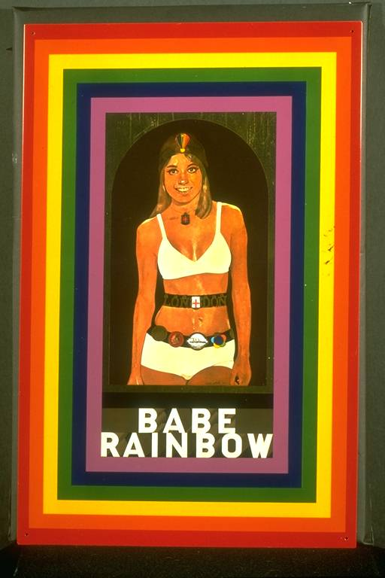 | 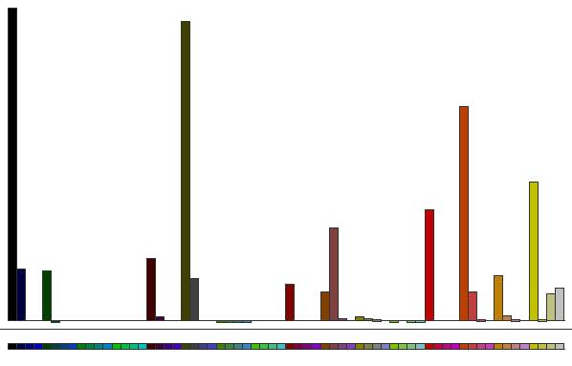

Histograms are generally normalised to avoid scale related problems. For example, an image that is 10x10 pixelsconsisting of just one colour, will have a histogram containing one populated bin with a frequency of 100, whereas if the image was 100x100, the frequency would be 10,000: values which are incomparable despite the image being visually identical. Normalisation of histograms is achieved by scaling the values until the area under the histogram sums to unity. This is achieved by dividing each of the bin values by the number of pixels in the image:
function normaliseHistogram()
for each bin in the histogram, b, do
value[b] = value[b] / numberOfPixelsInImage
endfor
endfunction
Once histograms are normalised, they are directly comparable. This means the matching process is very fast and the speed is only dependent on the number of quantised colours chosen.
Histogram matching is achieved by summing the absolute differences between all the equivalent quantised colours within the query and database histograms.
function matchHistograms( Histogram1, Histogram2 )
for each bin in Histogram1, b, do
difference = abs( Histogram1[b] - Histogram2[b] )
score = score + difference
endfor
endfunction
The score is a distance measure, that is, an exact match is given a score 0. The maximum achievable score is 2 (for example if two normalised histograms of images containing only one, mutually exclusive, colour were matched, different bins in each histogram would have a frequency of 1 [normalised by the image's pixel count]. Each of these differences would be abs( 1 - 0 ) = 1, and the sum would be 2).
One disadvantage of using colour histograms is that they are whole-image matching algorithms. This means that all pixels in the image are considered, whether these be pixels belonging to a pertinent object, or are just background noise. For example, the following image has been photographed against a white background which dominates the histogram feature vector. This means that good matches to this will also have fairly dominant white backgrounds, as well as containing the green and brown of the pots.
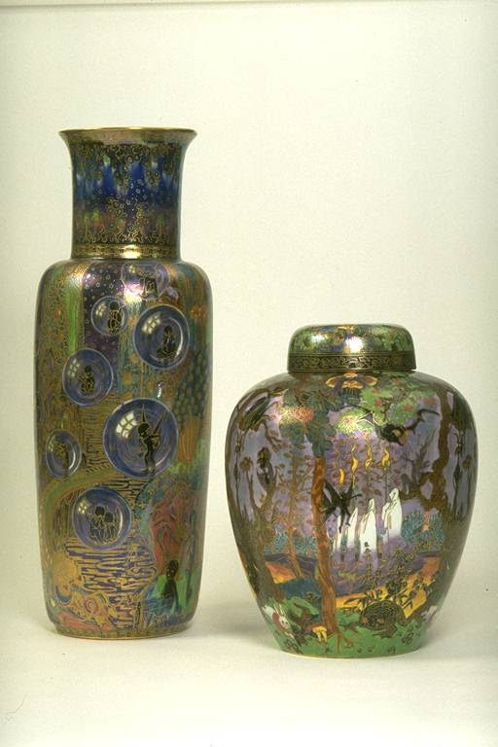 | 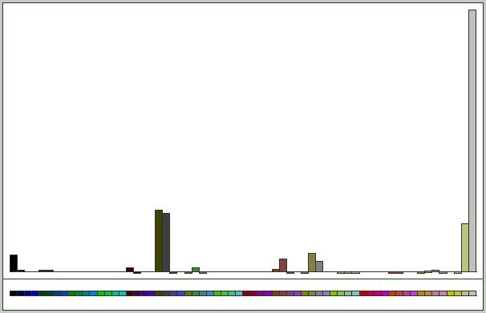
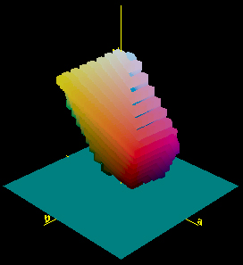
Figure 1 - The CIELab colour plot of a spectrum
Also, the colour histogram does not contain any spatial information on the colour, e.g. a red and green chequer board will not be distinguished from a red and green striped flag.

Lab Colour Histogram

The Lab colour histogram is merely a version of the RGB colour histogram but in the CIELab colour space. This colour space is much more perceptually uniform for humans. That is, a distance between two colours in the space is of the same perceptual difference independently of their position in the space. The CIELab colour space looks similar to the 3D visualisation on the right, which is an Lab plot of the colour selection spectrum in Photoshop.
The Lab histogram works in exactly the same manner as the RGB histogram, with a few minor differences:
The Lab values run from 0..100, -100..+100, -100..+100 for L, a, and b, respectively. This means the bin calculation needs to take this into account
Because the Lab space is very sparse outside of the main column coarse bin selections will not be adequate. A 6x6x6 Lab histogram seems the smallest possible number of bins without loosing too much resolution, while retaining a reasonable calculation time. Of course, the module is fully configurable.
Other than these small differences, the Lab Histogram creation and matching is the same as that of the RGB histogram, and suffers the same downfall related to background noise.

Monochromatic (Grey-scale) Histogram
The monochromatic histogram module was designed specifically to be used on monochromatic images, such as UV, or X-ray reflectograms. It is merely a simplification of the RGB/Lab colour histograms into one dimension. This means that it is far less discriminating about images generally. However, in the case of monochromatic images, it is more discriminating than the colour histograms. The reason for this is that the colour histograms have only a very small number of bins dedicated to monochromatic colours; a 4x4x4 RGB colour histogram has only 4 bins available for greys, whereas a comparable size monochrome histogram would have 64 bins, all available for greys. Figure 2 shows how images transform into the histogram feature space. Figure 3 shows how a monochrome image is transformed into the RGB space and how the monochrome histogram will be better for monochrome image discrimination.
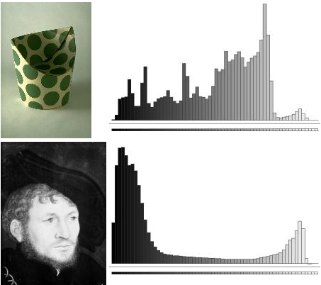
Figure 2 - A colour and monochrome image and their monochrome histograms.
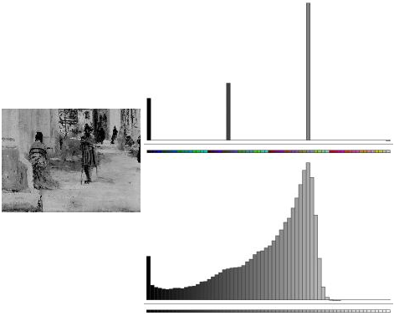
Figure 3 - A monochrome image in RGB histogram space and monochrome histogram space.
Matching is obtained using the same method as for colour histograms; each query histogram bin is compared to the equivalent bin in the match histogram, and the differences summed.

Colour Coherence Vector
The colour coherence vector is an extension to the RGB colour histogram. It provides a spatial dimension to the match by discriminating between coherent and incoherent pixels. A coherent pixel is one that belongs to a sizeable region of the same colour, whereas an incoherent pixel is one that does not belong to a sizeable region of the same colour. Pixels are added to either a coherent histogram, or an incoherent histogram. The given size for coherence and incoherence was 5% of the image size - considered to be a good compromise that balanced the two histograms.
For example, the following two images contain the same proportion of black and white pixels (8,192 of each in 128x128 images). The chessboard image is arranged into squares, each 16x16 [256] pixels. The other image has two large regions, each 64x128 [4096] pixels. Each image contains 65,536 pixels, 5% of which is 3276 pixels. So regions less than 3276 pixels will be placed into the incoherent histogram and regions bigger than this will be put in the coherent histogram. The histograms are shown to the side of each image. The left histogram is the incoherent histogram, and the right histogram is the coherent histogram. It's possible to see that all the pixels from the chessboard are placed into the incoherent histogram, whereas the other image's pixels are all placed into the coherent histogram.
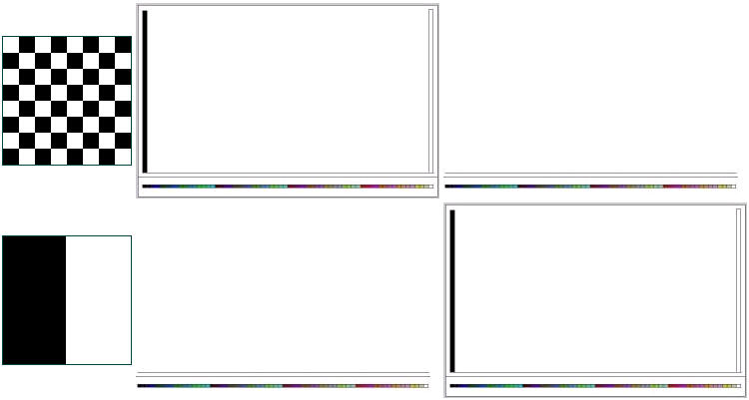
Figure 4 - Building a CCV (Colour Coherence Vector)
To achieve the CCV, the regions in an image are labelled and their size stored. The CCV is computed from a list of the regions within the image, adding the size of each region to the appropriate histogram.
Because the CCV is effectively a histogram with an extra dimension, you still get the same problems associated with background noise as you do with normal histograms. Backgrounds that are predominantly one colour will just fall into the coherent histogram and dominate the colours within that histogram.

Colour Picking
The colour picker allows users to select colours to search for within images. If an image contains the colour, or colours, selected for searching it will be returned as a match. The similarity of the amounts of colour(s) selected will give the final score. The colour picker is a special case module, in that it requires both a back-end matching algorithm and a front-end interface component (to allow selection of the colours).
The interface allows selection of multiple colours (any number) and alterations of the amounts of each colour required. The colours can be selected from a colour patch, or by mixing colours in HSB, RGB, or Lab space. Selected colours are shown as a bar chart along the centre of the applet, and the "more" and "less" buttons allow the use to alter the amount of each colour (see 3).
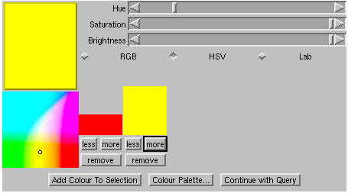
Figure 5- The Colour Picker Java Applet Interface

As well as colour selection, the colour picker can store a set of pre-defined colours from which the user may select with the colour palette (see 4).
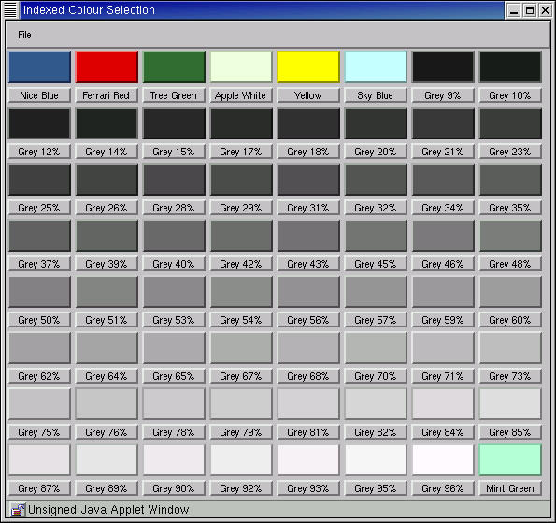
Figure 6 - The Colour Palette
The colour picker is able to be run stand-alone by an administrator to allow the colours to be updated and saved to a compatible file.

To allow integration into the Artiste web-based interface, it is written as a Java applet. The applet uses only Java 1.0 to provide its interface, to allow maximum compatibility between browsers.
IT Innovation converted the applets into JavaBeans so that they can be controlled more tightly by the Artiste system.

Once a colour selection has been made, such as the red and yellow in Illustration 3 above, a colour histogram is built containing the relative amounts of each colour as specified. This uses the same size colour histogram as the colour histogram matching code (4x4x4 = 64 bins). The colours in the example will give a histogram with bins containing the relative amounts of each colour, as shown in 5.
Matching is performed in a similar manner to the colour histogram. However, to allow images which do not contain the requested colours to be disregarded as matches, the process needs to be altered slightly:
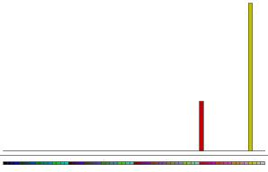
Figure 7, Histogram built from colour selection in Figure 5

If a colour exists (i.e. a histogram bin is populated) in the query histogram which does not exist in the reference histogram, the match is immediately disregarded and flagged as "no match",
If a colour exists in the reference histogram which does not exist in the query histogram, the match score is unaffected,
If a colour exists both in the query histogram, and the reference histogram, the score is increased by the absolute difference between the amounts.
This functionality can be increased by also including a "fuzziness" rating, which allows the user to restrict the images that are returned to images containing only certain amounts of colours, within some threshold. For example, setting the fuzziness rating to 50%, would only flag images as matches which contained the selected colours and contained them in amounts within 50% and 150% of the amount of colour selected. The default value for the fuzziness rating is 99% which implements the first matcher.

The matching algorithm looks like this, in pseudo code:
FUNCTION colourMatch( QueryHistogram, RefHistogram, fuzziness )
FOR each bin in histogram, b, DO
IF QueryHistogram(b) is not empty THEN
IF RefHistogram(b) < QueryHistogram(b) + fuzziness
AND RefHistogram(b) > QueryHistogram(b) - fuzziness THEN
score = score +
abs( QueryHistogram(b) - RefHistogram(b) )
ELSE
return with NO_MATCH
ENDIF
ENDIF
ENDFOR
ENDFUNCTION
The colour picker will be prone to background noise, as the histogram matching is. For example, if all the images in the database had white backgrounds, and you wished to find a white, or very light object, the background would dominate the match and irrelevant matches would be returned. However, it is much less likely to be affected by such problems. Most objects will be distinct against the background, and it would be on these which the colour search is most likely to take place. A problem may occur if the database contains objects against many different coloured backgrounds.
Title : SENS, INTERIEUR DE LA CATHEDRALE
Creator : COROT, Jean Baptiste Camille
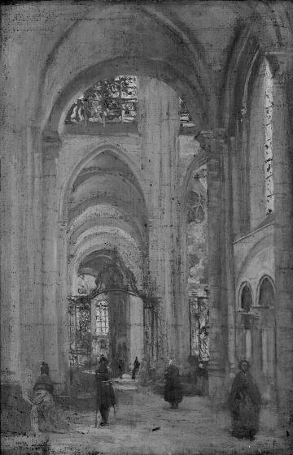  Figure 8 - U.V. - lit image | 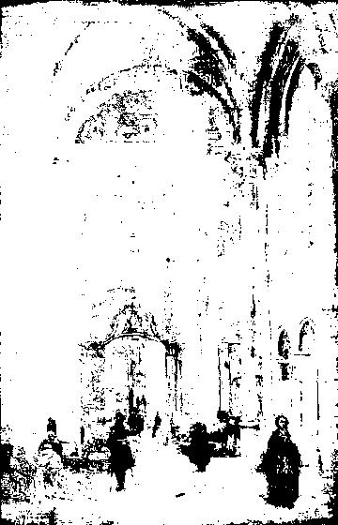  Figure 9 - U.V. thresholded | 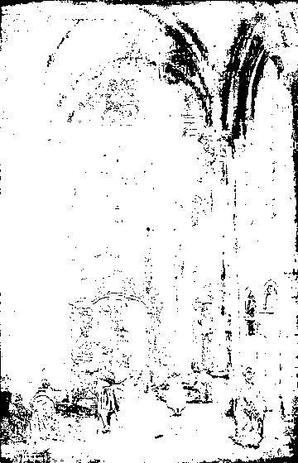  Figure 10 - U.V. thresholded image reverse-masked by the natural thresholded image
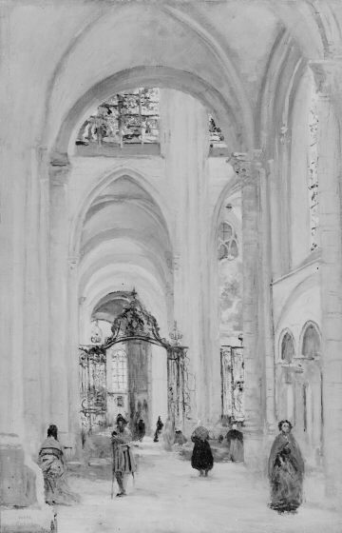  Figure 11 - Naturally lit image | 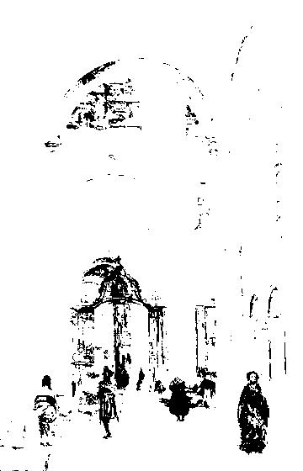  Figure 12 - Natural thresholded

UV Spot Detection
The U.V. spot detection algorithm reads in a photographic image of a painting, taken under Ultra-Violet (U.V.) lighting conditions and returns the percentage coverage of dark spots caused by the non-reflection of the U.V. light.
Dark spots shown under U.V. light are a result of previous restoration work undertaken on the particular painting and the amount of previous restoration directly affects the cost of future restoration work to be undertaken by the galleries on the paintings.
It was initially expected that we would be able to threshold the U.V. image at an appropriate level and simply count the proportion of thresholded pixels, thus returning a good estimate of the proportion of dark spots under U.V. lighting.
Unfortunately it turns out that the photographs taken under U.V. light are not very consistent and while some of them do show clearly defined areas of differentiated dark patches, some of the others appear to be like a dimmed version of the original picture, often with dark parts of the image coming through at a similar threshold limit to the dark spots.
It was thought that if areas are dark in the original image and show through in the U.V. image, but not due to restorative work, these could then be masked out by thresholding the image taken under natural light and subtracting those areas from the threshold of the thresholded U.V. image. The original image could be automatically found by querying the database with the appropriate parameters - i.e. extract the Title and Creator from the entry for the U.V. image by searching against the filename and then search for a picture with the same Title and Creator but with natural light rather than U.V. in the lighting-type field.
These procedures were therefore carried out manually using the test database search engines and using VIPS as an image processing tool, judging the appropriate threshold levels by eye. Unfortunately, some of the matching natural light images were of a different size to the U.V. reflective images and therefore the masking process was not performed on these images.
Illustrated above in t-10 are examples of the effects produced by the various techniques used to transform the U.V. images.
Due to the way in which the U.V. spot algorithm was envisaged to be used, it was decided that a stand-alone tool will be made available to the partners to allow them to manipulate the U.V. images manually – thereby helping to make their prognosis faster and easier. This can be provided as a VIPS workspace.

Texture-based Algorithm Descriptions
This section describes, in detail, each of the algorithms developed by IAM for Artiste, based on texture matching.

Pyramid Wavelet Transform
The PWT algorithm allows the matching of images based on their texture distribution. It uses a technique called Wavelets to generate a texture representation of the image. Wavelet analysis is a relatively new tool that provides a platform for overcoming the drawbacks of a Fourier analysis. From the mathematical point of view, wavelets are a set of basis functions. This set of functions is generated from the dilations and translations of a unique function called the mother wavelet. Wavelets can also be viewed as band pass filters. The wavelet basis can be viewed as a bank of filters with various bandwidths. The complete set of the wavelet filter bank covers all frequencies in the Fourier domain and therefore all frequency elements of an image can be extracted from a set of wavelets. Pyramid-structured wavelet transform (PWT) is a process of transforming an image from the time representation into a time-scale representation, using the orthogonal wavelet family.
Figure 13 - The Pyramid Wavelet Transform
The PWT is a special fast algorithm which decomposes an image into 4 different frequency channels by low-pass and high-pass filtering the image horizontally and vertically. Figure 13, above, shows how the decomposition is done for a particular image.
The number of frequency channels can be further increased by repeating the procedure on the LL channel. The decomposition stops when the resolution of the channel reaches a certain value, usually 16x16. Figure below shows the result of applying a three-level decomposition of an image as shown in Figure 14.
Figure 14 - The Pyramid Wavelet Decomposition
A feature vector can then be generated from the PWT output by computing the mean and/or the standard deviation of the energy from all the channels present in the output of the PWT decomposition.
The pyramid-structured wavelet transform has several advantages, most notably:
- The speed of the algorithm
- The accuracy of the feature vector
- The compact nature of the feature vector, i.e. small number of features
The PWT decomposition is a very fast algorithm compared to other techniques. The accuracy of the feature vector is very high considering this speed. Usually there is a trade-off between high accuracy and high computational speed, but with the PWT both are achieved. Finally the compact features associated with PWT make indexing the features much easier. Its simplicity also implies that PWT is more suitable to be used with a more complex algorithm such as the multiscale sub-image matching for texture, and the query by fax algorithm.

Query by Low Quality Image
The motivation for the query by low quality image comes from a requirement by some partners to respond to queries for pictorial information which are submitted to them in the form of fax images or other low quality monochrome images of works of art. The museums have databases of high resolution images of their artefact collections and the person submitting the query is asking typically whether the museum holds the art work shown or perhaps some similar work.
Typically a query image will have no associated metadata and will be produced from a low resolution picture of the original art work. The resulting poor quality image, received by the museum, leads to very poor retrieval accuracy when the query image is used in a standard query by example search environment using, for example, colour or texture matching algorithms. Query by low quality image or query by fax thus has to be treated in a different way from the standard query by example searches. For the preliminary investigation, we made the assumption that query images represented the full original artwork and are not partial image queries.
The feature vector generation of a database image consists of two main steps, which are binary image matching and wavelet transform. The two steps are applied to a resampled input image of size 256x256.
During the binary image matching stage, a set of 99 binary images are created for each database image. These 99 images correspond to 99 different percentages of black pixels within the image. The idea here is, if sufficient binaries are created, one of them will be very similar to the binary version of the fax and thus making similarity measures more accurate.
Once the set of binary images are created, a PWT (see section 3.3.1) is applied to all of the binary images, resulting in 99 feature vectors for each database image.
Figure 15 - The query by fax matching algorithm
During interactive querying, the feature vector of the query image is generated by resampling and converting the query image to binary, and applying the wavelet transform. Feature vector comparison is then made between the query image feature vector and the set of database feature vectors with the same black pixel percentage as the binary query image. Images are retrieved based on the distance measure between query and database image feature vectors.
There are several advantages of the proposed query by fax algorithm:
- High accuracy in retrieving similar images based on fax images.
Fax images are very poor in nature, and using a standard feature extractor to generate the feature vector for similarity match will result in poor performance. Combining the binary image matching method with the wavelet transform improves the retrieval accuracy significantly.
- High computational speed.
The binary image matching requires 99 binaries to be processed, but the computational speed of the wavelet transform helps to make this a minor issue. The compact features of the wavelet transform also increase the speed in computing the distance between feature vectors. Finally, the PWT is performed on binary images (1 bit) rather than on standard grey level image (8 bit), improving the computational speed.

Shape-based Algorithm Descriptions
This section describes, in detail, each of the algorithms developed by IAM for Artiste, based on shape matching.

Border Similarity
The border similarity measure is based upon the border finder algorithm (see below). This algorithm detects and creates a polygon of the outer-most edge in an image. This is usually the frame, or border, of a painting. It then uses the sum of the Euclidean distance between the two sets of polygonal points to calculate a feature distance.
For example, if the border finder algorithm returned a set of points for two images, P1 and P2, the distance between the two sets of points would be given by:
$D=\sum_{t=0}^{N}{E(P1_{i}−P2_{i})}$ Where $E(P−Q)=\sqrt{(P_{x}−Q_{x})^{2}+(P_{y}−Q_{y})^{2}}$

Border Finder
The border finder uses a snake-like, rubber-band algorithm for closing in around the object within an image. A set of equidistance points are distributed around the edge of an image and each point moves towards the image centre if the pixels surrounding it lie within some homogeneity threshold. If they fall outside this threshold the point will not move and will become stationary for the remainder of the algorithm. This has the effect of
enclosing a well-defined shape in the image with points (and thereby generating a polygon approximation of the shape).
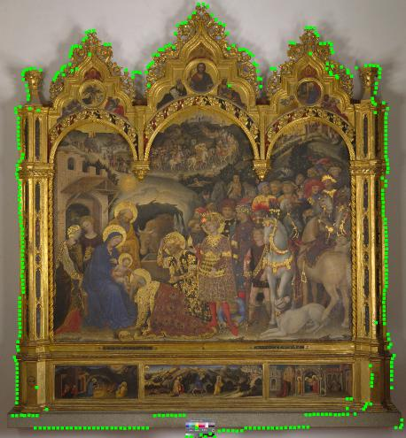
Figure 16 - Border Tracing using the Border Finder
There are two important assumptions made in this approach.
The required object is alone in the image,
The required object is against a background which will not affect the algorithm.
The algorithm is generally quite robust to backgrounds which change gradually. Problems occur when the object is not alone in the image (the image contains colour charts, or some other object of which the shape is not required), or if the object that the shape is to be traced is on an incorrect background (e.g. A black object on a black background, a painting with no frame that merges into the background, or a background containing edges).

The border finder algorithm executed on screen-sized versions of the images - which are resized if they are considered too large.
6 shows an example of an image of a painting which has had its border traced. The green dots represent each of the seeded edge points which were converging towards the centre and have stopped at points along their trajectory by an edge.
This algorithm is used by the border similarity and border classifier algorithms.

Border Classifier
The border classifier algorithm takes a polygon shape from the border finder algorithm and attempts to classify it using a neural network. The neural network is trained using examples of the types of classifications that are required. Below are the types of images used to train the classifier. The final image is considered "rubbish", and used to positively train the network to decide what an invalid input is.

The images are all input into a 16x16 grid at the input of the neural network. Each element of the grid can take inputs at various strengths. Once the network is trained, it is able to take an image, similar to the training images, and attempt to classify the input image border shape.
The border finder polygon is converted into an image compatible with the input matrix of the neural network - a 16x16 monochrome image. Each of the classifications at the output of the neural network then get a confidence score associated with them - a measure of how likely the input image is to be of that classification.
For example, if we take the border, detected using the border finder algorithm, in the previous section and convert it into a 16x16 monochrome image we get this:

This is merely a rasterisation of the border polygon in Illustration 6 into a 16x16 grid, with anti-aliasing. If we then use this as an input into the neural network we can determine what the most likely classification of this border will be.
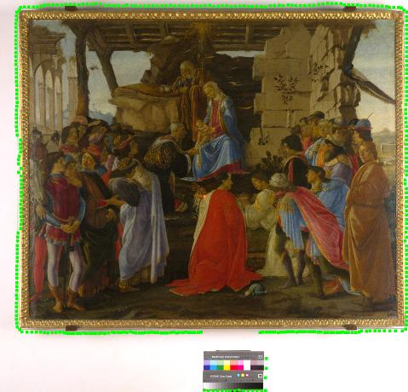
We have developed a small tool to allow us to view the neural network in action. The input matrix is shown on the left, while the output classification scores are shown on the right. It is possible to see in Illustration 7 below that the input image is correctly classified as a triptych - by having a dominantly high confidence for that classification.
The input matrix on the left of the neural tester is manipulatable in real-time and the tester can draw a shape into the input matrix and see the expected results immediately.
The border classifier is good at determining shapes from a well defined border, however, the downfalls of the border finder algorithm can cause incorrect classifications. As mentioned in the previous section, the border finder has problems with identifying the border of a shape if there are other objects in the scene. This causes the shape of the border to be incorrectly traced, and therefore the input to the neural network is incorrect, and an incorrect classification occurs. Because the neural network has a low resolution input matrix many small inconsistencies are removed. In the above example, the colour chart at the bottom of the image causes a small bump in the bottom of the neural input. However, this is minor in comparison to the rest of the match. However, in images where the background objects are larger, this causes a problem.

For example, the image above has a colour chart which has caused a large inconsistency in the neural input (shown right), and the neural network classifies this image as a circle. More training may help in overcoming these problems, although a better border finder algorithm would be preferable, because it would allow more algorithms to be developed around it.

Stretcher Detection
The stretcher detector allows matching of reverse images of paintings on canvas by their stretchers. The stretchers are the supports used to ensure the canvas is taught so that it can be painted upon. The stretchers appear as planks of wood on the rear images of these paintings. By detecting the types of supports for paintings correlations can be made with the cracks in the paint of the painting.
The stretcher detector algorithm uses the Hough transform for lines to detect strong vertical or horizontal lines within the image of the reverse of the painting.
The Hough transform is a technique developed by P.Hough in the late 1950s. It is based on a parameterization of the equation of a line into an accumulator space. The line detector uses the equation of a line:
$$y=\text{mx}+c$$
We can re-write this equation to make x and y constants, and vary m and c. Now, all lines that pass through point (x,y), of which there are theoretically an infinite number, have this equation. We make a new feature space, mc-space, which has m and c as the axis. At a constant (x,y) the graph of m against c is linear and inversely proportional:
$$−c=\text{mx}−y$$
Now, imagine two points on a line in image space. For each of the points (p,q) and (p’,q’), two different lines are mapped into mc-space. The crossing of the lines in mc-space represents the values of m and c of the line in image space joining points (p,q) and (p’,q’).
If we extend this on to all values of x and y, we can assess what the equations of the lines in the image are by the crossings of lines in mc-space. To detect the crossings we treat the mc-space as an accumulator space.
For every pixel that is foreground, we draw a line in accumulator space representing all values of m and c for the values of x and y. We can use Bresenham’s line algorithm to achieve this in our discrete accumulator space. At each discrete position in the accumulator space lying on this line, we increase the value by one. We do this for all values of x and y where a foreground colour exists. At the end of the algorithm there will be peaks in accumulator space where one discrete element of mc-space was increased by the algorithm multiple times – i.e. where there are crossings of lines in mc-space. The strength of these peaks represent how many pixels in the image lie on the line represented by those values of m and c. We can make the accumulator space smaller and only detect lines that are vertical (m close to infinity), or horizontal (m close to zero).
To achieve this we need to have a definition for foreground and background pixels. Because we are searching for lines within the image, we use an edge detection operator before hand. This operator returns an edge image which contains strong white lines where there are edges (large contrast gradients) in the original image, and black where there are not.
This algorithm is fairly robust at detecting lines within the image – but only those lines which are able to be extracted with an edge detection algorithm – that is, they need to have a strong contrast against the rest of the image. For this reason this algorithm is not suitable for plank detection, due to planks being particularly inconspicuous.
Once we have detected the lines they need to be grouped into stretcher elements. There are, in most cases, 2 lines per stretcher (one on each side) and so the number of stretcher elements can be estimated by dividing the number of detected lines by 2. However, this is not entirely accurate due to the stretchers at the extremes of the images sometimes lacking leading edges. A costly way to achieve this would be to take small patches of image in between each detected line, and perform texture analysis on it to make a classification of its structure – whether it is wood or canvas. For the Artiste system we did not implement this through time constraints.

Multiscale Variants
This section described, in detail, each of the algorithms developed by IAM for Artiste, based on a multiscale decomposition of the image for sub-image location.

Multiscale RGB Colour Histogram
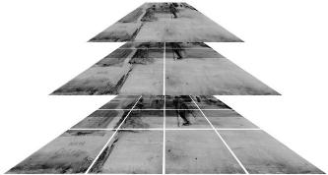
The multiscale RGB histogram allows sub-image finding based on the general colour distribution of tiles within the images. This is a very basic match which allows detection of a query image within a database image at any scale.
Figure 17 - Multiscale Pyramid Structure
The highest resolution image is converted into 64x64 tiles, overlapping by 32 pixels in each dimension. The image resolution is halved and, again, divided into 64x64 tiles (of which there will be 4 times less). The lowest resolution is of 64x64 pixels and 1 single tile. For each tile a RGB histogram is created and stored, so that the final feature vector is a set of RGB histogram feature vectors, one for each tile.

Both the query image and the database image are converted into a pyramid structure, and then each of the tiles in the query image are compared against each of the features for the tiles in the database image using the RGB histogram matching algorithm.

The query is converted to a pyramid to facilitate the database image being a sub-image of the query image (double sub-image detection). An alternative is to assume the query is a sub-image of the database image only, and perform a RGB histogram match of the whole query image against each of the tiles in the database image.

To achieve a speed up in the matching, the features for each of the tiles are compressed by an index. Rather than storing every single bin in each histogram, only those bins that are populated are stored. This can reduce the storage requirements considerably. However, it introduces a matching problem, because the populated bins may vary between features, disallowing direct comparison. It would be possible to ‘unpack’ the compressed features and then compare those features, however, it is possible using an algorithm developed by Stephen Chan, to compare the compressed features while they are still compressed. A histogram’s populated bins would be stored as {bin_number:frequency}; for example, {0:10, 3:4, 6:12} would represent a histogram with 3 populated bins. A second histogram has a compressed feature {0:1, 2:6, 8:4}. The matching algorithm steps through these features accumulating a score as though the feature was uncompressed. These two histograms would be matched as follows:

- Compare first two values: {0:10}, {0:1}.
  - Indexes match, so score becomes sum of absolute difference:
score += abs( 10-1 ) = 9
- Compare second values: {3:4}, {2:6}
  - Increment score by value of smaller index:
score += 6
- Compare next value with the same unused value: {3:4}, {8:4}
  - Increment score by value of smaller index:
score += 4
- Compare next value with the same unused value: {6:12}, {8:4}
  - Increment score by value of smaller index:
score += 12
- No value pairs left, so we add the left over value on:
  - Increment score by value of final index:
score += 4
- Final score is: 35.

An example of the mutliscale matching is shown below in Figure 18. The image on the left is the query image which is a sub-image of an image within the database.

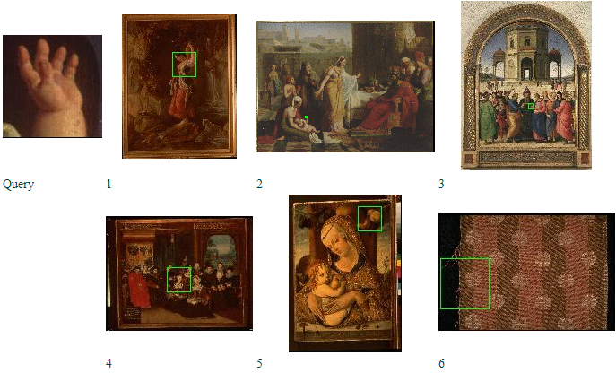
Figure 18 - An example multiscalar match. The matching regions are highlighted in green. The matching image is at rank 2.

This algorithm is implemented stand-alone – that is, it does not require any other modules (the colour histogram or the generic multiscale) to operate.

Multiscale Monochromatic (Grey-scale) Histogram
The module allows retrieval of similar images based on the general distribution of brightness in the image and sub-images. It is only suitable for monochromatic images, such as black and white scans from IR-reflectance, or similar. Colour images are converted to monochrome before comparison using this module.
The detail finder finds sub-images by dividing the query and the database image into a number of tiles over a number of resolutions, in the same way as the multiscale RGB Histogram described in section 3.5.1, except for each tile a Mono histogram is created and stored, so that the final feature vector is a set of Mono histogram feature vectors, one for each tile.
Both the query image and the database image are converted into a pyramid structure as the multiscale RGB Histogram.
Comparison of the features is based on the compressed feature algorithm described in section 3.5.1.
This algorithm is implemented stand-alone – that is, it does not require any other modules (the monochrome histogram or the generic multiscale) to operate.

Multiscale Colour Coherence Vector
The MCCV algorithm allows retrieval of similar images based on the general colour distribution of the image and sub-images, with discrimination between colours in images which are homogenous to some sizable area.
The detail finder finds sub-images by dividing the query and the database image into a number of tiles over a number of resolutions, , in the same way as the multiscale RGB Histogram described in section 3.5.1, except for each tile a CCV is created and stored, so that the final feature vector is a set of CCV feature vectors, one for each tile.
Both the query image and the database image are converted into a pyramid structure as the multiscale RGB Histogram.
Comparison of the features is based on the compressed feature algorithm described in section 3.5.1.
This algorithm is implemented stand-alone – that is, it does not require any other modules (the CCV or the generic multiscale) to operate.

Multiscale PWT
The module allows retrieval of similar images based on the general texture distribution of the image and sub-images.
The texture detail finder finds sub-images by dividing the query and the database image into a number of tiles over a number of resolutions calculating the PWT for each of the tiles.
The highest resolution image is converted into 64x64 tiles. The image resolution is halved and, again, divided into 64x64 tiles (of which there will be 4 times less). The lowest resolution is of 64x64 pixels and 1 single tile.
For each tile a PWT is created and stored, so that the final feature vector is a set of PWT feature vectors, one for each tile.
Only the database image is converted into a pyramid structure, as the query is a single scale PWT feature that is compared to each of the tiles in turn using the PWT matching algorithm. This does not allow the database image to be a sub-image of the query, but increases the overall response of the algorithm.
Feature matching is based on the standard PWT feature matching (see section 3.3.1) and does not employ compressed feature matching. This is because the MPWT algorithm uses the generic multiscale feature as described in section 3.5.5.

Generic Multiscale Feature
The generic multiscale feature allows any single scale feature to be used as a multiscale feature. The multiscale feature works in a similar manner to the multiscale variants above, however, the feature is written in a way that makes it an application that uses the Artiste API - that is, it uses the interface defined to achieve its polymorphic behaviour.

As with the stand-alone systems, the highest resolution image is converted into 64x64 tiles. The tiles are not overlapping, which although reduces detection accuracy, it increases response time 4-fold. The image resolution is halved and, again, divided into 64x64 tiles (of which there will be 4 times less). The lowest resolution is of 64x64 pixels and 1 single tile.
For each tile the algorithm’s GenerateIF function is called to generate the appropriate feature vector, which is then stored. This makes the final multiscale feature a set of the appropriate feature vectors for the algorithm, one for each tile. Compression of the features generated from GenerateIF could be achieved with the prior knowledge that the features are comparable with the algorithm described in section 3.5.1 – which is a simple compression of a standard point-to-point Euclidean distance measure. If the algorithm’s feature is not compatible, then it is invalid to use this technique, therefore it is not implemented in the generic multiscale currently.
Only the database image is converted into a pyramid structure, as the query is a single scale feature that is compared to each of the tiles in turn using the appropriate CompareIF function in the algorithm. This does not allow the database image to be a sub-image of the query, but increases the overall response of the algorithm.

Score Normalisation
This section describes in detail the method used for normalisation of the scores to be used within Artiste.
The primary motivation for initiating a score normalisation process was to enable the meaningful use of a combination of different features when searching by image content in the Artiste system.
Initial discussions also suggested the possibility of using ranking information to combine scores, but since this ranking information is not stored in the artiste system, the only practical alternative is to combine scores. Since the different algorithms come up with wildly different score ranges and distributions, we need to transform the scores into values that can be combined meaningfully.

How Should we Normalise Scores?
The ideal way to set up score normalisation would be to set up a regular offline batch job to compare all of the images in the Artiste database against each other and to convert those results into functions or a lookup table which could be accessed by the algorithms at runtime to normalize the scores.
Unfortunately, due to time limitations, this approach was unlikely to be implemented in time for product development deadlines, so we used a representative sample of the images from the database of images (the sampling technique will be detailed later in this report) and produced a matrix of comparison results for each algorithm (in so far as possible) and translated these results into functions describing the cumulative frequency of scores for each image processing algorithm, normalised to values between 0 (representing a perfect match) and 1 (representing the worst possible match).
These functions have subsequently been implemented into the algorithms and tested using local test harnesses.

Sampling the Image Database
The Artiste Image database contains over 50,000 images and it seemed impractical in terms of time to implement the ideal solution of comparing every image against every other image for each of the image processing algorithms, so it was decided to take a representative sample of each of the galleries' images and to prepare the sample data from those samples.
Because each gallery has it's own character of images - for example the V&A collection contains many photographs of objects on a white background with a black border, while the C2RMF collection contains many borderless images of canvasses taken under different lighting conditions as well as detail photographs and photographs of the backs of the paintings, we took a random sample of roughly 3000 images from each of the V&A, National Gallery, C2RMF collections. We only used 50 images from the Uffizi collection since this is all we had.
The sampling procedure was simple; we listed the files, ordered alphabetically and took every nth image, resulting in approximately the desired number of images.

Producing the Comparison Matrix
The next step of the procedure was to compare each of the images from the sample group against each of the other images in the sample group using each of the different algorithms. This produces a matrix of scores which can then be used to produce a score frequency graph.
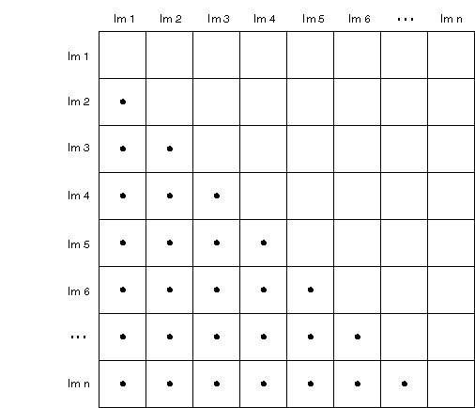
Figure 19 - Image Comparison Matrix
Each of the dots in the matrix represents a unique comparison. All of the scores in the central diagonal will be perfect scores of zero distance and can be ignored, as can those above the diagonal which simply duplicate the scores reflected by the central diagonal.

Producing Score Frequency Distributions
Once this score matrix has been generated, we have to quantize the scores, i.e. divide the score range into a number of distinct score ranges and then count how often a score occurs in each of those ranges, thus producing a score frequency distribution.
Some of the algorithms give integer scores - PWT (Texture) ranges from 0 to ~30,000, Monochrome Histogram from 0 to ~130,000 and thus do not need to be quantized, Colour Histogram and CCV (Colour Blobs) both have score ranges from 0 to 2 and were divided into ranges of 1/10,000 in order to produce the frequency distribution.
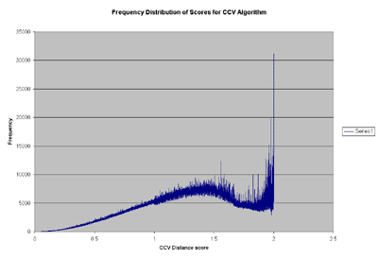  Figure 20 - Frequency Distribution for CCV | 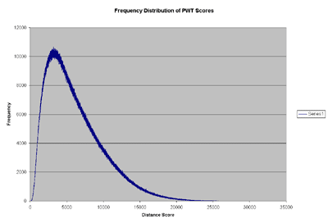  Figure 21 – Frequency Distribution for PWT
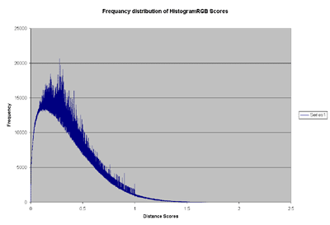  Figure 22 - Frequency Distribution for Colour Histogram | 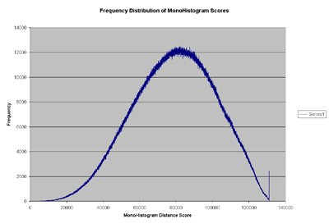  Figure 23 - Frequency Distribution for Monochrome Histogram

Converting the Frequency Distribution into a Normalised Probability
Given the frequency distribution, we now need to produce a normalised score based on the probability of achieving scores within a particular range. This can be achieved by first producing a cumulative curve based on the frequency distribution, and then normalising the cumulative frequency to a maximum value of one.
E.g. The Cumulative Frequency curve for the CCV algorithm looks like this:
Once we have this cumulative frequency curve, all we need to do is to take the maximum cumulative frequency value and divide all of the cumulative frequencies by that value, and we get a curve to transform the algorithm score into a normalised value.
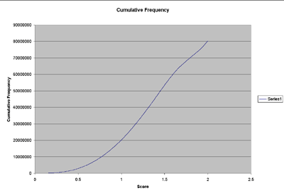
Figure 24 - Cumulative Frequency Distribution for CCV
It is interesting to consider what it is that these normalised scores actually represent. A particular score produced by a particular algorithm can now be transformed into the probability that there will be a better result than the current score within the sampled collection of images (and by implication, within the entire image collection). Thus a normalised score of 1 tells us that it is probable that all of the images within the database will obtain a better score than the current image, conversely a score of 0 tells us that there is (probably) no better match in the database than the current image.
Here are the normalised transformation curves for each of the image processing algorithms:
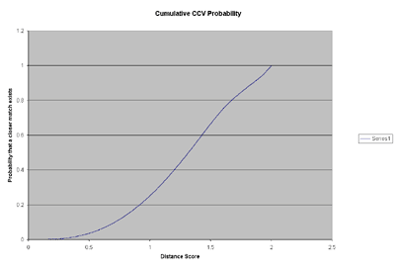  Figure 25 - CCV | 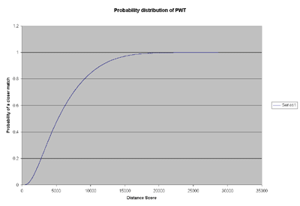  Figure 26 - PWT
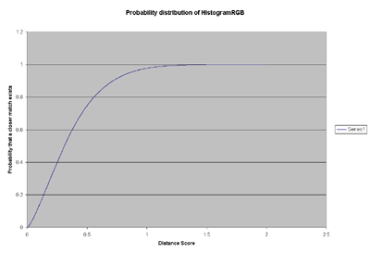  Figure 27 - Colour Histogram | 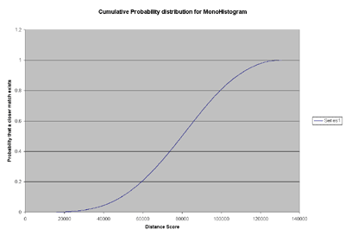  Figure 28 - Monochrome Histogram

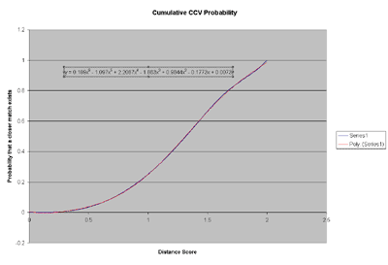
Figure 29 - Polynomial trend line derived using Microsoft Excel

Implementing the Normalisation

The normalisation curves represent relatively complex curves which are not easily transformed into an equation, so we are now faced with the problem of how best to implement a transformation from the algorithm's score to the normalised value.
It is possible to use Microsoft Excel to map a trend line onto the curve, but this is only an approximate curve, and is particularly inaccurate at the start of the curve, where we believe there is most need for an accurate translation because that is where the best matches are, in which we are inherently most interested.
In addition to this poor match at a critical position, the trend line is described by a sixth level polynomial which would produce a considerable overhead if it were to be applied for each image in the entire database.
Another solution to this issue might be to further quantize the results and to produce a lookup table which is indexed by the score and then retrieves the equivalent normalisation value.
However, the solution that has been adopted is to produce a polynomial function for the first 20% of the probability function, allowing a simpler (4th or 5th level) polynomial function and then to approximate the remainder of the function with a simple linear equation, which will distort the results, but should have the effect of maintaining the ordering of equivalent score-probability values.
Using the example of the CCV equation, figure 12 shows how these equations map to the experimental results.

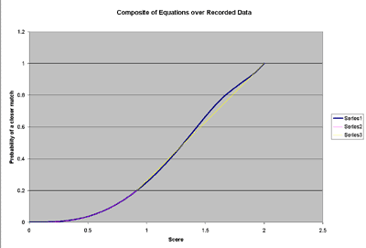
Figure 30 - Shows equations superimposed over experimental results

Experimental Modules
This section described, in detail, the algorithms which are still under development by IAM but for which stand-alone prototypes are available in the laboratory.

Multimodal Neighbourhood Search
The MNS algorithm, created by Jiri Matas and Dimitri Koubaroulis of the CVSSP group at the University of Surrey, was originally intended for indexing video sequences for the purpose of rapid content-based retrieval, and also to allow tracking of objects through the sequences. The size of the frame signature generated by MNS is typically very small at around 100 bytes for an average frame. The retrieval algorithm that computes signature similarity compensates for differing lighting conditions, is not affected by changes in scale, rotation, translation, and it is resistant to noise. Generation of the signature is very rapid, without requiring any spatial segmentation or filtering.
The extraction of the colour pair features follows a three stage process. Firstly the image is split into a grid of neighbourhoods which are perturbed by a small random amount to avoid aliasing problems, and then the colour distribution of each neighbourhood is identified using the mean shift algorithm. Neighbourhoods that contain two significant modes (the largest two modes must occupy at least seven eighth of the area of a neighbourhood) have the bi-modal value stored as a six dimensional vector representing the RGB colour pair. This space is denoted RGB² space. The set of colour pairs that is most representative of the image is then found using the mean shift in the RGB² space, providing the final signature.
For signature comparison the algorithm attempts to match pairs of elements from the two sets such that each pair satisfies some predicate. The original MNS algorithm was aimed at video databases and so the predicates were based on physical surface reflectance characteristics, such as the diagonal model of illumination change.
For a match, the two sets contain the six dimensional colour-pairs from a query image and a test image, respectively. The matching algorithm first builds a matrix of all the pair-wise distances between the two feature sets and orders these values in a list. It then traverses this list from minimal pair distance to maximal pair distance taking the first occurrence of each feature in the query set and adding the distance to the score. The algorithm penalises any unmatched query features by adding a fixed penalty for each unmatched feature. The more query features that are matched to test features, the lower the overall score, and the more similar the signatures and hence images.
Due to a lengthly testing process it has not yet been determined whether the MNS algorithm will give any advantages over the current algorithms in Artiste. Indeed, if there are no distinct advantages it would be unnecessary to include MNS as a potential feature within Artiste, or any other system. However, it is possible that the MNS algorithm will be proved to give a faster response time to sub-image queries while still achieving a similar accuracy, or give better results than a simple histogram match on whole image queries.
This work is part of a PhD project being undertaken at the University.

Colour Pigment Detection
Early painters were limited in their colour palette by the set of naturally available pigments which could be used to make their paints. This means that any shading they have applied to their paintings must be a mixture of pigments, or a pigment with various amounts of white used to desaturate the colour. We undertook some work with the help of a student from ENST, Paris, to attempt to automatically detect the pigments that were used during the painting of a work.
By creating a CIELab histogram of the accurate colour image of a painting we generate a 3D representation of all the colours in that painting. Conversion to Lch (Luminance, Chroma, and Hue) is a simple transformation. The Ostwald colour system that is based on the principle that a colour can be defined by its hue, black content and white content so we can expect to find a roughly linear dependence between L and c components (i.e. a pigment has had added only black or white to alter the shade). By using a linear regression estimation (least square estimation) over L and c components we can find an approximate line that may represent the various amounts of white or black added to the pigment. By detecting multiple axes through colour space it is possible to find crossings, where pure pigments must lie.
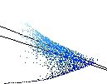
Figure 31 - Cross section through Lch-space of blue pigment.
From the detecting of pigments, and from the approximated linear paths through colour space determined by the way in which the artist used shading, it may be possible to generate an approximation for painting style..

Crack Detection
Craquelure in paintings can be a very important element in judging authenticity, use of material or environmental and physical impact because these can lead to different craquelure patterns. Although most conservation of fine artwork relies on manual inspection of deterioration signs, the ability to screen the whole collection semi-automatically was put forward by the partners to be a useful contribution to preservation.
Crack formations are influenced by aging and physical impacts and also to the wooden framework of the paintings. It is hoped that the mass screening of craquelure patterns will help to establish a better platform for conservators to identify the cause of damage.
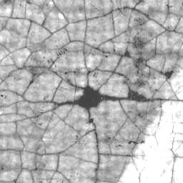 | 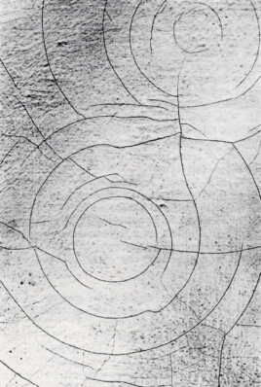 | 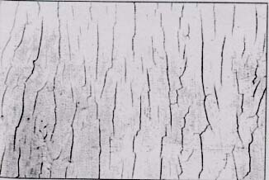 | 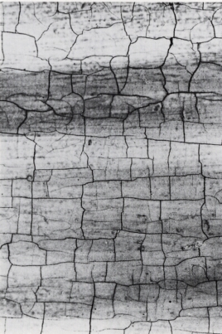 | 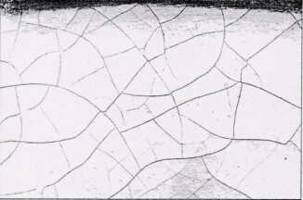
spider-web | circular | uni-directional | Rectangular | Random
Figure 32 - Common types of crack patterns
Figure 32, above, illustrates common crack types. A content-based system, such as Artiste, can assist conservators in analysing crack patterns if it can be proven to provide near-equal classification accuracy and higher retrieval speed to those of manual processes. Such crack detection and classification is a very difficult problem, and, below, we detail some of the techniques we have used to achieve it.
Our system is divided into two different, but inter-related, modules: Application Module and Processing Module. The Application Module is a front end interface to crack analysis and deals with general application issues such as querying, matching and sub-image search. The Processing Module is the back end vision system that provides the detection functions.
The processing module provides a computer vision solution to crack analysis. Theoretically, the role of this module is to process images, which can be from user queries or from a database. It consists of low-level and high-level computer vision processes. The stages are:
- Image pre-processing,
- Crack detection,
- Statistical pattern structuring,
- High-level feature extraction, and
- Unsupervised classification.
Image pre-processing is used to enhance the appearance of the image and takes the form of histogram equalization and convolutional image filtering (such as smoothing or noise reduction). Coloured region suppression is also useful for coloured images. High-pass frequency filtering can be a good solution to reduce the effect of uneven illumination.
For detecting cracks within the pre-processed images, we experimented with several line detector algorithms such as the compass line detector, the Vanderbrug algorithm, multi-orientation Gabor filtering and morphological filtering. Of these algorithms, morphological filtering provides the best flexibility and efficiency. The top-hat algorithm in particular can also be used for enhancing crack patterns.
To segment crack patterns from the background, Otsu’s thresholding technique is used. Better results can be expected if a more complicated thresholding algorithm is implemented. The segmented cracks are then thinned to 1-pixel wide and cleaned to eliminate isolated pixels. A sample result crack extraction is shown in.
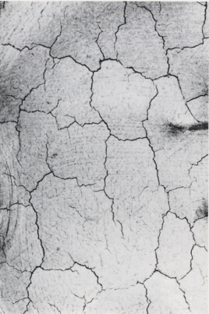 | 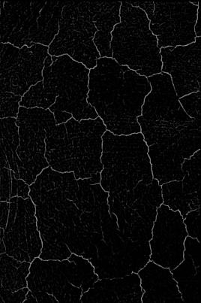 |  | 
(a) | (b) | (c) | (d)
Figure 33 - a) original image, b) output of close top-hat operation, c) after threshold, d) thinned and cleaned.
A chain code based crack following algorithm is then applied to the binary crack image. The main aim of this stage is to structure statistical information. In short, the algorithm traverses the cracks’ chain code and collates statistical information (e.g. crack length, orientation, etc.) whilst marking junctions and end points.
In order to distinguish crack patterns, the features used to describe them should have a high discriminating power. As an initial implementation we use orientation. There are multiple ways of looking at orientation for describing crack patterns. Orientation can be analysed locally and globally. Locally means describing the orientation of every line segment of a crack network and adding up their weighted values to compute an orientation-based measure which represents the whole crack network. Global analysis does not take into consideration the impact of line segments into the final measure.
We also experimented with techniques which model crack networks as straight line representations or in some literature known as polygonisation. This approach replaces each qualified line segment with a straight line, and the slope of these lines are quantised to the nearest orientation index. An orientation histogram is constructed and used for further analysis. Along with that, the ratio between the straight line and actual line length is calculated to get a rough measure of how “curvy” a line segment is.
Spatial density of the crack pixels can describe how densely or sparsely populated a region is and, similarly, spatial distribution indicates how evenly or locally distributed crack patterns are in an area. These may also be useful in detecting and classifying crack networks.
Choosing the best features to use for classification is important because the more features that are used, the more complicated the classifier becomes. A balance between accuracy and complexity is required.
Implementing an unsupervised learning algorithm provides a way to classify our data automatically. Unsupervised learning does not require classified data to train the classifier, unlike supervised learning. We experimented with several clustering algorithms namely k-means clustering, fuzzy k-means clustering and competitive learning.
The Application Module is a test harness that allows the user to make queries. Queries can be made either by class or by example.
A simple scenario would be a situation where a user issues a query in the form of a crack image or simply a text stating a particular crack type. Another scenario is a simpler problem where a user specifies a particular region in an image and requests meaningful data related to the region, such as statistical details or highest class membership information. Any output is presented to user, either in the form of highlighted regions of interest on an image, or textual data. This module will guide the flow of processes based on query specifications issued by users.
USER QUERY
- by example
- by class
QUERY PROCESSOR
- organize the flow of events based
on user specifications
OUTPUT PRESENTATION
- present output based on the type of query
Figure 34, Application Module
This module is not present in the Artiste system, because currently it is not accurate enough to generate meaningful data, unsupervised, for a range of images. The project is still being progressed as part of a PhD project being undertaken by a student in the IAM lab. If the work can attain a better classification accuracy by combining more features to obtain a more effective classifier, then the system could potentially be of use in future systems.

    - Grid-based Matching
The current algorithms in Artiste allow searching based on the general distribution of certain features within images, and therefore these algorithms are prone to background noise affecting the match accuracy. Also the location of the required feature is not taken into account in the matching process.
Using a grid of features allows us to overcome some of the limitation of the standard algorithms. The simplicity of the grid system allows interfaces to be created to select regions of the image to match, which would not be easily achievable with the standard multiscale feature. By matching only selected regions we are able to achieve spatial matching with location awareness. It also allows us to search for sub-images without regard for background noise.
We have a prototype Java version of this algorithm using colour histograms for matching images, however, there is currently no Artiste API compliant C++ algorithm to achieve the matching. The Java interface could be made into a Java applet for use within a web browser, and the Artiste system, but is only of value once a C++ compliant algorithm has been implemented.
In the prototype, the image is divided into 64 (8x8) equally sized regions each of which has a histogram associated with it.
The interface allows selection and deselection of elements of the grid within the image. A selected element implies that it is a pertinent area containing features which are to be searched for. As well as selection and deselection, the interface allows for application of pertinent features into certain elements via the “paint bucket” interface. This imparts the user with the ability to select a colour, or a region of an other image, and “paint” it into elements on the grid.
Matching is facilitated in two ways: spatial matching, and non-spatial matching. Spatial matching matches the contents of the selected elements using particular feature algorithms. In the prototype a Java version of the QBIC quadratic colour histogram matching algorithm is used, but in an Artiste-like environment, this could be any feature module conforming to a particular interface, such as the Artiste Image Processing API interface. Selected elements are matched against their corresponding elements in similarly divisioned database images. When more than one element is selected, the distance scores from the feature matcher are added together. This means the closer the database elements are to the query elements the more similar the final score is. Also facilitated is non-spatial matching, which matches the content of all the selected elements with the content of every element in the database image’s grid. This effectively introduces sub-image matching in a faster, but less accurate, way than the multiscale variants.
For example, a selection could be made on the centre of an image where a pertinent object is. Applying a spatial match will find the closest objects to the required object which also lie in the centre of the image (thereby removing any affects the background has).
Figure 35, below, shows our prototype user interface for grid matching.
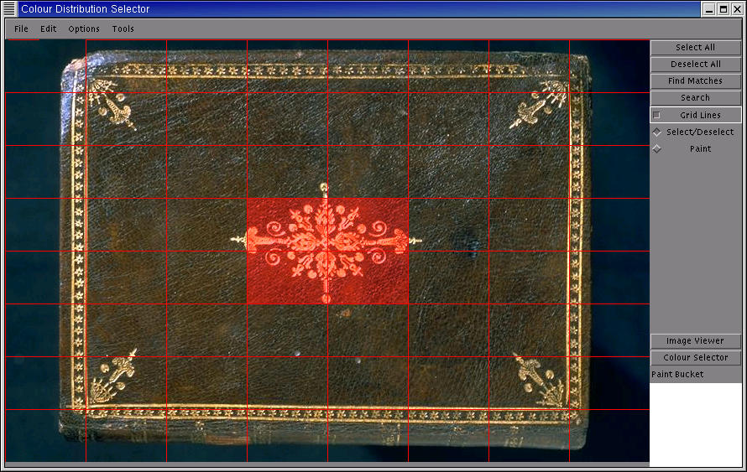
Figure 35 - Spatial Grid Matching, where user has selected regions for matching.

Performance Testing

Evaluation Procedures
In preparation for the evaluation, feature vectors for each of the algorithms were pre-generated from a database, which consisted of over 1000 images ranging from 444,000 pixels to 30,000,000 pixels in size.

For the CCV and histogram algorithms, the evaluation procedures are as follows:

Randomly select 100 images, I, from the database.
For all image operations, O (Blur, noise, sub-sample, identity)
For each image I_{n} in I
Apply image processing operation O to image I_{n} to produce image J.
Create feature vector F from image J.
Compare F with all appropriate feature vectors in database.
Order similarities and record rank information (i.e. position of correct match in ordered list).

The image operations are applied at different strengths. The image processing operations, blur, noise, sub-sampling, were applied to the image queries in increasing strengths. For the identity operation, there can only be one strength setting. In total, eight different strengths were used for each image processing operation for each algorithm. This is described in more detail in section 3 below.

The purpose of these tests is to visualize how the algorithms cope with different forms of image corruption under different degrees of severity. The tests should indicate how well the algorithms might perform in real-world applications.

For the multiscalar CCV and histogram algorithms, the evaluation procedures are as follows:

Randomly select 100 images, I, from the database.
For each image in I randomly select a random sized sub image area and store in K
For all image operations, O (Blur, noise, sub-sample, identity)
For all each image I_{n} in K
Apply image processing operation O to image I_{n} to produce image J.
Create feature vector F from image J.
Compare F with all feature vectors in database.
Order similarities and record rank information.

The difference in testing between the CCV/ histogram and the multiscalar algorithms is the extra step of extracting a random sized sub-image from the parent image. The CCV/ Histogram tests evaluate the performance of whole image retrieval whereas the multisclar algorithm tests evaluate the performance of whole image retrieval from an image fragment.

Details of Image Processing Operations
The blurring operation consisted of the application of a 3x3 averaging window that was applied once for the first strength of blur, twice for the second and so on.

The noise operation adds noise to images. The strength of noise corresponds to a control parameter called sigma, which is the standard deviation of the Gaussian noise distribution. The strength of one corresponds to a sigma of one, a strength of two corresponds to a sigma of two and so on.

The resize operation reduces the size of images by a specified percentage. The strength factor determines this percentage. The strength of one is corresponds to 0% reduction in image size, the strength of two corresponds to 10% reduction, the strength of three for a 30% reduction and so on.

The Evaluation Results
The graphs presented are cumulative graphs of the retrieval results. The graphs should be interpreted as, Y percent of all images were found to be within the top X hits. The legends in the graph are used to indicate the strength at which the algorithm was applied, where S1 is the weakest through to S8 the strongest.

CCV Evaluation

Histogram Evaluation

MCCV Evaluation

MHistogram Evaluation

MonoHistogram Evaluation

MMonoHistogram Evaluation

Analysis of Results
This section aims to provide general comments on the performance of the algorithms, and some comparison of results between algorithms.

CCV
The blur tests show that over 80% of images are retrieved as the top hit. Almost 100% of retrievals are within the top 10. The high percentage of perfect hits for the highest blur strength indicates that CCVs can cope well with blurring effects on images.

The noise tests show that over 80% of images are retrieved as the top hit for strength one and over 45% for the highest strength. However, over 80% of the retrieved images are within the top 10 hits in all cases. The graph shows that CCVs are less resistant to noise than blurring.

The identity test approaches 100% in retrieval.

The resize tests show that over 95% of images are retrieved as the top hit. 100% of the images are correctly retrieved within the top 5 hits. The CCV tests indicate that the current implementation of CCVs can cope well with scale invariance.

Histogram
The blur tests show that over 85% of images are retrieved as the top hit. The results for these tests are comparable to the CCV Blur tests, but the histogram blur tests results do not approach 100% as rapidly as the CCV tests for a given rank.

The noise tests show that over 80% of images are retrieved as the top hit for strength one and over 30% for the highest strength. The histogram tests indicate that they are not as resistant to noise as CCVs.

The identity test approaches 100% in retrieval.

The resize tests show that over 95% of images are retrieved as the top hit. 100% of the images are correctly retrieved within the top 10 hits.

MCCV
The blur tests show that over 70% of images are retrieved as the top hit. Possible improvements may be made by adjusting parameters critical to the operation of the MCCV, e.g. the jump size of the window, and size of the window. These tests may be used to gauge the optimal parameters.

The noise tests show that at least 60% of images are retrieved as the top hit for strength one and nearly 45% for the highest strength.

The identity test shows at least 88% of images are in the top hit, and the percentage of correct retrievals is 95% within the top 5 hits

The resize tests show that at least 70% of images are in the top hit, and over 80% within the top 3 hits.

MHistogram
The blur tests show that over 70% of images are retrieved as the top hit. These results may be improved by adjusting the same parameters as MCCV (the jump size of the window, and size of the window).

The noise tests show that nearly 60% of images are retrieved as the top hit for strength one and almost 45% for the highest strength.

The identity test shows at least 88% of images are in the top hit, and the percentage of correct retrievals is 95% within the top 9 hits.

The resize tests show that almost 70% of images are in the top hit, and over 80% within the top 4 hits.

HistogramMono
The blur test shows that over 88% over the images are retrieved as the top hit, which is even better than the normal histogram, showing that the monochrome histogram is less susceptible to blurring than the colour histogram.
The noise tests show that the monochrome histogram is very susceptible to noise, however, the top hit rate reducing to a poor 10% under noisy conditions. This means the monochrome histogram would be no use for a query by fax algorithm, for example.
The identity test has 100% retrieval accuracy.
The resize test indicates the monochrome histogram is not susceptible to various size images. This is expected, as the histograms are normalised for image size. It was 100% retrieval up to strength 6.

MHistogramMono
The multiscale monochrome histogram is a better discriminator than the standard multiscale histogram, and therefore some of the results fall low because the monochrome histogram is more susceptible to changes.
The hit rate for blurred images starts at 70%, but falls to below 40% and similarly, slightly poor results are found for the noise images.
As expected, the retrieval rate for identity tests is not as good as that of the normal histogram. This is because data is being lost by removing colour information making it less discriminating between colour images (because there are less possible feature value combinations). However, the tests still approach 85% accuracy at rank 1.
The resize tests follow the same general pattern, that under very small changes the multiscale monochrome histogram remains good, but under larger changes of the original image, the retrieval rate drops off dramatically.

Conclusions
In summary, the global CCV is superior to the basic colour histogram in most of the tests. However, the histogram has the advantage of rapid generation and comparison. Although processing power is less of an issue the memory requirements for generating CCVs can sometimes be a limiting factor when compared to histograms.

This global CCV and histogram results translates well to the Multiscale versions of the algorithms. MCCV generally fared better than MHistogram.
The monochrome histogram provides good retrieval rate in both single, and multi scale versions. However, it is rather sensitive to noise.
Further evaluation details for algorithms may be found in the publications listed at the end of this report.

System Comparison
This section gives a brief overview of some of the content based retrieval systems that have been developed elsewhere. Many of these were initiated in research laboratories, and some now are available as products.

QBIC
IBM's QBIC System is probably the most well known content-based retrieval engine for video and images. The image feature extraction engine uses colour, shape, and texture. The use of colour in QBIC was originally limited to the overall colour histogram of an image, or percentages of colour within an image, however, more recent versions of QBIC have included a widget which allows queries based on the spatial colour layout of images to be created (query by sketch). This system is based on a grid mechanism similar to that described in section 3.7.4. The shape features consist of area, circularity, eccentricity, major axis orientation, and a set of algebraic moment invariants.

eVe
eVe (the eVision Visual Engine), is a commercial product developed by eVision, LLC Technologies. The engine uses automatic segmentation techniques applied to colour, texture, shape, and visual and text meta-tag searching. It attempts automatic segmentation by grouping pixels based on pixel similarity and labels the clusters as objects. Although they profess that this “brings unsupervised segmentation to the commercial world” many of their examples contain objects on white background, and those which don't are poorly segmented. The query engine is query-by-example only. This helps with their visual tagging system, where all the objects in the catalogue are pre-clustered based on visual similarity. Users can add metadata to the clusters of images based on certain features (i.e. only the shape, or colour) allowing the searching process to return results quickly based on the clusters.

PicToSeek
PicToSeek is a content-based image search system, designed for use on The Web by the Intelligent Sensory Information Systems research group, at the University of Amsterdam. The system uses a colour model that is colour constant - that is, it is independent of the illumination colour, shadows, and shading cues. PicToSeek, however, is only concerned with the whole image histograms, and does not allow spatially oriented queries.

Virage
Virage is a system produced by Virage Inc. that performs content-based retrieval on video and images, using colour, texture, composition (colour intensity distribution), and structure (shape layout). It also allows for combinations of the above to be used in a single query, unlike QBIC. Weights can be varied for each feature type according to the user's needs. The framework was also extended to include domain specific features (such as face detection), as well as the general features (colour, texture, etc.).

RetrievalWare
RetrievalWare is a commercial system developed by Excalibur Technologies Corp. that, among other things, uses colour, shape, texture, brightness, colour layout and image aspect ratio in a query-by-example paradigm to match images. Like Virage, it allows combinations of these features to be used.

VisualSEEk
VisualSEEk is a content based search engine designed at the Center for Image Technology for New Media, at Columbia University, New York. The system uses colour set back-projection to extract regions of colour from images. Colour back-projection is a way of automatically extracting salient regions, by quantizing the image based on the `colour sets' - which are thresholded histograms. Because colour sets are binary, the histogram matching functions can be reduced which allows efficient indexing. VisualSEEK allows spatial-colour retrieval based on a query built from areas of solid colour, and semantic relations between those areas. The system also includes a wavelet based texture feature. WebSEEk is a web-based version of the VisualSEEk engine that supports queries on both keywords and visual content.

ColorWISE
Color-WISE is an image similarity retrieval system which allows users to search for stored images using matching based on the localized dominant hue and saturation values. It uses a cunning fixed segmentation of overlapping elements to ensure that the matching is slightly fuzzy. The system computes separate histograms for hue, saturation, and intensity, and reduces their size by finding their area-peak - basically removing noise that is small amounts of isolated colours. Color-WISE uses Microsoft Access to perform the database functions, and uses a similarity metric based on IBM's QBIC system. Querying in Color-WISE is achieved with query-by-image.

PhotoBook
Photobook from MIT consists of a number of ``subbooks'' which allow shapes, textures and faces to be extracted from images. Users can query based on the features in each of the subbooks. Later versions allowed human authors to help annotate images, based on ``models of society'' that reflect the particular domain and set of users.

The Digital Library Project
The Digital Library Project taking place at the University of Berkeley, California, has developed a system called Blobworld which uses low-level grouping techniques to create ``blobs of stuff'', which can be texture, colour, or symmetry. The blobs can be matched against their content, and their position, and it is possible to use high-level techniques to analyse the semantics of the blobs (such as where they are in relation to other blobs), and conclude what they might represent.

Image MINER
Image-MINER is an image and video retrieval system developed by the AI group at the University of Bremen. Their colour indexing system for images uses local histograms in a fixed grid geometry. Further grouping of the fixed elements occurs to get `colour-rectangles', which are signatures for their input images. The colour based segmentation module, is part of the larger Image-MINER system which includes video retrieval methods, including shot detection and subsequent `mosaicing'.

MARS
MARS (Multimedia Analysis and Retrieval System) is a multimedia retrieval system that is designed to retrieve text, images and video. The image retrieval engine they use is based upon colour and texture. Colour histogram intersection and colour moments are used to match whole images, as well as co-occurrence matrix and wavelet based methods of texture analysis.

Other CBR Retrieval Systems
ART MUSEUM is one of the earliest content based image retrieval systems, developed in 1992. Some other systems include IMatch by mwlabs which uses colour, texture, and shape for content based retrieval, DART by AT&T which also uses colour, texture, shape, as well as locally smooth regions, Netra using colour, texture, shape and spatial location information, with a neural net based automatic image thesaurus construction.

Artiste Comparison
The major difference between all these current systems and the value of Artiste, is that Artiste is specifically produced for the purposes of the museums and galleries, and therefore has bespoke functionalities which these other systems do not provide.
Artiste has some things in common with these other systems. For example, all the systems, including Artiste, have the ability to search for images based on their colour distribution (histogram matching), and many of them also have some whole image texture measure (similar to Artiste’s PWT module). Only eVe and VisualSEEk have the ability to supplement their content-based methods with metadata based searching. Artiste lacks the shape based querying of QBIC, Virage, RetrievalWare and Photobook, and does not have a dedicated query-by-sketch interface as QBIC, eVe and the Digital Library Project provide. However, sketches can easily be imported to Artiste and used with the existing algorithms.
Artiste, however, is the only one of the systems that allows the matching of queries for sub-images (with the multiscalar algorithms) and is the only system to facilitate dynamic links and navigation. It is unique in supporting mutit-lingual, searchable metadata, while supporting ZNG.

Publications
Spatial Colour Matching for Content Based Retrieval and Navigation,
David Dupplaw, Paul Lewis, Mark Dobie.
The Challenge of Image Retrieval, February 1999, Newcastle, UK,
Handling Sub-Image Queries in Content-Based Retrieval of High Resolution Art Images.
Stephen Chan and Kirk Martinez and Paul Lewis and C. Lahanier and J. Stevenson, International Cultural Heritage Informatics Meeting (ICHIM01), p.157-163 (2001).
Content-Based Multimedia Information Handling: Should we Stick to Metadata?
Paul Lewis, David Dupplaw and Kirk Martinez,
Cultivate Interactive Issue 6, February 2002,
http://www.cultivate-int.org/issue6/retrieval/
Using Colour Pair Patches for Image Retrieval,
Mike Westmacott, Paul Lewis and Kirk Martinez
Proceedings of the First European Conference on Colour in Graphics, Imaging and Vision, 245--248, June 2002.
Craquelure Analysis for Content-Based Retrieval.
Fazly. S. Abas, and Kirk Martinez,
Proceedings of the 14th International Conference on Digital Signal Processing, July 2002.

Query by Fax for Content-Based Image Retrieval,
Mohammed F. A. Fauzi and Paul Lewis,
Proceedings of International Conference CIVR 2002, London, July 2002, pages 91-99.
Interoperability between Multimedia Collections for Content and Metadata- Based Searching.
P. Allen and M. Boniface and P. Lewis and K. Martinez,
WWW2002.

All of the above publications are also available from the ECS, Southampton University, publications database: http://www.bib.ecs.soton.ac.uk/ .

