2. STAR-CCM+ user coding
An airfoil in a free shear layer (a wake, or due to the stratification of the atmosphere).
Design the inlet conditions for this case. Then apply this inlet condition for a computation of an airfoil
(you can use your coursework airfoil).
The field function for this profile is implemented as follows:
- Right-click the Tools > Field Functions node and select New.
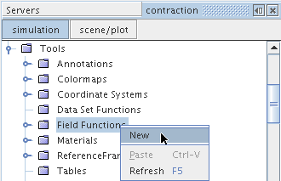
A new User Field Function 1 node will appear in the Field Functions tree.
- Right-click the User Field Function 1 node and select Rename...
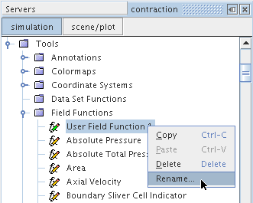
- Change the name to inflow_bc0 in the Rename dialog and click OK.
- In the Properties window, set the Type to Vector.
- Continuing in the Properties window, click the (Custom Editor) button for the Dimensions property. The Dimensions dialog will appear.
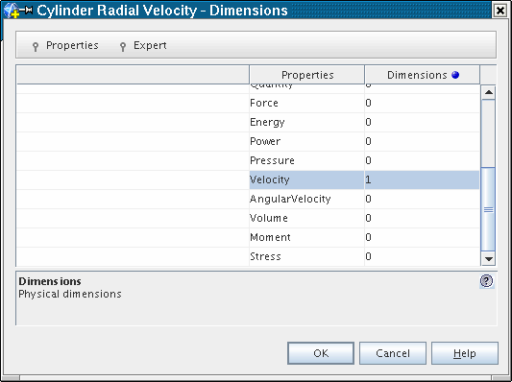
- Set Velocity to 1 as shown and click OK.
- In the Properties window, set Function Name to inflow_bc0.
- Click the (Custom Editor) button for the Definition property. The Definition editor dialog will appear.
- Enter the following definition:
[(($$Centroid("Laboratory")[1] < 0) ? (10+1/12.5*$$Centroid("Laboratory")[1])* cos(5.0/180.*3.1415927) : (10+1/12.5*$$Centroid("Laboratory")[1])* cos(5.0/180.*3.1415927)), ((10+1/12.5*$$Centroid("Laboratory")[1])* sin(5.0/180.*3.1415927)), 0]
Note that the function $$Centroid("Laboratory ") returns a cartesian vector of the face centroid coordinates in local coordinate system Laboratory; the subscript operator [] is appended to access a single component of the centroid vector (with an index of [0], [1], or [2]).
The Properties window will be as shown below when you are done.

Setting Boundary Conditions and Values
In this section we will set physical values where necessary,
- Expand the Regions > Fluid > Boundaries > farfield1 > Physics Conditions node.

Double click the Velocity node, and setup as below,
You should also setup appropriate turbulence intensity and turbulence viscosity ratio for this inlet.

Setup other inlet, e.g. farfield2.

